What’s an E-book?

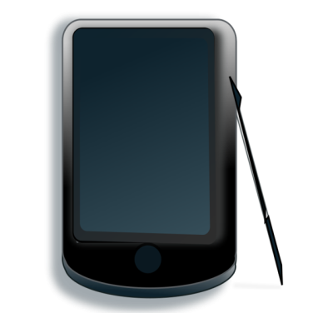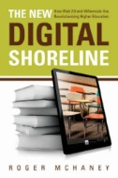
Insert the words in the blanks:
arrows | available | buttons | delivery | designed
devices | digital | downloadable | electronically | format
freely | in line with | Individual | login | members
off | on | online | period | print
printed | reader | scroll through | suppliers | system
to | to | up to | web page

An e-book (short for electronic book) is a digital version of a traditional print book designed to be read on a personal computer or e-book reader. Some libraries offer access to electronic books through the online catalogue. A universally accepted format and simple delivery system are needed. It is synonymous with digital book, ebook, and online book.
E-books are usually online versions of existing printed book titles, though very occasionally they only exist electronically. University members can access online titles to which the Library subscribes, and there are also some collections of freely available e-books.
If the e-book is presented as a web page rather than a PDF file, there is also usually the option to scroll through pages using forward and backward arrows / previous and next buttons. The majority of e-books can be read on and off campus, using your login data.
We obtain e-books from a range of different suppliers who use a range of delivery platforms which provide different functionality. As a general guide, it is only possible to print or save up to one chapter of a book, in line with “fair dealing”.
Individual chapters are usually available for download. In some cases entire books may be downloaded for a certain period. Entire e-books can only be downloaded to personal computers and mobile devices. Any e-book which offers a downloadable PDF can be read on Kindle.

