**History of building construction 2017/2018**

**Lesson 2 Exercises**

*12th March 2018*

**Glossary**

a. Pendentive

b. centering

c. formwork

d. rib

e. putlog hole

f. step ring

g. compression

h. lintel

i. tension

j. line of thrust

k. scaffolding

l. hoop tension

m. boveda tabicada

1. Stone or brick arches built into Roman concrete vaults; 2. circumferential tensile stresses that occur in the lower part of a dome: 3. the state of a material that is being compacted together; 4. a flat beam that spans an opening between two walls or columns; 5. a tile vault developed by Moorish builders common throughout the Mediterranean region; 6. the internal line of forces within a structure due to the applied loads; 7. the state of a material that is being stretched or pulled apart; 8. steps often built along the outer haunch of domes or semidomes; 9. a temporary structure used to support an arch or vault during construction; 10. the holes in a wall in which the ends of scaffolding beams were lodged during contruction; 11. the covering of the centering of a vault to create the form on which the concrete is placed; 12. a structure for workers to stand on when they are working high up on the outside wall of a building; 13. a triangular segment of a spherical surface, filling in the upper corners of a room, in order to form a circular support for a dome.

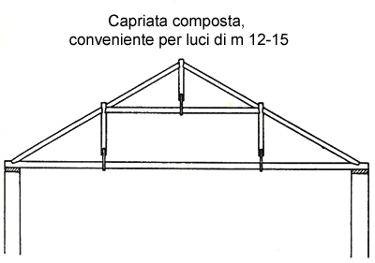

Match the terms to the corresponding part of the truss:

Tie beam, king post, queen post, rafter, tension, compression, collar tie

**Comprehension**

Lynne Lancaster, *Auguste Choisy and the economics of Roman construction*

p. 308 Choisy and the idea of the monolithic concrete vault

Choisy’s concept of monolithic concrete vault is based upon both materials and structural behavior

________________________________________________________________________________________________________________________________________

Theoretical and realistic monolithic properties

________________________________________________________________________________________________________________________________________

p. 310 The use of buttressing elements

Choisy’s interpretation of vaulting ribs as a means to achieve economy of construction

________________________________________________________________________________________________________________________________________

The role of Roman brick ribs as an economical device for the use of materials

________________________________________________________________________________________________________________________________________

p. 318 Choisy’s interpretation of brick lining on the intrados of vaults

The economical impact of brick linings for vaulting construction

________________________________________________________________________________________________________________________________________

Rome’s apartment blocks in 19th century and the use of “timbrel vaults”

________________________________________________________________________________________________________________________________________

p. 323 The relationship between economy of construction and society

What are the professional “collegia”?

________________________________________________________________________________________________________________________________________

p. 325 Conclusion

The engineering background of Auguste Choisy and his innovative interpretation of Roman architecture

________________________________________________________________________________________________________________________________________

Describe the different approach to Roman construction made by engineers/architects and archaelogists/historians

________________________________________________________________________________________________________________________________________

**Discuss**

Try to explain the “trial and error” knowledge in ancient construction considering some examples.