**History of building construction 2017/2018**

**Lesson 1 Exercises**

*7th March 2018*

1. Cement
2. Concrete
3. Dome
4. Kiln
5. Limestone
6. Coffer
7. Lime
8. Buttress
9. Post
10. Relieving arch
11. Haunch

1) a round roof with a circular base; 2) a type of white stone that contains calcium, used in building and in making cement; 3) a large oven for baking clay and bricks; 4) A recessed decorative feature used in vaults; 5) a grey powder made by burning clay and lime that sets hard when it is mixed with water; 6) A structure built up against a wall for support or reinforcement; 7) An arch built into a wall usually to counter the pressure from an opening below; 8) A vertical element that may be used to support walls or horizontal beams; 9) a white substance obtained by heating limestone, used in building materials; 10) building material that is made by mixing together cement, sand, small stones and water; 11) the side of an arch between the crown and the pier.

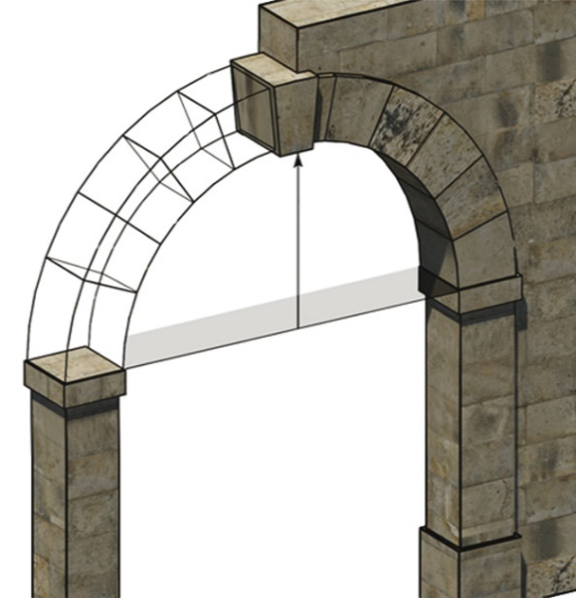

Connect the terms to the corresponding part of the arch:

a.Voussoir, b. Keystone, c. Haunch, d. Springing of the arch, e. Line of thrust, f. Intrados, g. Estrados, h. Span of the arch, i. Rise of the arch, j. Buttress; k. Crown of the arch

The Pantheon videolesson by prof. Diane Kleiner Comprehension

Complete the sentences

1) The model helps us to reconstruct the ancient Pantheon complex, analyse the description identifying the various components

………………………………………………………………………………………..

………………………………………………………………………………………..

2) Describe a typical Roman temple and underline the difference with the innovative Pantheon’s design ……………………………………………………………………………………………………………………………………………………………………………………

3) The function of the relieving arches on the circular drum, the rotunda

…………………………………………………………………………………………

4) Describe a typical frigidarium and illustrate the similarities with the Pantheon’s plan

……………………………………………………………………………………………………………………………………………………………………………………

6) Hadrian an its architect Apollodorus of Damascus and their interaction

……………………………………………………………………………………………….……………………………………………………………………………………

7) Dione Cassio’s and Hadrian’s pumpkin domes

…………………………………………………………………………………………

………………………………………………………………………………………….

8) What are pumpkin domes?

…………………………………………………………………………………………………………………………………………………………………………………….

9) The Temple of Venus and Rome and its podium

……………………………………………………………………………………………………………………………………………………………………………………