History of building construction 2018/2019

Lesson 5 Exercises
1 st April 2019

Choice of words (Fill the gaps)

1) The Maison _____________was designed by Le Corbusier in ________as a housing prototype that would address a Europe-wide housing shortage in the years leading up to the_____________. The original construction system consisted of _____________ slabs, an integral stairway and slender_______, which together reduce modern building to its bare minimum “ a concrete structural__________”.

Pilotis, frame, Dom-ino, Great War, 1914, horizontal

2) Designed by Le Corbusier and his cousin, ____________, with interior spaces and furnishings by Charlotte Perriand, the Villa ______________was named after its original owners. Intended as a country home for the family, the Villa was built between _______________on an open area of farmland in the town of_______________.

Poissy, 1929-1931, Pierre Jeanneret, Savoye

3) “The realization of the Unité at _____________has shown the splendour which is possible by the use of_________________concrete as a natural material of the same rank as stone______________ or terra cotta. It seems to be really possible to consider concrete as a reconstructed_______________, worthy of being exposed in its ____________state.”

Stone, reinforced, Marseilles, wood, natural

4) Each apartment of the Unité contains two ____________connected with an interior stair case. The ___________with a height of _____________m extends over 2 floors. A large window of _____________x 4.80 m allows a full view of the beautiful surrounding__________________.

Landscape, 4,80, day room, floors, 3,66

5) Le Corbusier's "Chapel of our lady of the height" is a ______________chapel perched on a commanding hill above the village of _____________________it is the latest of a long history of chapels on the site. The thick_______________ walls - especially the buttress-shaped south wall - and the vast ________________of the concrete ________________give the building a massive, sculptural form.

Ronchamp, shell, roof, pilgrimage, curved.

True/False

1) Le Corbusier designed the Citrohan home with the intention of creating a space that was not only efficient but also affordable. By making the house orderly and available to the masses, Le Corbusier envisioned creating a space that was uplifting and offered a solution to the chaos resulting from the war.

□ True
□ False

2) Le Corbusier perceived industrialism and technology as negative for the society, which is what he was attempting to do with the design of his houses.

□ True
□ False

3) Le Corbusier envisioned the Citrohan house as being efficient like a car. He named it the Maison Citrohan as an intended compliment to the Citroën automobile manufacturing company and because he believed it to be as efficient as the new machines.

□ True
□ False

4) Le Corbusier’s Five-Point manifesto: pilotis (the use of columns to lift the building above the ground plane), the ground garden, the free plan, the narrow window, and the free façade.

□ True
□ False

5) Le Corbusier’s collaborations in the late 1950s with Iannis Xenakis and Edgard Varèse on the La Tourette Monastery near Lyons and the Phillips Pavilion in Brussels, concerned experimental investigations of music, acoustics, and space in architecture.

□ True
□ False

6) The famous Albert Einstein phrase "It's a tool that makes the good easy and the bad difficult" refers to the Ronchamp Chapel.

□ True
□ False

Match the detail and the building, than the building and the architect.

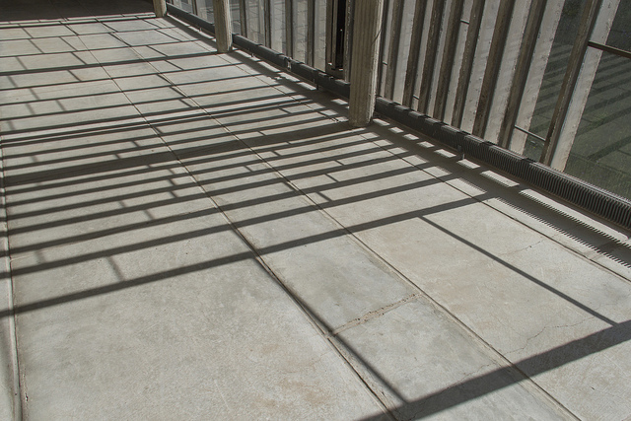

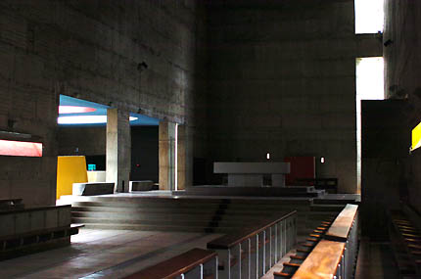

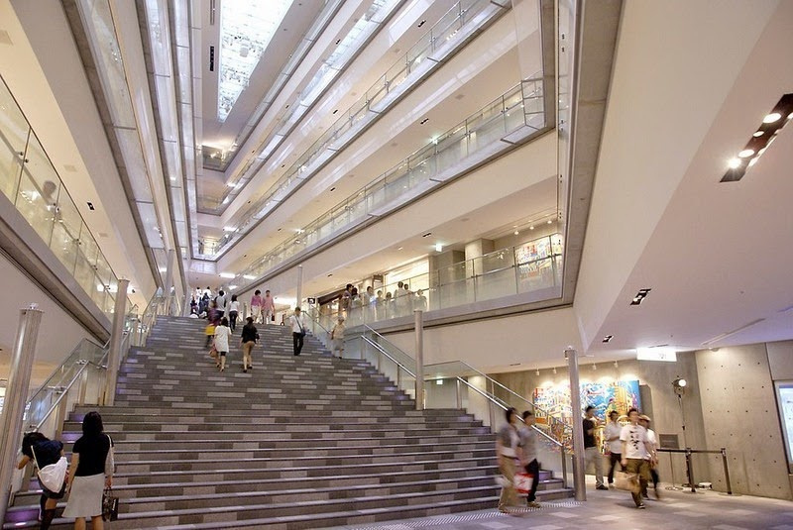

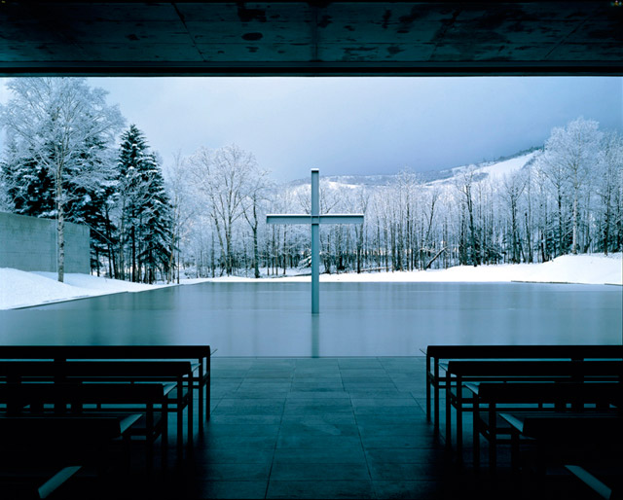

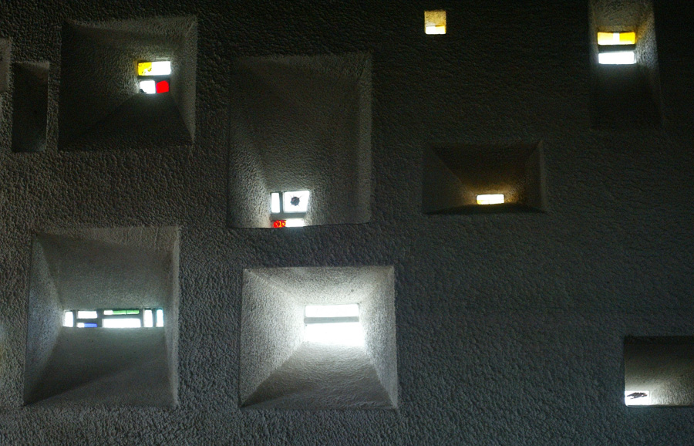

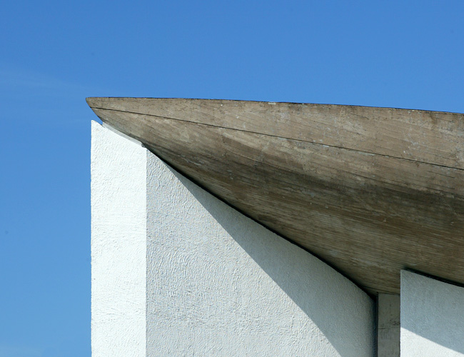

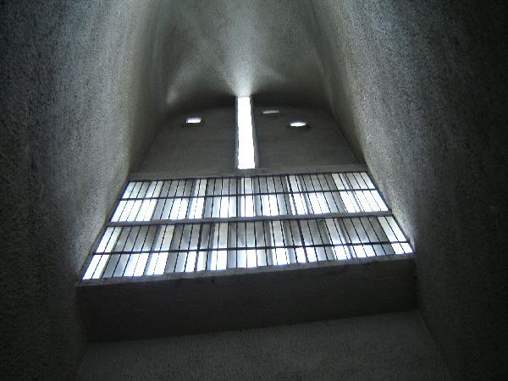

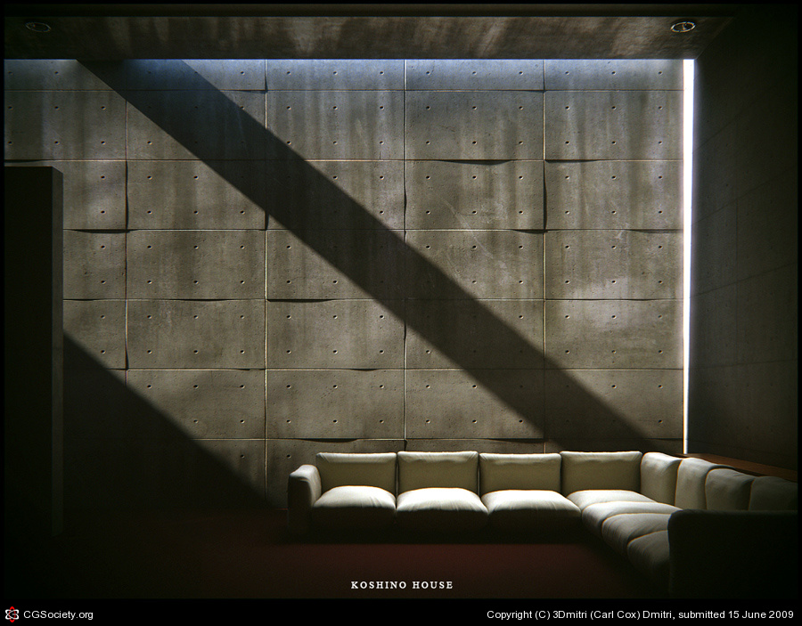

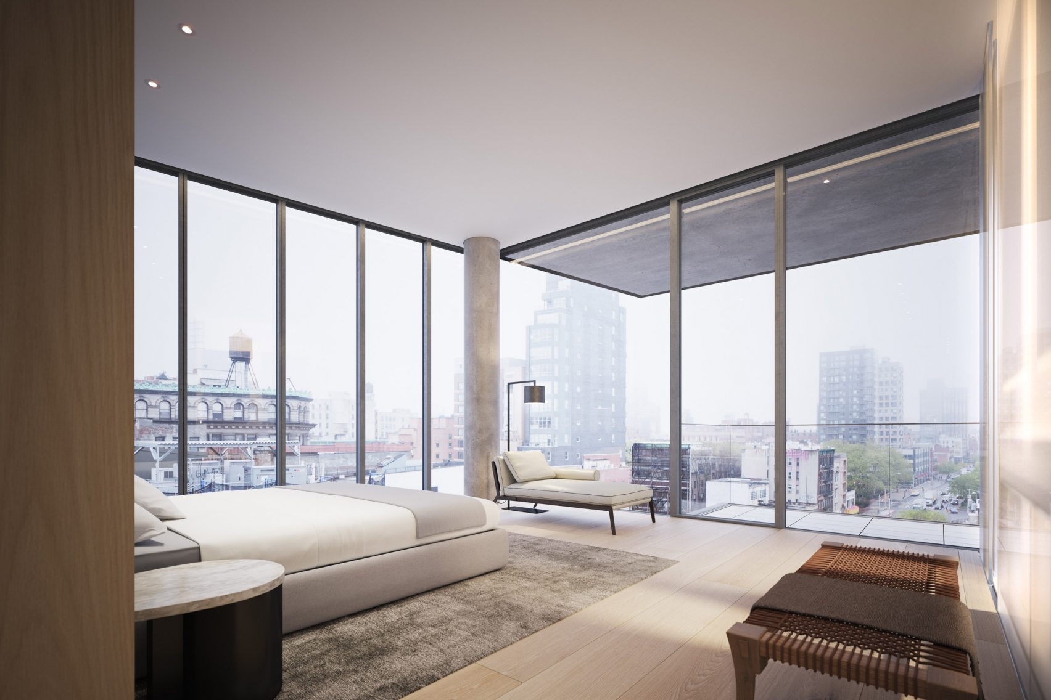

TA - Tadao Ando or LC – Le Corbusier

- Ronchamp, light “tower” ; B) Omotesando Hills inside; C) The Church on the water; D) La Tourette, lateral chapel; E) La Tourette refectory; F) Ronchamp the roof detail; G) Nolita Elizabeth street NY; H) Ronchamp the south wall form inside view; I) Koshino House.

