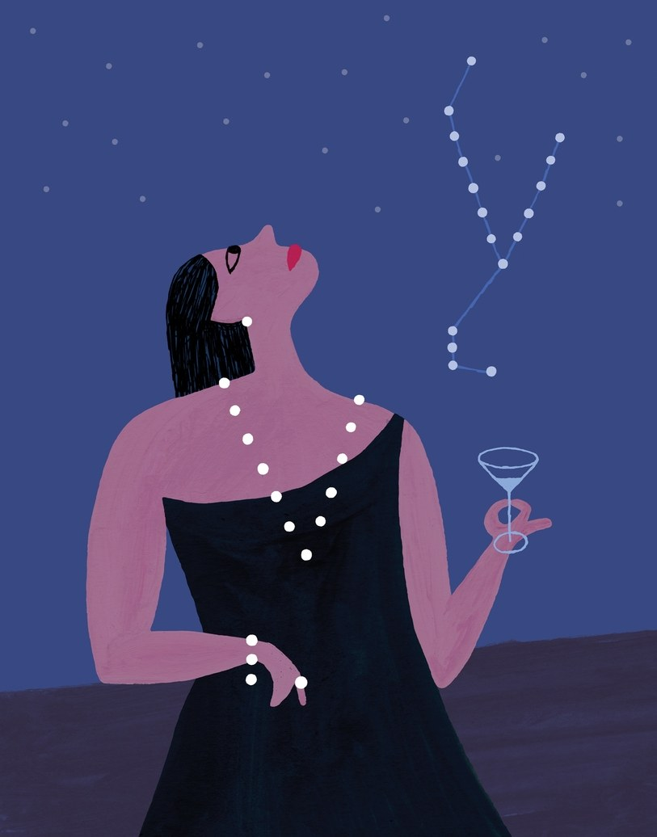

The New Yorker, October 2019

***A new generation of practitioners is meeting the public’s appetite for astrology.* Illustration by Miguel Porlan**

On a Sunday night in June, the twenty-nine-year-old astrologer Aliza Kelly was preparing to broadcast an Astrology 101 live stream from her apartment, on the Upper East Side of Manhattan. A glittering SpectroLED light panel made the living room feel like a tiny movie set. “My manager took me to get these lights at B&H,” she said.

A windowsill was lined with gifts from clients—an illustrated zodiac, a white orchid. Kelly sat cross-legged on a taupe ottoman, wearing cat eyeliner and large hoop earrings, greeting people and waving as they appeared in the online chat room. “That is one of my favorite things, as a Leo and as a person—building community,” she said. It was a little before eight-thirty, and some of the fifty-two participants—who had paid between $19.99 and $39.99 each—were typing hellos; one woman, in Europe, had set her alarm for 2:30 a.m., to log in. Once the class started, Kelly clicked through a slide deck about ancient Babylonia; William Lilly, the “English Merlin,” who was consulted by both sides during the English Civil War; and the signs of the zodiac. To explain the traits of Aries, she put up a picture of Mariah Carey (“She loves getting presents”). For Pisces, she had Rihanna and Steve Jobs. “My main favorite thing is to talk about the signs as celebrities,” she said. “Because these are modern-day mythological figures. In ancient Greece, if you said ‘Athena,’ everyone knew, Oh, that’s what Athena is *like*.”

Kelly’s schedule is typical for a millennial astrologer. She writes books (on zodiac-themed cocktails); does events (at the private club Soho House); offers individual chart readings (a hundred and seventy-five dollars an hour); hosts a podcast (“Stars Like Us”); makes memes (“for lolz”); manages a “virtual coven” called the Constellation Club, with membership levels that cost from five dollars to two hundred; and has worked as a consultant for the astrology app Sanctuary. She also writes an advice column for *Cosmopolitan*, and hosts an occasional *Cosmo* video series in which she guesses celebrities’ signs based on their answers to twelve questions. According to the editor-in-chief, Jessica Pels, who has expanded the magazine’s print coverage of astrology to nine pages in every issue, seventy-four per cent of *Cosmo* readers report that they are “obsessed” with astrology; seventy-two per cent check their horoscope every day.

Astrology is currently enjoying a broad cultural acceptance that hasn’t been seen since the nineteen-seventies. The shift began with the advent of the personal computer, accelerated with the Internet, and has reached new speeds through social media. According to a 2017 Pew Research Center poll, almost thirty per cent of Americans believe in astrology. But, as the scholar Nicholas Campion, the author of “Astrology and Popular Religion in the Modern West,” has argued, the number of people who know their sun sign, consult their horoscope, or read about the sign of their romantic partner is much higher. “New spirituality is the new norm,” the trend-forecasting company WGSN declared two years ago, when it announced a report on millennials and spirituality that tracked such trends as full-moon parties and alternative therapies. Last year, the *Times*, in a piece entitled “How Astrology Took Over the Internet,” heralded “astrology’s return as a compelling content business as much as a traditional spiritual practice.” *The Atlantic* proclaimed, “Astrology is a meme.” As a meme, its life cycle has been unusually long. “My account, it was meant to be a fun thing for me to do on the side while I was a production assistant,” Courtney Perkins, who runs the Instagram account Not All Geminis, which has more than five hundred thousand followers, said. “Then it blew up and now it’s like—I don’t know. I didn’t mean for this to be . . . life.”

In its penetration into our shared lexicon, astrology is a little like psychoanalysis once was. At mid-century, you might have heard talk of id, ego, or superego at a party; now it’s common to hear someone explain herself by way of sun, moon, and rising signs. It’s not just that you hear it. It’s who’s saying it: people who aren’t kooks or climate-change deniers, who see no contradiction between using astrology and believing in science. The change is fuelling a new generation of practitioners. Fifteen years ago, astrology conferences were the gray-streaked province of, as one astrologer told me, “white ladies in muumuus decorated with stars.” Kay Taylor, the education director of the Organization for Professional Astrology, said that those who came of age in the seventies were worried about the future of the profession. Now, she said, “all of a sudden there’s this new crop.” In the past year, the membership of the Association for Young Astrologers has doubled.

The corporate world has taken note of the public’s appetite. Last year, the astrologer Rebecca Gordon partnered with the lingerie brand Agent Provocateur to produce a zodiac-themed event where customers could use their Venus signs to, in Gordon’s words, “find their personal styles.” This spring, Amazon sent out “shopping horoscopes” to its Prime Insider subscribers. Astrology is also being used to help launch businesses. This summer, the forty-six-year-old siblings Ophira and Tali Edut, known as the AstroTwins, started Astropreneurs Summer Camp, a seven-week Web-based course. Participants analyzed their birth charts to determine whether they were Influencers, Experts, or Mavens/Messengers, and got advice on how to tailor their professional plans accordingly.

The popularity of astrology is often explained as the result of the decline of organized religion and the rise of economic precariousness, and as one aspect of a larger turn to New Age modalities. Then, there’s the matter of political panic. In times of crisis, it is often said, people search for something to believe in. The first newspaper astrology column was commissioned in August, 1930, in the aftermath of the stock-market crash, for the British tabloid the *Sunday Express*. The occasion was Princess Margaret’s birth. “What the Stars Foretell for the New Princess” was so popular—and such a terrific distraction—that the paper made it a regular feature. After the financial collapse in 2008, Gordon, who runs a popular online astrology school, received calls from Wall Street bankers. “All of those structures that people had relied upon, 401(k)s and everything, started to fall apart,” she said. “That’s how a lot of people get into it. They’re, like, ‘What’s going on in my life? Nothing makes sense.’ ” Ten years later, more than retirement plans have fallen apart. “I think the 2016 election changed everything,” Colin Bedell, an astrologer whose online handle is Queer Cosmos, told me. “People were just, like, we need to come to some spiritual school of thought.” As Kelly put it, “In the Obama years, people liked astrology. In the Trump years, people need it.”

“The idea at the heart of astrology is that the pattern of a person’s life—or character, or nature—corresponds to the planetary pattern at the moment of his birth,” the historian Benson Bobrick writes in his 2005 book, “The Fated Sky.” “Such an idea is as old as the world is old—that all things bear the imprint of the moment they are born.” Western astrology had its origins in ancient Mesopotamia, and spread throughout Egypt, Greece, the Roman Empire, and the Islamic world. Astrology helped people decide when to plant crops and go to war, and was used to predict a person’s fate and interpret his character. Would he have good luck with money? Would he ascend the throne? (When the astrologer Theogenes cast Augustus’ chart, Bobrick writes, the astrologer “reportedly gasped and threw himself at his feet.”)

According to Bobrick, Theodore Roosevelt kept his birth chart on a table in his drawing room, and Charles de Gaulle and François Mitterrand sought advice from astrologers. (Astrology has also been used to intentionally mislead political enemies. In 1942 and 1943, the Allies distributed a fake astrology magazine called *Der Zenit*, which, among other things, endeavored to disguise the Allied ambush of German U-boat operations.) Ronald Reagan’s chief of staff said that Reagan consulted an astrologer before “virtually every major move and decision,” including the timing of his reëlection announcement, military actions in Grenada and Libya, and disarmament negotiations with Mikhail Gorbachev.

For some adherents, astrology can explain everything from earthquakes (Saturn crossing the south node) to the rise of social media (an increase in Cesarean sections has led to an increase in births between 9 a.m. and 5 p.m., and thus a rise in the number of suns in the tenth house, which governs reputation and prestige). But what attracts most people to astrology today has more to do with psychology. Psychological astrology, influenced by Carl Jung, treated the birth chart—a diagram that shows the individual’s relation to the cosmos at birth—as the representation of the psyche and used it to talk about such things as purpose, potential, and self-actualization. It’s hard to understand the deep appeal of astrological practice without having or observing an individual chart reading, an experience whose closest analogue is therapy. But unlike therapy, where a client might spend months or even years uncovering the roots of a symptom, astrology promises to get to answers more quickly. Despite common misconceptions, an astrologer is not a fortune-teller. In a chart reading, she doesn’t predict the future; she describes the client to herself.

To view this video please enable JavaScript, and consider upgrading to a web Couching characteristics in the language of astrology seems to make it easier for many people to hear, or admit, unpleasant things about their personalities—and to accept those traits in others. (The friend who comes over and never leaves? She can’t help it. She’s a Taurus.) Most astrologers say that it’s important not to use your sign to excuse bad behavior. Still, as the AstroTwins have written, “astrology is kind of like the peanut butter that you slip the heartworm pill in before giving it to your Golden Retriever. You can tell someone, ‘You’re such a spotlight hog!’ and they kind of want to slap you. But if you say, ‘You’re a Leo. You need to be the center of attention,’ they’re like, ‘Yeah baby, that’s me.’ ”

For centuries, drawing an astrological chart required some familiarity with astronomy and geometry. Today, a chart can be generated instantly, and for free, on the Internet. Astrology is ubiquitous on YouTube, Facebook, Instagram, and Twitter, and in downloadable workshops, classes, and Webinars. A new frontier has opened with mobile apps.

In July, I was ushered into a glass-enclosed conference room on the sixth floor of a building in Tribeca to meet with Banu Guler, the thirty-one-year-old co-founder and C.E.O. of the astrology app Co-Star, whose Web site promises to allow “irrationality to invade our techno-rationalist ways of living.” Guler is a casting director’s idea of a tech executive. She is a vegan who used to design punk zines and was a bike messenger until she got into “a gnarly car wreck.” She has cropped hair, a septum piercing, and a tattoo of Medea on the back of one leg. Why Medea? I asked. “Witchcraft,” she explained. A copy of Liz Greene’s “Relating: An Astrological Guide to Living with Others on a Small Planet” lay between us. Guler hasn’t read it, but it’s been on her Goodreads list forever.

The market for astrology apps has changed dramatically in the past few years. In 2015, when Aliza Kelly was raising money for a short-lived astrology dating app called Align, she was mocked by prospective investors. (“Literally, this one guy wrote, ‘I usually wish people well, and in your case I don’t, because you’re defying science and the Enlightenment era,’ ” she told me.) Now venture capitalists, excited by a report from IBISWorld which found that Americans spend $2.2 billion annually on “mystical services” (including palmistry, tarot reading, etc.), are funnelling money into the area. Co-Star is backed by six million dollars. Since its launch, in 2017, it has been downloaded six million times. Eighty per cent of users are female, and their average age is twenty-four.

Co-Star has competitors. There’s the Pattern, an app whose creepily accurate psychological and compatibility analyses are generated by birth charts but are delivered free of any astrological references. (The actor Channing Tatum recently had a meltdown on social media—“How do you know what you know about me, Pattern?”—after his pattern, apparently, hit too close to home.) The doyenne of popular astrology, Susan Miller, employs an assistant, four editors, and eight engineers to produce her books, calendars, Web site (it has eleven million views annually), and app, which caters to those who find the forty-thousand-word forecasts on her site insufficient. (Miller was an early Internet presence, and her style is at once maternal and optimistically pragmatic. At a recent event in Macy’s flagship store, in Herald Square, she told the audience, “Freezing your eggs is expensive, but I want every girl here who doesn’t have a baby to do it!”) Sanctuary offers free daily horoscopes and, for twenty dollars a month, a fifteen-minute text exchange with an astrologer. One person I interviewed compared it to “a psychic 900 hotline for the DM era.” The most informative app is Vice’s Astro Guide, which the company imagines as a “tool not just for self-care but for cosmic wellness.”

Co-Star’s daily horoscopes appear under categories that are only slightly incomprehensible, such as “Mood Facilitating Responsibility” or “Identity Enhancing Emotional Stability.” The app generates content by pulling and recombining phrases that have been coded to correspond to astronomical phenomena. Currently, the company employs four people to write these “bits” of language—two poets, an editor, and an astrologer. The app sometimes generates nonsense—“You will have a bit of luck relating to your natural sense of self-control,” it told me recently—and can be blunt to the point of rudeness. Users like to screenshot and post Co-Star’s push notifications, activities that help explain why the company doesn’t spend anything on advertising. “Don’t even try to make yourself understood today. It’s not worth it” is a typical example of the tone. Guler relishes it. “It’s not, like, ‘Go sit and journal and write four sentences about the world you wish to see,’ ” she said, leaning across the table. “It’s, like, ‘Go take a fucking cold shower.’ ”

On the day we met, Guler, like everyone in her office, was wearing all black. This happens, she said, “not infrequently.” (Whether it happens more frequently when journalists are visiting, she did not say.) Guler first realized that astrology could be a business when she went to a party for a friend’s newborn with a birth chart as a gift, and everyone at the party wanted one for her baby, too.

When Guler was a child, her mother used to do readings from the grounds in her thick Turkish coffee. It was, Guler said, a way to have conversations about feelings that would otherwise be difficult. “The sludge, for lack of a better word, forms shapes,” she said. “It’s, like, ‘There’s this divot or valley here—what’s going on with you? Something bad?’ ” Today, she said, “anxiety’s up, depression is up, loneliness is up.” But, with astrology, “you can use this language to walk into a room and be, like, ‘I’m going through my Saturn return. I’m reckoning with restrictions and limits and boundaries right now.’ ”