4. A Case Study

As mentioned above, the English-speaking public have never actually been asked if they would prefer foreign films to be subtitled or dubbed. Thus, in 2006, together with Mario Paolinelli and Eleonora Di Fortunato, established film translators in Italy and members of AIDAC, as well as other colleagues both from academia and the profession, the authors were involved in a venture designed to promote the concept of dubbing Italian films into English. The Casa del Cinema in Rome was the venue for the viewing of two Italian products, Bbobbolone (Daniele Cascella, 2003, Italy) and Tutto brilla (Massimo Cappelli, 2005, Italy), both dubbed into English by a team headed by Gregory Snegoff, an American screen translator based in Rome. Various dignitaries from the world of politics and film distribution were invited to the showing in an attempt to convince them of the value of marketing dubbed products in the English-speaking world. Snegoff is one of the very few accredited dubbers working into English and his versions of the two shorts were generally considered to be of a high quality.
Regardless of the success of this venture in business terms, and the reaction so far has been tepid, the dubbed version of the short Tutto brilla will now be analysed on the basis of the kind of observations made above. This short is a humorous dig at the vacuous lives of three middle-aged, middle-class women in northern Italy who amuse themselves by humiliating a vacuum-cleaner salesman. The latter gets his revenge by tricking them into trying what they think is cocaine. In fact he has them sniff ground aspirin, but he himself feigns a collapse and gains their sympathy. Before he joins his family, who are waiting in the car outside, the gullible ladies each buy a vacuum-cleaner. It’s an amusing trick and the moral message is packed home.

4.1 Structure-related language features

Film dialogue which, as we have seen, shares analogies with both theatre and literary language along with other varieties inherent to natural conversation, is an evolving artistic element in any sound film: characters can be rendered more individual and realistic when defined by language, their actions and gestures are shaped by words and what is being said becomes more central than what is being seen (Vassé 2006). The power of the word emerges even more clearly in shorts, exemplified here in the 15-minute long Tutto Brilla, the video at the centre of this analysis. Standard length feature films still have to compress complex plots via very “short, sharp and tight” (Carter et al. 1997: 285) dialogues, where nothing is superfluous, humdrum or banal (Taylor 1999). The need to be linguistically pertinent, economic and informative is therefore accomplished to the maximum extent in short films to the detriment of linguistic realism. The shorter the film, the tighter the dialogues, which cannot leave room for digressions, dilution or time-taking devices, and have to get rid of most performance phenomena used to reproduce the normal accompaniment of ordinary spontaneous speech. Even the dramatic narrative structure which characterizes feature films (Parent-Altier 1997; Remael 2004, Cattrysse, Gambier 2008) is more evident in shorts. Indeed, in Tutto brilla the partition into four moments (Exposition, Development, Climax and Denouement) referring to the original form of the well-made play (Remael 2004: 107; see also Parent-Altier 1997: 134) is instantly recognizable.
In the short in question, the opening section or exposition lasts a few minutes and sets the scene. This is where characters and plot are delineated and where the first two dramatic elements of the film, i.e. the protagonist and his objective, emerge. Door-to-door salesman Mr Rolli is introduced in a fairly conventional way, using the conversational frame of interphone interaction, though he offers an auguri/best wishes in the Italian version which the dubber ignores. His cheery homily Il futuro che bussa alla porta is translated with The future is more affordable today which at first glance seems inaccurate, until it is noted that the professional translator has taken lip synchronisation into consideration and provided a corresponding bilabial plosive. A number of the choices made in the dubbing of Tutto brilla stem from these phonological considerations. The vocative Signore in Signore, fate bene attenzione! is left out and replaced by Now in order to catch the nasal /n/ sound. Snegoff (p.c.) refers to these strategies as ‘tricks’ that the adaptor learns.
The three housewife friends, who constitute what Parent-Altier (1997: 134) refers to as obstacle, are effectively introduced through the visuals, the situation, and a few one liners revealing the sarcastic and mordacious inclination of the first lady (E allora vediamolo in funzione questo nostro futuro!) the naivety and simplicity of the second (Scusate, io non ho capito bene, cosa sarebbe? Un aspirapolvere?), and the bossy attitude of the third (Là, là, là, nell’angolino!).
The status of Mr Rolli becomes clearer when he starts presenting the product he has to sell through the incipit of a presentation discourse, part of which we find also in the development and the climax. Language is not creative at this stage, but it draws heavily on established formulae which are maintained in the dubbed version. This though is enough to give the audience the most relevant hooks to get oriented. The dialogue pace is slow and interaction almost lacking. The exposition soon fades into the development stage, where we see a progressive advance to a more complex scenario. Mr Rolli is engaged in showing the potentials of the vacuum-cleaner he is hoping to sell, and the women are drinking and chatting on the sofa. Each nucleus in the conversation, that is Mr Rolli (the main character) on the one hand and the three ladies (the obstacle) on the other, act as if they were alone, thus establishing an unreal situation which is made acceptable only by the medium (Vassé 2006: 33). The verbal contact of the gossiping housewives with the male character is limited to the women occasionally giving him directions and pointing out exactly where he should be cleaning. Uninterested in the peculiarities of the vacuum-cleaner, the women keep on chatting in the background, providing a short but effective instance of decentered speech: no factual information is provided by the group of characters talking at this stage and the “naturalistic verbal chaos”, which functions just as “verbal wallpaper” (Kozloff 2000: 118-119), is subordinated to dialogues and serves to enhance them. Language is used to complete the scenario, make it more real, shift the focus on the dramatic action. The polylogue is typically exploited to reproduce everyday situations and contextualize events without influencing the plot construction, but also to “illustrate the characters in their social setting [and] to create the atmosphere of a selected subculture, showing the language and mindset that this group has in common” (Kozloff 2000: 71-73). Language-wise, the polylogue analyzed consists of fast but clear-cut turn taking, disconnected topics ranging from pregnant nannies to going to the gym, and various unintelligible turns uttered very quickly.
In the following utterance

Lady | La mia tata è incinta. | My daughter’s nanny has gotten herself pregnant again.

the extra, and potentially more scandalous, information provided in the English version is swallowed up in the general chit-chat. The form and the situation of the dialogue are far more important than the content, the noise of the vacuum-cleaner is as relevant as the tangle of voices, since both are equally major elements of the soundtrack.
Towards the end of this stage the translator has to account for a risqué play on words:

Noi la scopa elettrica non la vogliamo. Già si scopa poco, figuriamoci se c’è anche il rischio di prendersi la scossa.

He handles this by creating a different sexual reference, the play on the word scopa not being transferrable, but maintaining the context of the implement, and then the ending is the same. The length of the utterance, as can be seen, is almost exactly equal.

Around here sex is becoming so rare that the handle of the broom is starting to give us ideas but not at the risk of electrocution.

An ashtray falling down on a snow white carpet while everyone is carelessly engaged in trivial matters marks the end of this stage, auditorily signalled by a silent pause.
We are suddenly taken into the climax, the longest section of the film where the most relevant and exciting part of the story takes place. The ladies start interacting with Mr Rolli as in a more realistic scenario. Conversation is interrupted for a while to leave room for the first uninterrupted monologue, where the salesman exploits the dramatic impact of the word and acquires the status of dominant character. Short sentences, simple lexicon and taxis, convincing statements and a rhetorical question characterize the monologue, which does not include any elements resembling natural speech. The initial repetition (Guardatevi! Guardatevi!) is not used as a strategy to imitate the need to gain time but it is exploited carefully to function as an important rhetorical device with a deliberately strong dramatic function. Indeed, as happens in dramatic writing, repetition gives dialogues rhythm and power, and here it works as a strong attention-getter and a launching device; it emphasises the plot point causing viewers to dwell on what is about to be said and to give it more weight. Also the tag functioning as a response elicitor eh? in the ST and the pause preceding the onomatopeic expression Bang! are used dramatically to boost a suspenseful situation:

Salesman | Guardatevi! Guardatevi! È mezzogiorno è siete già ubriache fradice. Non ce la fate neanche a stare in piedi. E scommetto che non è neanche la prima volta. Ne facciamo un’altra di scommessa? Chi scoppia a piangere per prima, eh? Borse sotto gli occhi, capillari che esplodono… Bang! Come botti di capodanno. Signore, voi non ce la fate più e si vede! | Take a good look at yourselves! Go on have a look! It’s barely noon and you’re almost shit-faced. You can’t even stand up. And I bet big money it isn’t the first time either. How about another little bet? Who’ll be the first starting blubbering, eh? Wrinkles around the nose, capillars exploding, BANG! Like the 4th of july in Ohio. Ladies, you just can’t take it anymore and it is showing!

More of Snegoff’s ‘tricks’ can be seen in this speech. Come botti di capodanno becomes Like the 4th of July in Ohio for no other reason than matching lip movements and vowel sounds. In the next utterance he cleverly manipulates the wording to capture the repeated /n/ .

Lady | Senta è Natale. Nessuno può permettersi di essere così spietato. | Listen , it’s not nice! Nobody should be this heartless at Christmas time.

The calquing of an expression can be seen, and justified, in the use of the term psico-tossico-dipendenti/psycho-toxic-dependent (cf. Eng. drug addict). The use of he just fell over for cos’è, morto? is justified not only by lip synch considerations but also by the visuals, as Rolli can be seen falling. Culture-bound terms, of which there are few, are dealt with neatly: Io volevo un torrone/I wanted a chocolate log.
The climax is the stage where quasi-real conversation begins and dialogue starts to accomplish its role as the ‘engine’ of screen speech. Nevertheless, even though more action and interaction are involved to resemble spontaneous patterns, turn taking is always unnaturally clear-cut, no overlapping, pauses, hesitations or repetitions are exploited even in the most dramatic and life-like scenes. The climax ends when the thought-to-be-dead Rolli gets up alive. His second monologue marks the beginning of the denouement, the unveiling conclusion of the film, where the outcome of a complex sequence of events and the main dramatic complication (or crisis, see Parent-Altier 1997: 143-156) in the film plot are eventually revealed and settled. The housewives, deceived into buying a vacuum-cleaner each, are back to normal and so is Rolli, who joins his family waiting for him in the car. The dialogue pace turns slow and neat again.

4.2 The language of Tutto brilla: a micro-analysis

In general, though the storyline is simple and humorous, the language in the source text is fairly formal throughout the whole film, the only instances of informal speech being the following (cf. Maiden, Robustelli 2000: 84, 106, 144): the use of a demonstrative for a person (e.g. questo ‘this one’) which has a marked derogative function not rendered at all in the dubbed version;

Lady | Speriamo che questo si sbrighi perché io c’ho la palestra. | I hope he is quick. I’ll be late for the gym again.

the frequent combination of the verb avere ‘to have’ with ‘ci’, typical of the spoken register (e.g. c’ho) instead of the plain and unmarked verb form avere ‘to have’, which is here translated with the equally colloquial American English I’ve got, though this does not seem to be a consistent way of treating the source text (see example above);

Lady | C’ho un prodotto che è fantastico per il parquet. | I’ve got a product that’s fantastic for the parquet.

the interrogative particle che vs. cosa ‘what’ which is a common trait of informal or inaccurate spoken Italian (e.g. Che era) and which has no counterpart in the dubbed version;

Lady | Che c’entra, quelli sono gli spinelli che portano alle pasticche che poi portano all’eroina. | That’s something else. You are talking about grass, which brings you to pills, which then leads to heroine.

and finally the use of starci vs. esserci (e.g. ci sta ‘out there’s’), a register trait again not made available in the target version.

Salesman | La fuori ci sta la mia famiglia. | My family is outside in the car.

At the morpho-syntactic level, the use of the indicative mode in a context which would select the subjunctive, preferred in more elevated styles (Maiden, Robustelli 2000: 313), is a mark of informality shown in the following example where the present indicative is selected in a subordinate clause introduced by che ‘that’.

Lady (Camilli) | Dimentichiamo tutto, facciamo finta che non è successo niente. | Let’s forget all about. We’ll make believe nothing ever happened.

Aside from a very small number of interjections and discourse markers, no colloquial expressions are used and irony is often based on a register which does not fit the characters and the situation or topic of conversation. Such incongruity is exemplified in the following excerpt, where one lady enquires about the possible side effects of cocaine sniffing.

Salesman | Sì. Adesso infilate la banconota nel naso. E con un’unica sniffata affrontate la prima striscia. Così! Adesso tocca a voi. | Yeah. Now, you fit the banknote into your nostril, and with a quick sniff like this you can front the first line. Watch. Now it’s your turn.
Lady | No! Scusi! Io ho fatto la plastica al naso, è compatibile? | Sorry! One thing! I had my nose done recently, this is compatible, isn’t it?

In general terms, dialogues are meant to inform the viewer and not to confuse him (Kozloff 2000). In order to do so, they are purposely constructed using simple and limited vocabulary, short sentences, a limited number of embedded clauses, coordination as opposed to subordination, and a fine verbal competence on behalf of the interlocutors. Slowness and accuracy (Pavesi 2005: 33) are further elements that distinguish film language, and the latter definitely characterizes Tutto brilla at various levels. Most of the actors are theatre actors, and it shows, especially as far as diction is concerned.
In what follows, for instance, everything is uttered quickly and with perfect erudition. In a few seconds, two of the friends talking to Mr Rolli challenge him with quickly uttered mischievous insinuations. A series of short imperative sentences uttered in a row is followed in the second turn by four pressing questions:

Lady | Va beh. Tutto qui quello che sa fare? Forza, ci stupisca per davvero, dia una pulitina alle tende, non so, sotto i divani, sotto le scarpe, improvvisi! | That’s it. You’ve already exhausted  your repertoire? Do something surprising for us. Wash the curtains, clean under the sofa, vacuum under our shoes, you know, improvise!
Lady (Camilli) | Siamo nelle sue mani ragazzo mio. Che cos’è? non glielo hanno detto al corso di vendita? Che era? Un corso serale? | Come on, you have us hanging on your every word or didn’t they tell you that at your local vending class? (unclear)

The acting is obvious, given the prosodic pattern and the precise musical rhythm of the language flow, always uninterrupted and perfectly enunciated, emphasised by facial and body expressions, and the modulation of intonation (Della Porta 2001). The translator maintains the prosody though he rearranges the order of the utterances, again for synchronisation reasons and to keep the same rhythm. In the first lady’s speech, the beginning vowel sound /a/ in ‘Va beh’ and ‘That’s it’ and the final alliterative matching of ‘improvvisi’ and ‘improvise’ frame the translated discourse perfectly. Moving ‘Come on’ to the beginning of the translated version of the second lady’s speech neatly captures the /m/ sound in ‘Siamo’ Similarly the term ‘vending class’, a fortuitously American-English term, covers the ‘(corso di) vendita’.
A quick look at the two monologues and at the presentation of Rolli will round off this overview. The brief film purposely blends different textual genres which alternate to give dynamism to the dialogues. If the first interior dramatic monologue uttered by the salesman is addressed only to the ladies, the one below includes himself.

Salesman | Non mi era mai successo prima. È stato un attimo…ho rivisto tutta la mia vita…e poi il buio! Là fuori ci sta la mia famiglia…sono là, li vedete. Vendere aspirapolveri e mantenerci una famiglia…alla fine del mese non ci arrivi.  Mi ero lasciato tentare dal guadagno. Però io…io oggi ho capito. Basta! Ho chiuso! La coca è una brutta bestia signore. Vi fa sembrare la vita meravigliosa. Però la vita non deve sembrare meravigliosa. La vita deve essere … meravigliosa. | I’ve never had that happen before. It was like a flash… my whole life went by like that…and then…then it was over. My family is outside in the car. Go there, you can see. Selling vacuum cleaners and supporting a family…at the end of the month…(…..) I got sucked in for the money. But now, I’ve gotta figure it out. I’m done, It’s over! Let me tell you about coke..It’s nothing but a lie. It makes everything seem marvellous and great. But life is not supposed to seem marvellous …life is supposed to …be marvellous.

The presentation speech is a clear instance of written to be spoken pre-planned discourse, sharing features typical of advertising language. As for the latter, it is worth mentioning the direct exhortation of Rolli to pay attention to the advertised product (fate bene attenzione) and to its presentation (Lasciate che vi presenti Dinamite), which is meant to stimulate desire and arouse interest in the ladies or prospective buyers. The salesman is clever enough to use the right hackneyed expressions (eccezionalmente, proprio oggi) to attract the ladies’ attention and he wisely exploits individualizing flattery (perché siete voi) to make the ladies feel unique. The final promise of a free gift as a form of promotion enables Rolli to enhance his chances of being effective. Or at least it should…

Salesman | Signore fate bene attenzione perché qui dentro c’è il vostro futuro. Lasciate che vi presenti Dinamite […] Bene questo significa che qualcuna di voi è disposta ad acquistare. Ve lo dico perché eccezionalmente, proprio oggi, perché siete voi, io posso darvi la spazzola per il parquet. | Now pay close attention because in here is your future. Allow me to present Dynamite. […] Well, that’s good. At least one of you is ready to acquire one of these today. I’m saying that ‘cause only for the day, just for you, just ‘cause it’s you, you can have your parquet attachment absolutely free.

Catchy, clever, intriguing and succinct expressions, however, characterize most of Rolli’s speech, always trying to be persuasive and convincing, startling and cliff-hanging, in the classic copy-writer style:

Salesman | Venditore: Eh, ma voi volevate essere stupite! Voi volevate vedere il vostro futuro, no? Ma… […] C’è ancora una possibilità di salvezza. E solamente io sono in grado di darvela. Invisibile, potente, divertente. Molto, molto chic! | Salesman: Eh, but weren’t you the ones asking to be astonished? Weren’t you the ones who wanted to know your future, eh? But… […] There’s still a way opened for salvation. But I am the only one who can tell you how to find it. Invisible, powerful, fun and, oh, so very chic!

Now, leaving aside dubbing for a moment, we would like to end this section by turning briefly to subtitling, even though a thorough and detailed analysis of this other mode of audiovisual translation would require a far longer exposition. It is, however, interesting to refer to what strikes the viewer’s eye as a very important aspect related to usability: the source text is too often translated verbatim, so that the amount of information packed in each subtitle block makes the subtitles not conveniently reader-friendly as shown in the figure below:

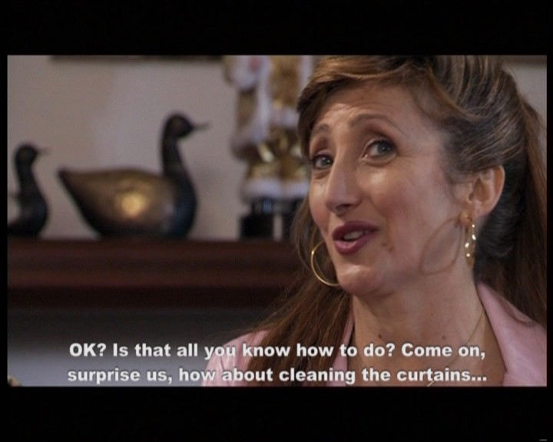 | 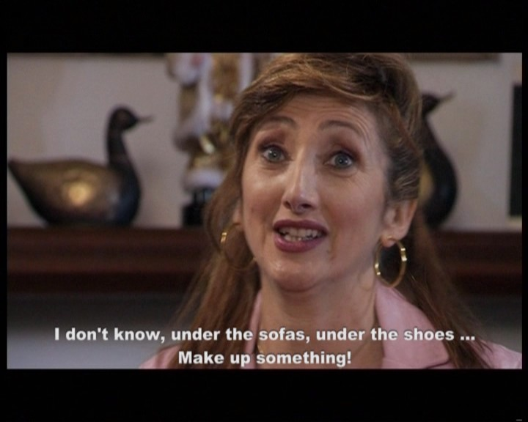

The very long subtitles occupy the whole width of the screen and are not even close to what Smiths (1998) refers to as “digestible chunks”, since more text than the amount that the audience can reasonably read in the time available is provided. This could reasonably be explained by either the lack of competence of a non-professional subtitler hired on the occasion of the film festival the short has been shown at, or by the need to hone this skill by professionals in this field operating in non-subtitling countries. The dubber, on the other hand, is protected from this kind of error by the time and visual constraints described above.

Starring Paola Tiziana Cruciali, Lunetta Savino, Carla Signoris, Edoardo Leo.
‘Short’, used interchangeably with ‘short film’ or ‘short subject’, is a term “used to mean a contemporary non-commercial motion picture that is substantially shorter than the average commercial feature film” (http://en.wikipedia.org/wiki/Film_genre). For a thorough overview and a classification of film genres see Dirks 2006.
The protagonist is the character whose story is told, while the objective is the protagonist’s desire, wish or motivation, whose nature qualify him/her as such and enable the viewer to identify himself with him/her (Parent-Altier 1997: 109-112).
Short and effective sentences (cf. Parent-Altier 1997: 102 note 3).
In the first case the translation I guess I will have to see it acting this future of ours betrays the American English employed, particularly in the use of the verb guess (cf. shit-faced for ubriache fradice a little later in the text).
Or polylogue; but cf. “multilogue” in Eggins and Slade (1997: 20), and “counter-dialogue” in Cattrysse and Gambier (2008: 51).
Cf. Eggins and Slade (1997) where gossiping is defined as a way of establishing and maintaining group membership.
Or turning point (Parent-Altier 1997: 86, 169).
Interestingly, the same trait is present in the wide corpus of 80s and 90s American films dubbed into Italian analyzed by Pavesi (1994) and Malinverno (1999).

