Acta Pharmacol Sin. 2009 Jun;30(6):694-701. Epub 2009 May 11.

Postsynaptic scaffolds for nicotinic receptors on neurons.
Neff RA 3rd, Gomez-Varela D, Fernandes CC, Berg DK.
Neurobiology Section, Division of Biological Sciences, University of California-San Diego, La Jolla, CA 92093-0357, USA.

Abstract
Complex postsynaptic scaffolds determine the structure and signaling capabilities of glutamatergic synapses. Recent studies indicate that some of the same scaffold components contribute to the formation and function of nicotinic synapses on neurons. PDZ-containing proteins comprising the PSD-95 family co-localize with nicotinic acetylcholine receptors (nAChRs) and mediate downstream signaling in the neurons. The PDZ-proteins also promote functional nicotinic innervation of the neurons, as does the scaffold protein APC and transmembrane proteins such as neuroligin and the EphB2 receptor. In addition, specific chaperones have been shown to facilitate nAChR assembly and transport to the cell surface. This review summarizes recent results in these areas and raises questions for the future about the mechanism and synaptic role of nAChR trafficking.
Trends Neurosci. 2006 Jan;29(1):8-20. Epub 2005 Dec 7.

How to build a central synapse: clues from cell culture.
Craig AM, Graf ER, Linhoff MW.

Source
Brain Research Centre and Department of Psychiatry, University of British Columbia, Vancouver, Canada V6T 2B5. amcraig@interchange.ubc.ca

Abstract
Central neurons develop and maintain molecularly distinct synaptic specializations for excitatory and inhibitory transmitters, often only microns apart on their dendritic arbor. Progress towards understanding the molecular basis of synaptogenesis has come from several recent studies using a coculture system of non-neuronal cells expressing molecules that generate presynaptic or postsynaptic "hemi-synapses" on contacting neurons. Together with molecular properties of these protein families, such studies have yielded interesting clues to how glutamatergic and GABAergic synapses are assembled. Other clues come from heterochronic cultures, manipulations of activity in subsets of neurons in a network, and of course many in vivo studies. Taking into account these data, we consider here how basic parameters of synapses--competence, placement, composition, size and longevity--might be determined.

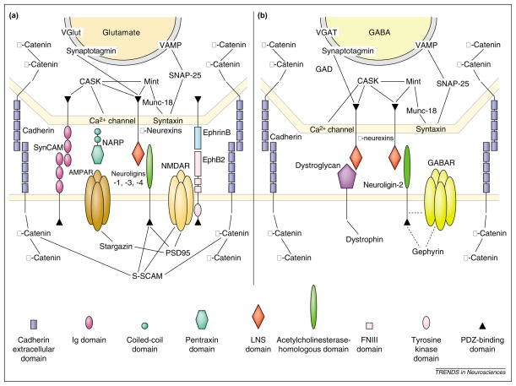
Molecular components of glutamatergic (a) and GABAergic (b) synapses. Only some of the components are shown, emphasizing cleft and transmembrane proteins and their interacting partners. Solid lines indicate reported protein–protein interactions; broken lines indicate presumed indirect interactions
Eur J Neurosci. 2009 Dec 3;30(11):2042-52. Epub 2009 Nov 25.

Activity-driven mobilization of post-synaptic proteins.
Gutiérrez RC, Flynn R, Hung J, Kertesz AC, Sullivan A, Zamponi GW, El-Husseini A, Colicos MA.
Department of Physiology, University of Calgary, Calgary, AB, Canada.

Abstract
Synapses established during central nervous system development can be modified through synapse elimination and formation. These processes are, in part, activity dependent and require regulated trafficking of post-synaptic components. Here, we investigate the activity-driven remodeling of cultured rat hippocampal neurons at 14 days in vitro, focusing on the post-synaptic proteins PSD-95, Shank, neuroligin (NL)1 and actin. Using live imaging and photoconductive stimulation, we found that high-frequency activity altered the trajectory, but not velocity, of PSD-95-GFP and Shank-YFP clusters, whereas it reduced the speed and increased the number of NL1 clusters. Actin-CFP reorganized into puncta following activity and approximately 50% of new puncta colocalized with NL1 clusters. Actin reorganization was enhanced by the overexpression of NL1 and decreased by the expression of an NL1 mutant, NL1-R473C. These results demonstrate activity-dependent changes that may result in the formation of new post-synaptic sites and suggest that NL1 modulates actin reorganization. The results also suggest that a common mechanism underlies both the developmental and activity-dependent remodeling of excitatory synapses.

