LESSON 18-19:

Neurotrophin signalling

NT signalling through Trk and p75 receptors

The ability of Trk and p75 receptors to present different binding sites and affinities to particular NT determines both their responsiveness and specificity. During development, NT are produced and released from the target cells and become internalized into vesicles, which are then transported to the cell body. The biological effects of NT require signals be conveyed over long distances, from the nerve terminal to the cell body [Ginty, 2002 #76]. Several proteins are associated with the Trk and p75 receptors during transport, and signalling persists after internalization [Grimes, 1997 #77].
NT bind as dimers to p75- and Trk-family members. Trk receptor dimerization leads to trans-autophosphorylation and to the activation of intracellular signalling cascades mediating differentiation and survival. The Src homologous and collagen-like (Shc) adaptor protein links the activated receptor to two separate intracellular pathways. On one hand Shc binding increases phosphatidylinositol 3-kinase (PI3K) and Akt (protein kinase B) activities. Once activated, Akt phosphorylates several proteins important in controlling cell survival [Datta, 1999 #78][Yuan, 1999 #79][Yuan, 1999 #79]. These include:

- The Bcl-2-family member BAD (Bcl-2/Bcl-x-associated death promoter), which when not phosphorylated, promotes apoptosis by binding to Bcl-xL; phosphorylation of BAD results in its association with 14-3-3 proteins, preventing binding to Bcl-xL [Bonni, 1999 #80] [Datta, 1997 #81]
- IkB, which one phosphorylated activates the transcription factor NF-KB that has been shown to promote neuronal survival[Middleton, 2000 #82]
- The forkhead transcription factor or FKHRL1 which controls the expression of apoptosis-promoting genes such as FasL [Brunet, 1999 #83]
- The glycogen synthase kinase or GSK 3-β, which has been shown to promote apoptosis in cultured neurons [Hetman, 2002 #84].

On the other hand, phosphorylation of Shc increases the activity of Ras and the extracellular signal-regulated kinase (ERK). These events in turn influence transcriptional events, such as the induction of the cyclic AMP-response element binding (CREB) transcriptional factor. CREB has effects on the cell cycle, neurite outgrowth and synaptic plasticity [Lonze, 2002 #85] and recent works have shown that CREB regulates genes that are essential for survival in vitro of cerebellar granule cells and sympathetic neurons [Bonni, 1999 #86][Riccio, 1999 #87]. The small protein Rap1 accounts for the ability of NT to signal through ERK for sustained periods [York, 1998 #90]. In addition, phospholipase Cγ (PLC-γ) binds to activated Trk receptors and initiates an intracellular signalling cascade, resulting in the release of inositol phosphates and activation of protein kinase C-δ (PKC-δ). PLC-γ hydrolyses phosphatidylinositides to generate diacylglycerol (DAG) and inositol 1,4,5 triphosphate (IP₃). IP₃ induces the release of Ca2+ stores, increasing levels of cytoplasmic Ca2+. In recent work has been shown that NGF activates the DAG-regulated protein kinase PKC-δ which is required for activation of ERK cascade and for neurite outgrowth [Corbit, 1999 #91]. PKC-δ appears to act between Raf and MAPK/ERK in this cascade. In figure 8 the diagram of the NT signalling transduction pathways mediated by Trk receptor is delineated (from [Patapoutian, 2001 #92])
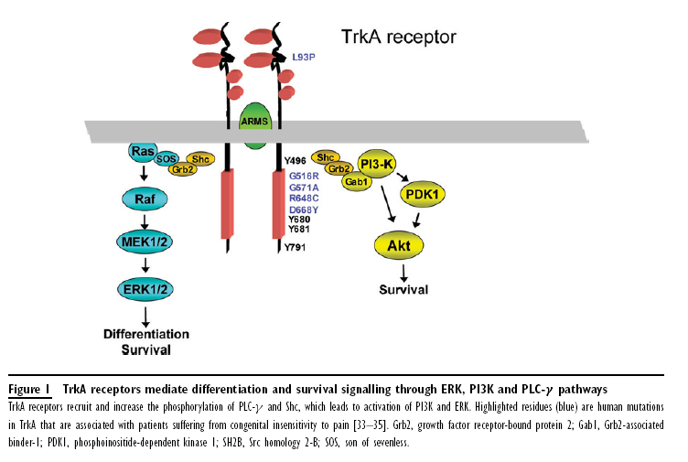

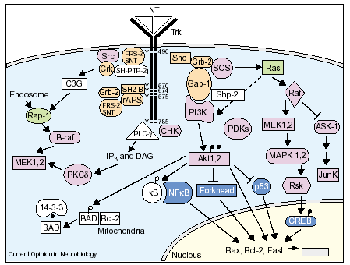
Figure 1. Diagram of NT signalling transduction pathways mediated by trk receptors. The different pathways are described in the text. The nomenclature for tyrosine (Y) residues is based on the sequence of human TrkA. In the diagram, adapter protein are colored in orange, kinases pink, small G protein green and transcriptional factors blue. APS, adaptor molecule containing PH and SH2 domains; CHK, Csk homologuekinase; MEK, MAPK/ERK;P,serine/threonine (filled phosphorylated).

Cooperation and distinct roles of Trk and p75 receptors

The p75 receptor can bind to each NT, and also acts as a co-receptor for Trk receptors. As we anticipated in a previous chapter, pro-neurotrophins are more selective ligands for the p75 receptor than mature forms [Lee, 2001 #66], and are more effective at inducing p75-dependent apoptosis.
Two models have been proposed, to account for how p75 could modulate Trk receptor function. The first is a ligand passing mechanism, which predicts that the high-affinity state is the result of ligand presentation by p75 to the TrkA receptor [Barker, 1994 #53]. The second model predicts that p75 and TrkA are capable of a ligand-independent association, which produces a high-affinity binding interaction [Chao, 1995 #54]. Recent evidence supports another function of the p75 receptor that is its involvement in apoptosis [Casaccia-Bonnefil, 1999 #56]. This hypothesis was proposed by Bredesen and colleagues from experiments conducted in cultured cell lines [Rabizadeh, 1993 #57]. Based on the observation that immortalized neural cells overexpressing p75 display an enhanced rate of apoptosis in response to serum withdrawal, a mechanism of ligand-independent death was proposed. According to this model, apoptosis promoted by p75 can be negated after binding to NGF. Nowadays the apoptotic pathway induced by p75 begins to be delineated. For instance, it is known that the death domain of p75 is capable to interact with the apoptotic adaptor molecule TRAF6 [Khursigara, 1999 #58] and that this interaction is dependent upon binding to NGF and with a lesser extent upon binding to BDNF and NT-4. TRAF6 signalling then starts including the activation of Jun N-terminal kinase (JNK), NF-kB and ceramide [Roux, 2002 #59]. Finally it was demonstrated that p75-mediated apoptosis activates several caspases, cysteine protease enzymes required for the apoptotic event [Gu, 1999 #60].
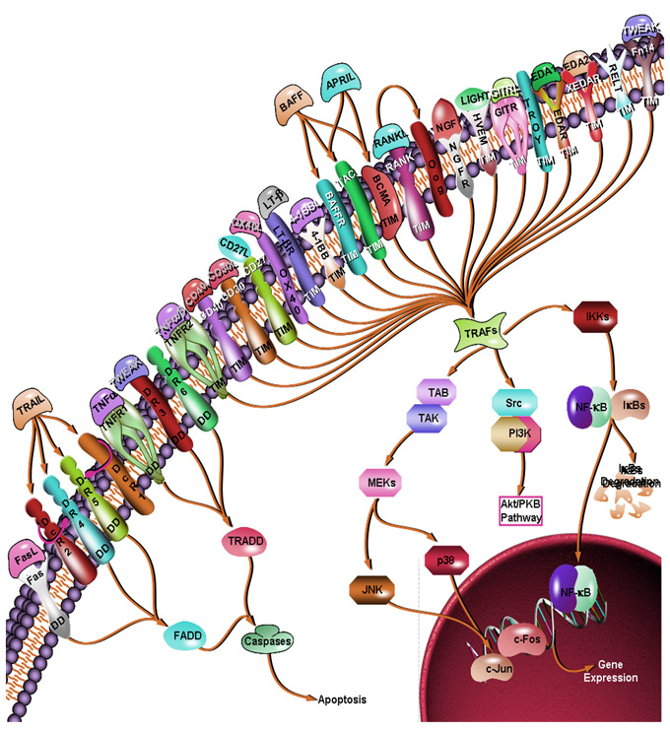
FROM: http://www.superarray.com/pathway.php?sn=TNF_Superfamily_Pathway
Members of the TNF (Tumor necrosis factor) receptor superfamily play pivotal roles in numerous biological events in metazoan organisms. Ligand-mediated trimerization by corresponding homo- or hetero-trimeric ligands, the TNF family proteins, causes recruitment of several intracellular adaptors, which activate multiple signal transduction pathways. 29 TNF receptor family members have been identified in humans. Based upon their cytoplasmic sequences and signaling properties, these TNF receptors can be classified into three major groups (Ref.1). The first group, including Fas/ CD95/ Apo1/ APT1, TNFR1/ CD120a /p55-R /TNFAR/ TNFR60, DR3/ TRAMP/ WSL1/ LARD /WSLLR/DDR3/TR3/Apo3, DR4/TRAILR1/Apo2, DR5/TRAILR2/KILLER/TRICK2A/TRICKB, and DR6/TR7, contains a DD (Death Domain) in the cytoplasmic tail. Fas, DR4 and DR5 interact with the FADD (Fas-Associated Death Domain) while TNFR1 and DR3 interact with the adaptor TRADD (TNFR-Associated Death Domain). These molecules, in turn cause activation of the Caspase cascade and induction of apoptosis (Ref.2).
The second group includes TNFR2/p75/CD120b/TNFR80/TNFBR, CD40/p50/Bp50, CD30/Ki-1/D1S166E, CD27/Tp55/S152, TNFR2-RP/TNFCR/TNFRIII, LT-BetaR, OX40/ CD134/ACT35/TXGP1L, 4-1BB/CD137/ILA, BAFFR, BCMA/BCM, TACI/CAML interactor, RANK/TRANCE-R, p75NGFR, HVEM (Herpes Virus Entry Mediator)/HveA/ATAR/TR2/ LIGHTR, GITR/AITR/ TNFRSF18, TROY/TAJ, EDAR, XEDAR/EDA-A2R, RELT and Fn14. These receptors contain one or more TIM (TRAF Interacting Motifs) in their cytoplasmic tails. Activation of TIM containing TNF receptors lead to recruitment of TRAF family members, and activation of multiple signal transduction pathways such as NF-KappaB (Nuclear Factor-KappaB), JNK (Jun N-terminal Kinase), p38, ERK (Extracellular Signal Regulated Kinase) and PI3K (Phosphoinisitide-3 Kinase) (Ref.3). The third group of TNF receptor family members, including DcR1/TRID/TRAIL-R3, DcR2/ TRUNDD/TRAIL-R4, DcR3 and Opg, does not contain functional intracellular signaling domains or motifs. Although this group of receptors cannot provide intracellular signaling, they can effectively compete with the other two signaling groups of receptors for their corresponding ligands. These DcR (Decoy Receptors) therefore function by impeding the activation of signal transduction pathways by other TNF receptors (Ref.4).
TRAFs are a major group of intracellular adaptors that bind directly or indirectly to many members of the TNF receptor superfamily. Six mammalian TRAFs, TRAF1 through TRAF6, have been identified. TRAFs can induce the activation of several kinase cascades that ultimately lead to the activation of signal transduction pathways such as NF-KappaB, JNK, ERK, p38 and PI3K, which can regulate cellular processes ranging from cell proliferation and differentiation to apoptosis. The TNFR superfamily contains a large number of proteins that regulate a very broad array of developmental and differentiating processes. Indeed, a number of biologic TNF blocking therapies are being used now to inhibit the inflammation associated with Crohn’s disease and rheumatoid arthritis. The continued examination of TNFR signal transduction will provide the tools for receptor or tissue specific interventions, allowing more targeted treatments that have fewer side effects.
References:
- Dempsey PW,Doyle SE,He JQ,Cheng G.
The signaling adaptors and pathways activated by TNF superfamily.
Cytokine Growth Factor Rev. 2003 Jun-Aug;14(3-4):193-209.
- Kischkel FC,Lawrence DA,Chuntharapai A,Schow P,Kim KJ,Ashkenazi A.
Apo2L/TRAIL-dependent recruitment of endogenous FADD and caspase-8 to death receptors 4 and 5.
Immunity. 2000 Jun;12(6):611-20.
- Darnay BG,Ni J,Moore PA,Aggarwal BB.
Activation of NF-kappaB by RANK requires tumor necrosis factor receptor-associated factor (TRAF) 6 and NF-kappaB-inducing kinase. Identification of a novel TRAF6 interaction motif.
J Biol Chem. 1999 Mar 19;274(12):7724-31.
- Gibson SB,Oyer R,Spalding AC,Anderson SM,Johnson GL.
Increased expression of death receptors 4 and 5 synergizes the apoptosis response to combined treatment with etoposide and TRAIL.
Mol Cell Biol. 2000 Jan;20(1):205-12.

One of the possible reasons for the apoptotic function of p75 could be that it is a mean for the refinement of correct target innervation during development and eliminate cells during periods of developmental cell death [Majdan, 1999 #61]. Apoptosis by p75 is also manifested after seizure or inflammation [Dowling, 1999 #62][Roux, 1999 #63]. This apoptotic function is accompanied by an increase of Rac and JNK activities, which are essential for NGF-dependent death [Harrington, 2002 #64]. Another function of p75 might be to mediate a non apoptotic or survival response [Khursigara, 2001 #65]; similar to the behaviour of other tumour necrosis factor receptors.

Recently, the spectrum of p75 ligands has been increased by the addition of unprocessed proneurotrophins (Harrington et al, 2004; Lee et al, 2001), and myelin-associated regeneration inhibiting proteins through a lingo 1-mediated association between p75 and the glycosylphosphatidylinositol (GPI)-linked Nogo receptor (NgR; Mi et al, 2004; Wang et al, 2002a; Wong et al, 2002). Most recently, an intriguing twist in the tale has been added by the implication of sortilin in high-affinity binding of pro-NGF molecules (Nykjaer et al, 2004). Sortilin is a member of the Vps10p family, the proteins of which are thought to act as sorting receptors for molecules in the secretory pathway and on the cell membrane (Mazella, 2001; Nielsen et al, 2001). The recently published crystal structure of NGF complexed with the extracellular domain of p75 reveals an NGF homodimer asymmetrically bound to a p75 monomer, a configuration that might allow the recruitment of another receptor to the complex (He & Garcia, 2004). These findings have led to the suggestion that the outcome of p75 signalling might be determined by the type of co-receptor involved in the complex: if trk is the co-receptor then survival is the outcome, if NgR–lingo 1 then inhibition of regeneration, and if sortilin then death (Nykjaer et al, 2004). However, this model, while appealing in its apparent clarity, has already been called into question by the finding that pro-NGF enhances migration rather than death of A875 melanoma cells, which express high levels of both sortilin and p75 (Shonukan et al, 2003). Furthermore, like TRKs, both sortilin and NgR belong to gene families with several members expressed in the nervous system (Hampe et al, 2001; Lauren et al, 2003; Pignot et al, 2003), raising the possibility that different complexes of these receptors respond to individual neurotrophins and other ligands. Finally, sortilin has been shown to bind to a range of other ligands or cargo proteins at the same site used by pro-NGF (Lefrancois et al, 2003; Mazella, 2001; Munck Petersen et al, 1999), creating diverse options for modulation or interference with proneurotrophin signalling through sortilin in vivo. Therefore, the identification of NgR–lingo 1 and sortilin as p75 co-receptors appears to introduce additional layers of complexity to the field. Conversely, the sortilin–p75 connection directs attention to a relatively neglected facet of p75 research in neurons, namely a cell-biology-driven approach.

The field still lacks definitive analyses of p75 biosynthesis, sorting and localization on the one hand, and internalization, transport and the eventual fate of signalling complexes of the receptor on the other hand. Given the polarized morphology of neuronal cells, we argue that such studies would fill the main gaps in our understanding of the modes of action of this multifaceted receptor.

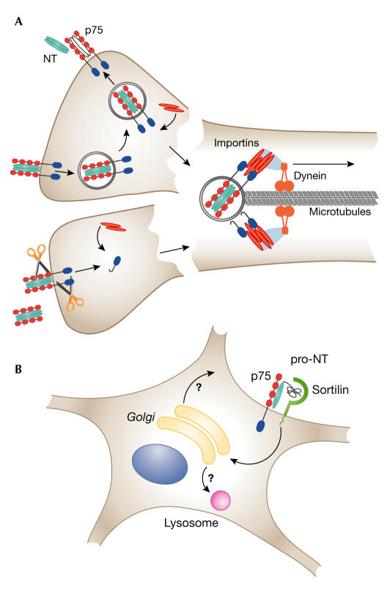
Plausible scenarios for long-range transduction of p75 signalling complexes. (A) Internalization of p75 with ligand to the recycling endosome (upper) or cleavage of p75 to release the intracellular domain (lower) may be followed in both cases by recruitment of intracellular interactors with nuclear localization signals. These might then serve as adaptors to link the p75 signalling complexes to an importin/dynein retrograde transport ensemble on the microtubules. (B) In the case of a sortilin-containing complex in the somatodendritic compartment, internalization and rapid translocation to the Golgi may be mediated by sorting signals in the cytoplasmic tail of sortilin. The complex might then transfer to lysosomes or, after dissociation, specific components might enter the anterograde pathway for recycling to the cell surface.

Summarizing:

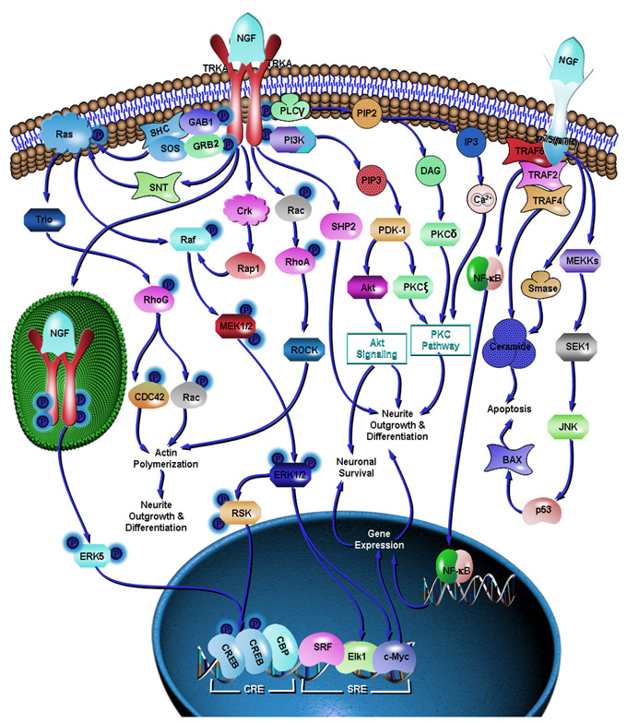
FROM: http://www.superarray.com/pathway.php?sn=NGF_Pathway

One of the most fundamental issues in current biology is how to maintain the critical balance between cell survival and death, both during development and in adulthood. Unrestrained cell division and survival leads to various forms of tumor, while excessive or premature cell death may lead to a variety of diseases such as Alzheimer's, Parkinson's and Multiple Sclerosis. In the nervous system, a family of Neurotrophins, which includes NGF (Nerve Growth Factor), BDNF (Brain Derived Neurotrophic Factor), NT3 (Neurotrophin3) and NT4/5 (Neurotrophin-4/5), maintains this critical balance of cell survival and death. The best characterized of these is the NGF, a neurotrophic protein which is important for the growth and survival of diverse peripheral and central neurons. NGF is expressed within discrete CNS (Central Nervous System) areas and is secreted by tissues targeted by sympathetic and some sensory neurons. The effects of NGF on neuronal growth and survival are mediated by a high affinity cell surface receptor TRKA (Tyrosine Kinase Receptor-A) and a low affinity neurotrophic receptor, p75(NTR) (p75 Neurotrophic Receptor). NGF may signal its neuroprotective actions through the TRKA receptor and trigger apoptosis in some cells through the p75 receptor (Ref.1 & 2).

Activation of TRKA leads to a cascade of intracellular events with consequent changes in the expression of genes encoding diverse enzymes, ion channels and other cellular components. This activation of TRKA is followed by receptor dimerization and transautophosphorylation of tyrosine residues on TRKA, which act as docking sites for a variety of downstream signaling effectors and adaptor proteins. Activation of TRKA results in rapid association of TRKA with PLC-Gamma (Phospholipase-C-Gamma), PI3K (Phosphatidylinositiol-3 Kinase) and the adaptor proteins. TRKA tyrosine phosphorylates the adaptor proteins GAB1 (GRB2-Associated Binding Protein-1) and SHC (SH2 Containing Protein), resulting in their association with GRB2 (Growth Factor Receptor-Bound Protein-2)-SOS, a complex that enhances the rate of GDP-GTP exchange on Ras, leading to Ras activation. Activated Ras binds to Raf, which in turn, phosphorylates and activates MEK (MAPK/ERK Kinase). MEKs are dual specificity kinases which phosphorylate the MAPKs (Mitogen-Activated Proteins)/ ERK1/2 (Extracellular signal-regulated Kinases). Phosphorylated ERK1/2 then participate in at least two cascades. ERK1/2 may translocate into the nucleus, where they phosphorylate the transcription factor Elk1, or they phosphorylate the RSK (Ribosomal S6 Kinase). Phosphorylation of Elk1 allows it to interact with the accessory transcription factor SRF (Serum Response Factor), after which it binds to the SRE (Serum Response Element) within the c-Fos promoter region and contributes to the initiation of transcription. Phosphorylation of RSK leads to its nuclear translocation and consequent phosphorylation of CREB (Cyclic Adenosine Monophosphate (c-AMP) Response Element Binding Protein). Phosphorylated CREB binds to the transcriptional coactivator protein CBP (CREB Binding Protein) and the SRF-Elk complex creating an extended transcriptional factor complex leading to c-Fos transcription. The activation of transcription factors regulates the expression of NGF-inducible genes and contributes to NGF-induced neurite formation. Crk and SNT also modulate MAPK activity in some neuronal cells. The small G-protein Rap1 that lies downstream of Crk, links to the MAPK cascade by physically binding to and activating Raf, whereas, SNT contributes to Ras activation (Ref.2, 3, 4 & 5). Sometimes CREB phosphorylation requires activation and endocytosis of TRKAs located at the axon terminals. Within distal axons, activated TRKAs are internalized into vesicles. These vesicles give rise to signaling endosomes that are transported from distal axons back to the cell bodies. The binding of NGF to TRKA receptors at the axon terminal results in local activation of ERK1/2 and ERK5 within the axon terminal and also activation of ERK5 in the cell body. Components of the ERK5 cascade are transported in endosomes together with TRKAs. The activated ERK5 moves from the cell body to the nucleus, where it mediates CREB phosphorylation and gene expression. The ERK5 pathway is required for CREB phosphorylation following neurotrophin stimulation of distal axons, whereas both ERK1/2 and ERK5 contribute to CREB activation following neurotrophin stimulation of cell bodies (Ref.6).
After being recruited by TRKA, PLC-Gamma catalyses the formation of DAG (Diacylglycerol) and IP3 (Inositol Triphosphate) from PIP2 (Phosphatidylinositol 4,5-Bisphosphate). These second messengers: DAG and IP3 stimulate PKC-Delta (Protein Kinase-C-Delta) and increase intracellular Ca2+ (Calcium) respectively, which may play a role in cytoskeletal rearrangements thus contributing to neurite outgrowth and differentiation. Another signaling intermediate that forms a complex with activated TRKA is PI3K (Phosphatidylinositiol-3 Kinase). At the membrane PI3K converts PIP2 (Phosphatidylinositol 3,4-bisphosphate) to PIP3 (Phosphatidylinositol 3,4,5-Trisphosphate) which in turn, activates a protein kinase called PDK-1 (Phosphoinositol Dependent Kinase-1). PDK-1 phosphorylates and activates another enzyme Akt, that occupies the central position in the activation of cell survival pathways in many cells. The activation of Akt induces the activation of several downstream effectors that lead to survival and differentiation of neurons. PDK-1 also contributes to neurite outgrowth through the activation of PKC-Zeta (Protein Kinase-C-Zeta) (Ref.2 & 5). Rac, Rho and CDC42, members of the Rho family GTPase proteins, actively participate in neurite outgrowth and differentiation. Activated TRKA gives rise to Actin Polymerization, by activating the Rac--&gt;RhoA--&gt;ROCK (Rho-Associated Coiled-Coil-Containing Protein Kinase) pathway. Actin polymerization and formation of filopodia or lamellipodia are important events leading to neurite differentiation. Another type of Rho family GTPase, RhoG, transduces the Ras signal to Rac1 and Cdc42 activation in neuronal cells. Trio (Triple Functional Domain-PTPRF Interacting) is an upstream regulator of RhoG for the NGF-induced neurite outgrowth. Trio--&gt;RhoG--&gt;Rac1 and Trio--&gt;RhoG--&gt;Cdc42 pathways form a central signaling route for neurite outgrowth (Ref.7).

NGF also binds, with lower affinity relative to TrkA, to the p75(NTR). p75(NTR) is a member of the TNFR (Tumor Necrosis Factor) receptor superfamily, having no tyrosine kinase domain. p75(NTR) activates a survival pathway that may involve the activation of NF-KappaB or the activation of the JNK (Jun N-terminal Kinase)/c-Jun death pathway. The main physiological functions of p75NTR are to activate TRKA-independent signal transduction cascades involving Sphingomyelinase, NF-KappaB (Nuclear Factor-KappaB, and JNK. p75NTR activates a survival pathway that may involve the activation of NF-KappaB through TRAF6 (TNF Receptor Associated Factor-6), whereas in limiting amounts of NGF p75NTR may activate the JNK death pathway. Regulation of NF-KappaB-dependent transcription occurs mainly via cytosolic retention by a family of inhibitory molecules known as I-KappaB.

Degradation of I-KappaB releases NF-KappaB molecules that in turn translocate into the nucleus to evoke their response. NF-KappaB transcription factors are a family of dimeric molecules, including NF-KappaB1 (p50/p105), NF-KappaB2 (p52/p100), RelA, RelB, and c-Rel, all of which are involved in regulating cell survival. NGF binding selectively to p75(NTR) brings about the activation of the proapoptotic JNK cascade. MEKKs (MAP/ERK Kinase Kinases) and SEK ((SAPK/ERK Kinase) are the upstream regulators of JNK. JNKs, in turn, upregulate p53 and the proapoptotic member of the Bcl2 family: BAX in a sequencial manner, which bring about apoptosis of the neuronal cells. p75(NTR) activation by NGF also recruits several TRAFs (TRAF2 and TRAF4) to the receptor that are involved in Ceramide generation. Ceramide is a key player in the induction of neuronal apoptosis. It can also be generated by p75(NTR) by the activation of Sphingomyelinase (Ref.8, 9, 10 & 11).
• Sofroniew MV,Howe CL,Mobley WC. Nerve growth factor signaling,neuroprotection,and neural repair. Annu Rev Neurosci. 2001; 24:1217-81. Review.
• Freund-Michel V,Bertrand C,Frossard N. TrkA signalling pathways in human airway smooth muscle cell proliferation. Cell Signal. 2005 Aug 6; [Epub ahead of print]
• Chao MV,Rajagopal R,Lee FS. Neurotrophin signalling in health and disease. Clin Sci (Lond). 2006 Feb;110(2):167-73.
• Cheung EC,Slack RS. Emerging role for ERK as a key regulator of neuronal apoptosis. Sci STKE. 2004 Sep 14;2004(251):PE45. Review.
• Schramm A,Schulte JH,Astrahantseff K,Apostolov O,Limpt V,Sieverts H,Kuhfittig-Kulle S,Pfeiffer P,Versteeg R,Eggert A. Biological effects of TrkA and TrkB receptor signaling in neuroblastoma. Cancer Lett. 2005 Oct 18;228(1-2):143-53. Review.
• Watson FL,Heerssen HM,Bhattacharyya A,Klesse L,Lin MZ,Segal RA. Neurotrophins use the Erk5 pathway to mediate a retrograde survival response. Nat Neurosci. 2001 Oct; 4(10): 981-8.
• Negishi M,Katoh H. Rho family GTPases as key regulators for neuronal network formation. J Biochem (Tokyo). 2002 Aug;132(2):157-66. Review.
• Schor NF. The p75 neurotrophin receptor in human development and disease. Prog Neurobiol. 2005 Oct;77(3):201-14. Epub 2005 Nov 16.
• Wallach D,Arumugam TU,Boldin MP,Cantarella G,Ganesh KA,Goltsev Y,Goncharov TM,Kovalenko AV,Rajput A,Varfolomeev EE,Zhang S. How are the regulators regulated? The search for mechanisms that impose specificity on induction of cell death and activation by members of the TNF/NGF receptor family. Arthritis Res. 2002; 4 Suppl 3: S189-96.
• Yuan J,Yankner BA. Apoptosis in the nervous system. Nature. 2000 Oct 12; 407(6805): 802-9. Review.
• Palmada M,Kanwal S,Rutkoski NJ,Gustafson-Brown C,Johnson RS,Wisdom R,Carter BD. c-jun is essential for sympathetic neuronal death induced by NGF withdrawal but not by p75 activation. J Cell Biol. 2002 Aug 5;158(3):453-61. Epub 2002 Aug 5
• Kruttgen A,Saxena S,Evangelopoulos ME,Weis J. Neurotrophins and neurodegenerative diseases: receptors stuck in traffic? J Neuropathol Exp Neurol. 2003 Apr; 62(4): 340-50. Review.

A spatial view of NT signalling pathways

Recent studies indicate that differences exist between the signalling pathways activated by NT stimulation of nerve terminals (retrograde signalling) and NT stimulation of cell bodies [Heerssen, 2002 #93][Ehlers, 1995 #94].
The NT signalling pathways seen in the chapter before culminate in the activation of transcription factors that alter gene expression. However, the peculiar characteristic of the nerve cells is that the signalling must traverse the full extend of the axon whose length can be as great as one meter, an enormous distance for non-electric signals. Thus, one question arises: how is the signal presented at axon terminals conveyed back to remote cell bodies? Recent studies of retrograde signalling suggest that the location at which a NT stimulates a cell is a crucial parameter in determining the signalling pathways activated and the following biological responses.
Three are the neurotrophin signalling spatial ways in a neuron:
- the signalling endosome
- the signalling within the axons
- the signalling at the cell body

- The signalling endosome

Several evidences indicate that vesicles containing activated Trk-ligand complexes transmit a neutrophic signal from nerve terminals to cell bodies. In vivo, activation of Trk receptor is propagated through the axon following application of NT to nerve terminals [Ehlers, 1995 #94;[Bhattacharyya, 1997 #95]. Studies with compartmented cultures have elucidated that Trk receptors convey retrograde NT signals: in these cultures the media surrounding the cell bodies in one compartment remains isolated from the media bathing distal axons in the neighbouring compartment; in this way NT can be applied only to distal axons mimicking the selective stimulation of neuron terminals that occur in vivo following release of targeted-derived neurotrophins [Campenot, 1977 #96][Campenot, 1994 #97]. NT applied to distal axons result in the rapid appearance of phosphorylated Trks within cell bodies [Riccio, 1997 #98; [Senger, 1997 #99][Watson, 1999 #100].
Using compartmented cultures that were previously developed by Campenot, and the green fluorescent protein (GFP) Watson and collaborators have demonstrated that a selective application to distal axons induces transport of Trk receptors to cell bodies, as visualized by increased cell body fluorescence. Co-precipitation experiments demonstrated that transported Trks are associated with NT [Watson, 1999 #100]; [Tsui-Pierchala, 1999 #101]. These ligand-bound receptors appear to be located in vesicles that are actively transported along microtubules. Mobley and colleagues have characterized a population of endocytic vesicles from PC12 cells stimulated with NGF. These vesicles contains activated Trks bound to ligand and derived from clathrin-coated pits [Grimes, 1996 #102] by a process that requires the GTP-ase dynamin and PI3K. These vesicles are designated as “signalling endosomes” [Beattie, 1996 #105].

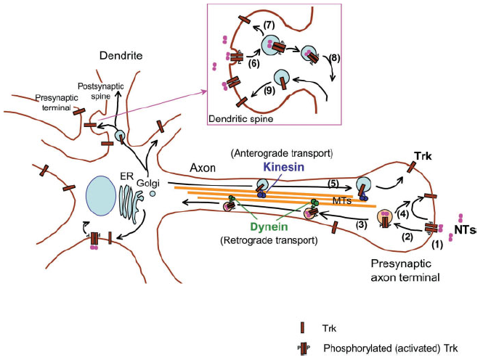
Figure 2 Trafficking and distribution of Trk receptors in neurons. Trk neurotrophin receptors are present in soma, dendrites, and axons. Trk-containing membranous vesicles are carried by motor proteins. Kinesin and dynein are microtubule-based motors responsible for long-range Trk transport. Kinesin: a plus end-directed (anterograde) motor. Dynein: a minus end-directed (retrograde) motor. NTs: neurotrophins. MTs: microtubules. Neurotrophins are secreted from target tissues or postsynaptic cells and bind to Trk receptors at axon terminal (1). Upon ligand binding, Trk receptors then undergo endocytosis involving GTPase dynamin (Zhang et al., 2000). The ligand-dependent Trk endocytosis is mediated by clathrin-dependent or -independent pathway (2). The internalized Trk-neurotrophin complex is then sorted and routed into either retrograde transport pathway (3) or recycling pathway (4). Neurotrophins have been shown to remain bound to retrogradely transported activated Trk (Tsui-Pierchala and Ginty, 1999; Delcroix et al., 2003; Ye et al., 2003). Retrograde transport of Trk-containing vesicles is microtubule-dependent process involving dynein motor and mediates neurotrophin retrograde signaling, such as neuronal survival and CREB phosphorylation in peripheral neurons (Riccio et al., 1997), while little is known about the retrograde signaling mediated by p75NTR. Whether Trk is transported with p75NTR in the same vesicular compartment or transported independently of p75NTR remains to be examined. Newly synthesized Trk receptors that transit through the Golgi apparatus are delivered along the axons to the terminal by kinesin motor (5). In central neurons, presynaptic axon terminal Trk may be involved in synaptic transmission. Trk receptors are also present in postsynaptic dendrites in central neurons and undergo endocytosis (6), recycling (7), and transport towards cell bodies (8). The insertion of TrkB receptors from intracellular pool to cell surface has been shown to be modulated by neuronal activity (9) and to involve several factors such as cAMP, Ca2_, and CaMKII. Regulation of dendritic versus axonal targeting of Trk receptors by molecular motors remains unknown. The trafficking and intracellular localization of Trk receptors are important for a neuron’s response to neurotrophins and many aspects of neuronal function.

Molecules associated with these endosomes include PLC-γ [Grimes, 1997 #106] and a Rap complex [Wu, 2001 #107]. Soluble NGF applied to distal axons induces phosphorylation of CREB in cell bodies, by contrast, no CREB phosphorylation can be detected when NGF is linked covalently to microspheres to prevent endocytosis [Riccio, 1997 #98]. These results reveal one distinctive feature of retrograde signalling: internalization of NGF is required for activation of transcription factors following nerve terminal stimulation, but not following direct cell body stimulation.

Recent studies have begun to unravel the mechanisms of retrograde transport of the signalling endosomes and will be discussed in the next paragraph.

- The signalling within the axons

It was lon known that Trks participate in local signalling events limited to nerve terminals and axons. Campenot demonstrated that NGF increase axon growth only at the location of stimulation [Campenot, 1977 #96]. NT stimulation of distal axons activated Trks and local activation of the classic Ras/MAP kinase pathway. Phosphorylated forms of MEK1 and 2 [Watson, 2001 #108] and the MAP kinase Erk1 and 2 (Watson et al, 2001; Atwal et al, 2000) can be detected in stimulated distal axons. When Erk1/2 signalling is inhibited within axons axonal outgrowth is decreased [Atwal, 2000 #109], thus local activation of this pathway contribute to axonal elongation perhaps via phosphorylation of microtubule-associated proteins.
A second cascade activated within axons is the PI3K lipid signalling pathway. NT elicit a local increase in PI3 kinase activity resulting in activation of the kinase Akt [Kuruvilla, 2000 #110]. This local stimulation of PI3K contribute to axon elongation. In addition, activation of the PI3K lipid signalling pathway seems to be crucial to allow the activated Trk receptors to be internalized by endocytocitosis, since pharmacological inhibitors of the PI3K block the signalling through signalling endosomes. Figure 9 represents the local signalling within the axon.
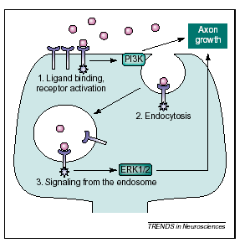
Figure 3. Local signalling within the axon. NT (purple spheres) binds to Trks (blue) at the nerve terminal. Location of the PI3 kinase cascade promotes both axon outgrowth and receptor endocytosis. Activated endosomal Trks within the terminal and axon might be primarily responsible for activating the erk172 pathway (from[Heerssen, 2002 #93]).
.

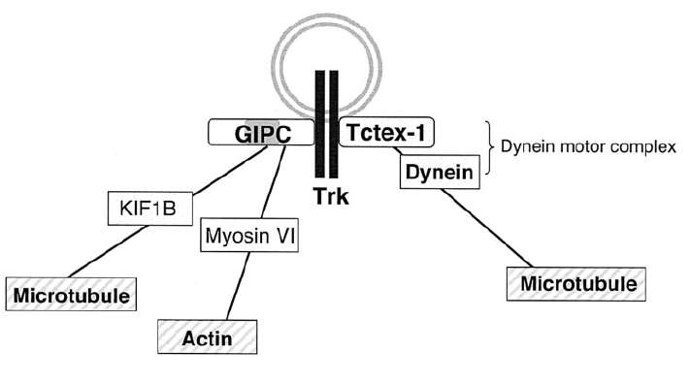
Figure 4 Model linking Trk-bearing vesicles to motors. GIPC and Tctex-1 are Trk-interacting proteins that may be involved in Trk trafficking. The interaction of these proteins with Trk has been found by yeast two-hybrid system and coimmunoprecipitation (Lou et al., 2001; Yano et al., 2001). GIPC: a PDZ domain-containing protein; Tctex-1: a dynein light chain subunit. KIF1B and myosin VI were found to bind to GIPC by yeast two-hybrid screen (Bunn et al., 1999). A functional ternary complex of Trk-GIPC-KIF1B (or myosin VI) remains to be shown. The Trk-Tctex-1-dynein motor complex was detected by immunoprecipitation from brain lysate (Yano et al., 2001).
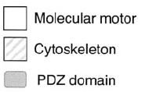

- The signalling at the cell body

The main pathways activated in cell bodies following NT stimulation of distal axons are the MAPK and PI3K pathways. In compartmented cultures NT stimulation of distal axons induces local activation of Erk1/2, but little or no activation of these MAP kinases can be detected in cell bodies. This is surprising given that stimulation of distal axons induces activation of CREB via translocation of activated Erks [Xing, 1998 #111]. Recent data have identified a new MAPK family member named Erk5 (or Big MAP kinase) which has a unique function in mediating nuclear responses to NT stimulation of distal axons [Watson, 2001 #108]. Direct cell body stimulation leads to phosphorylation and nuclear translocation of Erk 5 as well as Erk1/2. By contrast, NT applied to distal axons result in rapid activation only of Erk5 within cell bodies and nuclei of stimulated cells.
Retrograde signalling requires activation of the Erk5 cascade: both the expression of a dominant negative of Erk5 (MEK5) and pharmacologic inhibitors of the Erk5 pathway, applied to the cell body and not at the distal axons, prevents CREB phosphorylation [Watson, 2001 #108]. These data suggest a model in which distinct combinations of MAPK pathways are activated and traslocated to the nucleus, depending on the location at which a neuron is stimulated. Probably the differential use of MAP kinases provides a mechanism by which cell can interpret the “where” as well the “what” of growth factor stimulation. In figure 10 the NT signalling at the cell body.

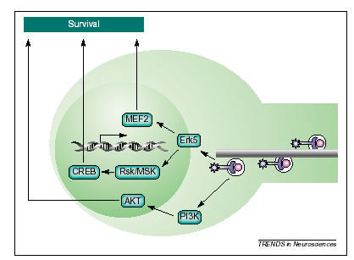
Figure 5. Signalling at the cell body. As retrogradely transported Trk-containing endosomes reaches the cell body, they activate at least two signalling pathways, both of which promote survival. Activation of PI3 kinase prevents apoptosis through stimulation of the anti-apoptotic kinase AKT. Trk-mediated erk5 activation at thecell body results in activation of the transcript factors CREB (via activation of the intermediate kinase Rsk/MSK) and MEF2 to support survival (from [Heerssen, 2002 #93]).

This spatial view on NT signalling pathways highlighted the cascades stimulated when NT released by postsynaptic cells function as target-derived survival signals. However, NT can also function as anterograde factors, released by presynaptic neurons to affect postsynaptic cells, or as paracrine factors, stimulating receptors on cell somas [Conner, 1997 #112][Altar, 1998 #113][Kohara, 2001 #114]. The data summarized in this chapter suggest that signalling pathways differ based on the local of stimulation; evidence indicates that the biological response to NT also depends on the location of stimulation. For example in developing retinal ganglion cells, BDNF stimulation of dendrites reduces arborization, whereas stimulation of axonal terminals increases arborization [Lom, 1999 #115]. In another example, NGF in the skin induces collateral sprouting of nociceptive neurons, by contrast perfusion of NGF onto the cell bodies in the spinal cord produces hyperalgesia without sprouting [Pertens, 1999 #116]. Therefore spatially distinct signalling differences, such as the differential use of individual MAP kinases, must underlie these location-specific biological effects of NT.

