LESSON 20:

The hippocampus and its plasticity

One of the favourite sites of action of BNDF in the CNS is the hippocampus, a best-characterized cortical structure that plays a key role in learning and memory.

To better understand the role of BDNF in synaptic plasticity, phenomenon linked to the more complex and superior process of learning and memory, it is necessary at this point to describe the most important brain region involved: the hippocampus.
The hippocampus, named for its resemblance to the sea horse (hippo = horse, kampos = sea monster, Greek), is among the best characterized cortical structures. Much is known about its synaptic organization and the functional characteristic of its neurons mainly because it is involved in some major neurological disorders such as Alzheimer disease and temporal lobe epilepsy, and moreover because neurophysiological studies suggest that the hippocampus plays a key role in certain aspects of learning and memory.
The hippocampus is a cylindrical structure whose longitudinal axis forms a semicircle around the thalamus. The present discussion refers to rodent hippocampus because this is the most common species for experimental analysis.
The hippocampus proper can be divided into four regions which have been traditionally designated CA1, CA2, CA3 and CA4 (from the Latin Cornu Ammon, or Ammon’s horn, because for its resemblance to a ram’s horn that was bear by the ancient Egyptian God Ammon). Another nomenclature refers to the hippocampal formation (or hippocampal region) including also the dentate gyrus (DG), the subiculum and the entorhinal cortex. The CA1 and CA3 regions constitute most of the hippocampus proper, while the region CA2 is so small and indistinct in some species that it is often ignored. Finally, the CA4 region corresponds to a particular layer of the DG named polymorphic or hilar region, or simply hilus.
Both the hippocampus and the DG are three-layered cortices.

The three fundamental layers of the DG are:
- The polymorphic layer or hilus
- The granular layer or stratum granulosum
- The molecular layer or stratum molecolare

The hippocampus proper consists of a:
- polymorphic layer or stratum oriens
- a pyramidal layer or stratum piramidale
- a molecular layer or stratum radiatum.

The molecular layer of the DG is continuous with that of the hippocampus.
In figure 11 the neuronal elements of the hippocampal formation are described.
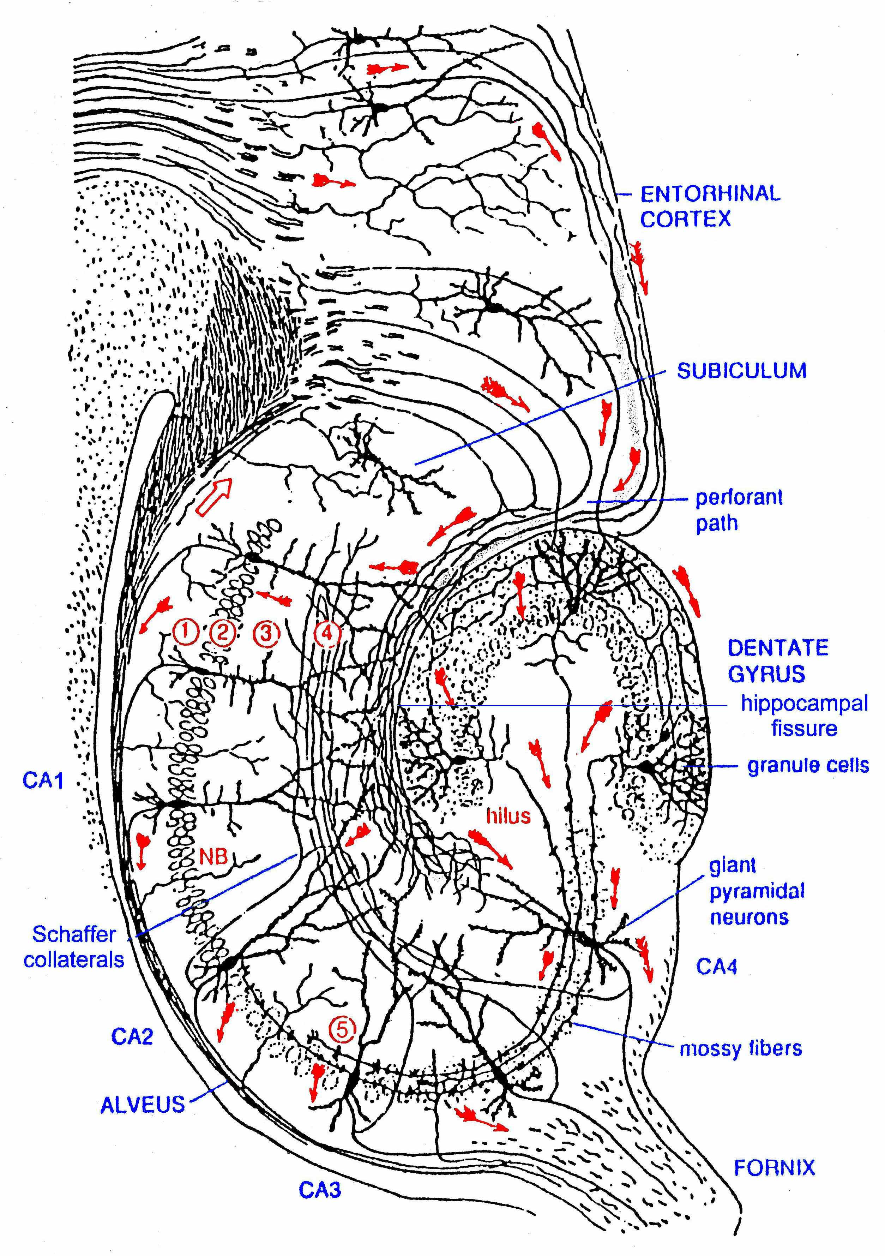
Figure11. Neuronal elements of the hippocampus. 1) Stratum oriens; 2) stratum pyramidale; 3)stratum radiatum; 4) stratum lacunosum-moleculare, 5) stratum lucidum. The red arrows indicate the paths of the hippocampus. [Brown, 1990 #137].

Following the three-layered structure of the DG and the hippocampus we can describe the cellular anatomy of their different layers.

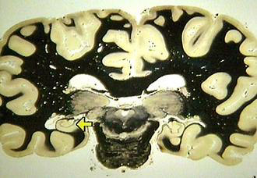

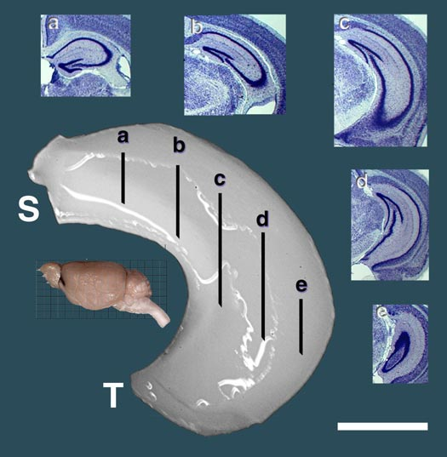
Fig.

Cellular organization of the hippocampus proper

The principal neurons of the hippocampus are the pyramidal neurons. The pyramidal cell bodies build up the majority of the stratum pyramidale. This stratum forms a curved sheet that is only 2 or 3 cell thick. The pyramidal cell bodies are conical (pyramidal), 20-40μm at the base, and 40-60μm in height; each has a thick apical dendrite, 5-10μm in diameter, that passes through the stratum radiatum to the stratum lacunosum-moleculare . There are also several basal dendrites, 3-6μm in diameter, that arborize over 200-300μm and form the stratum oriens. The apical and basal dendrites are covered with spines.
The morphology of the pyramidal cells varies gradually around the hippocampus. Proceeding from region CA3 to region CA1, the cell bodies become smaller and the apical dendrites longer, more slender, and more regular in their branching pattern. The cells in region CA3 are sometimes called giant pyramidal cells. The proximal segment of the apical dendrites of CA3 neurons receives the connections from the dentate gyrus mossy fibers and constitutes the stratum lucidum that can be distinguished by its translucent appearance from the stratum radiatum, containing the distal dendritic segment.
In the hippocampus, in addition to the pyramidal cells, there is a population of inhibitory basket cells of various sizes and shapes that have their cell bodies located in the pyramidal cell layer [Seress, 1989 #149].
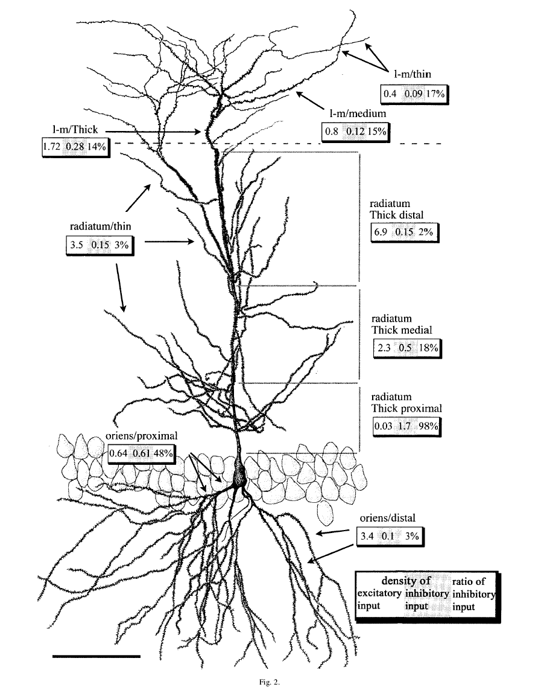
Neuroscience. 2001;102(3):527-40.
Total number and distribution of inhibitory and excitatory synapses on hippocampal CA1 pyramidal cells.
Megias M, Emri Z, Freund TF, Gulyas AI.
Institute of Experimental Medicine, Hungarian Academy of Sciences, P.O. Box, H-1450, Budapest, Hungary.
The integrative properties of neurons depend strongly on the number, proportions and distribution of excitatory and inhibitory synaptic inputs they receive. In this study the three-dimensional geometry of dendritic trees and the density of symmetrical and asymmetrical synapses on different cellular compartments of rat hippocampal CA1 area pyramidal cells was measured to calculate the total number and distribution of excitatory and inhibitory inputs on a single cell.A single pyramidal cell has approximately 12,000 micron dendrites and receives around 30,000 excitatory and 1700 inhibitory inputs, of which 40 % are concentrated in the perisomatic region and 20 % on dendrites in the stratum lacunosum-moleculare. The pre- and post-synaptic features suggest that CA1 pyramidal cell dendrites are heterogeneous. Strata radiatum and oriens dendrites are similar and differ from stratum lacunosum-moleculare dendrites. Proximal apical and basal strata radiatum and oriens dendrites are spine-free or sparsely spiny. Distal strata radiatum and oriens dendrites (forming 68.5 % of the pyramidal cells' dendritic tree) are densely spiny; their excitatory inputs terminate exclusively on dendritic spines, while inhibitory inputs target only dendritic shafts. The proportion of inhibitory inputs on distal spiny strata radiatum and oriens dendrites is low ( approximately 3 %). In contrast, proximal dendritic segments receive mostly (70-100 %) inhibitory inputs. Only inhibitory inputs innervate the somata (77-103 per cell) and axon initial segments. Dendrites in the stratum lacunosum-moleculare possess moderate to small amounts of spines. Excitatory synapses on stratum lacunosum-moleculare dendrites are larger than the synapses in other layers, are frequently perforated ( approximately 40 %) and can be located on dendritic shafts. Inhibitory inputs, whose percentage is relatively high ( approximately 14-17 %), also terminate on dendritic spines.Our results indicate that: (i) the highly convergent excitation arriving onto the distal dendrites of pyramidal cells is primarily controlled by proximally located inhibition; (ii) the organization of excitatory and inhibitory inputs in layers receiving Schaffer collateral input (radiatum/oriens) versus perforant path input (lacunosum-moleculare) is significantly different.

Neurons of the dentate gyrus

Cells of the polymorphic layer (hilus)

The polymorphic cell layer harbours a variety of neuronal cell types [Amaral, 1978 #138], but little is known about many of them. The most common and impressive cell type is the mossy cell. The cell bodies of the mossy cells are large (25-35μm) and are often triangular and multipolar in shape. Three or more thick dendrites originate from the cell body and extend for long distance within the polymorphic layer never enter the adjacent CA3 field. These cells seem to be glutamatergic and their proximal dendrites have the peculiarity to be covered by very large and complex spines (lateral protuberances specific for excitatory inputs) called “thorny excrescences” that are site of the termination of the mossy fiber axons [Ribak, 1985 #140]; [Frotscher, 1991 #141].

Cells of the granule cell layer

The principal cell type of the dentate gyrus is the granule cell. This cell has an elliptical body with a width of approximately 10 μm and a height of 18μm. Each granule cell is closely opposed to other granule cell and in most cases there is no glial sheath intervening between the cells. The granule cell has a very characteristic cone –shaped tree of spiny dendrites with all the branches directed towards the superficial portion of the molecular layer. Along the deep surface of the granule cell layer, so called basket cells with pyramidally shaped cell bodies are found wedged between the granule cell and polymorphic layers. The basket portion of the name refers to the fat that the axon of these cells form pericellular plexuses that surround the soma of granule cells. Many of these neurons are immunoreactive for GABA and are therefore acting, in large part, as inhibitory interneurons.

Cells of the molecular layer

The molecular layer is mainly occupied by the dendrites of granule, basket and various polymorphic cells as well as terminal axonal arbors from several sources. At least two neuronal cell types are also present in the molecular layer. The first one should be considered as another kind of basket cell; it is located deep in the molecular layer, has a triangular cell body and gives rise to an axon that appears to contribute to the basket plexus within the granule cell layer [Hazlett, 1978 #142]; [Kosaka, 1984 #143]; [Ribak, 1983 #144]. A second type of neuron, the so-called “chandelier” or axon-axonic cell, originally found in the neocortex, has been observed in the molecular layer of the DG ([Kosaka, 1983 #145][Somogyi, 1985 #146];[Soriano, 1989 #147][Halasy, 1993 #148]. The axo-axonic cell is named for the fact that its axon descends from the molecular layer into the granule cell layer and then terminates only on the axon initial segments of granule cells with symmetric synaptic contacts. These cells are immunoreactive for GABA so it is possibly they represent a second means of inhibitory control of granule cell output.

Inputs and functional organization of the hippocampus

The main inputs to the hippocampus and DG arise from the entorhinal cortex, the septal region and the controlateral hippocampus.

- The entorhinal cortex provides a major input to the hippocampus, DG and subiculum via the fibers of the alvear and perforant pathways. The perforant pathways originates in layers II and III of the entorhinal cortex and “perforates” the hippocampal fissure before terminating in all parts of the hippocampus. It is also one of the excitatory paths of the hippocampus.
- Septum and diagonal band. A second significant input originates in the medial septal nucleus of the diagonal band. It enters the hippocampus by four routes: the fimbria, the dorsal fornix, the supracallosal striae and the amygdaloid complex. The terminations are distributed throughout the hippocampus, but preferentially in the regions CA3 and DG. This input includes both cholinergic and GABA-ergic fibers and may be important in regulating the excitability of the hippocampus.
- Controlateral hippocampus. A third input consists of commissural fibers from the controlateral hippocampus.

The functional organization of the hippocampus has been traditionally described in terms of the “trisynaptic circuit” [Andersen, 1971 #150]. The hippocampus was imagined to be a stack of planar circuits, each containing the same sequence of just three types of excitatory synapses. The trisynaptic sequence is as follows:

- Fibers of the perforant pathways from the entorhinal cortex interact with the dendritic spines of the granule cells of the DG in the molecular layer, creating the so-called perforant path.
- The granule cells send their axons named mossy fibers to the CA3 region, where they terminate on the thorny excrescences of the proximal dendrites of the CA3 pyramidal cells in the stratum lucidum, creating the mossy fibers path.
- Finally, the pyramidal neurons of the CA3 region send their axons, named Schaffer collateral axons, to the CA1 region, where they form synapses on pyramidal neurons creating the Schaffer collateral path.
In figure 12 a representation of the trisynaptic excitatory circuit of the hippocampus.

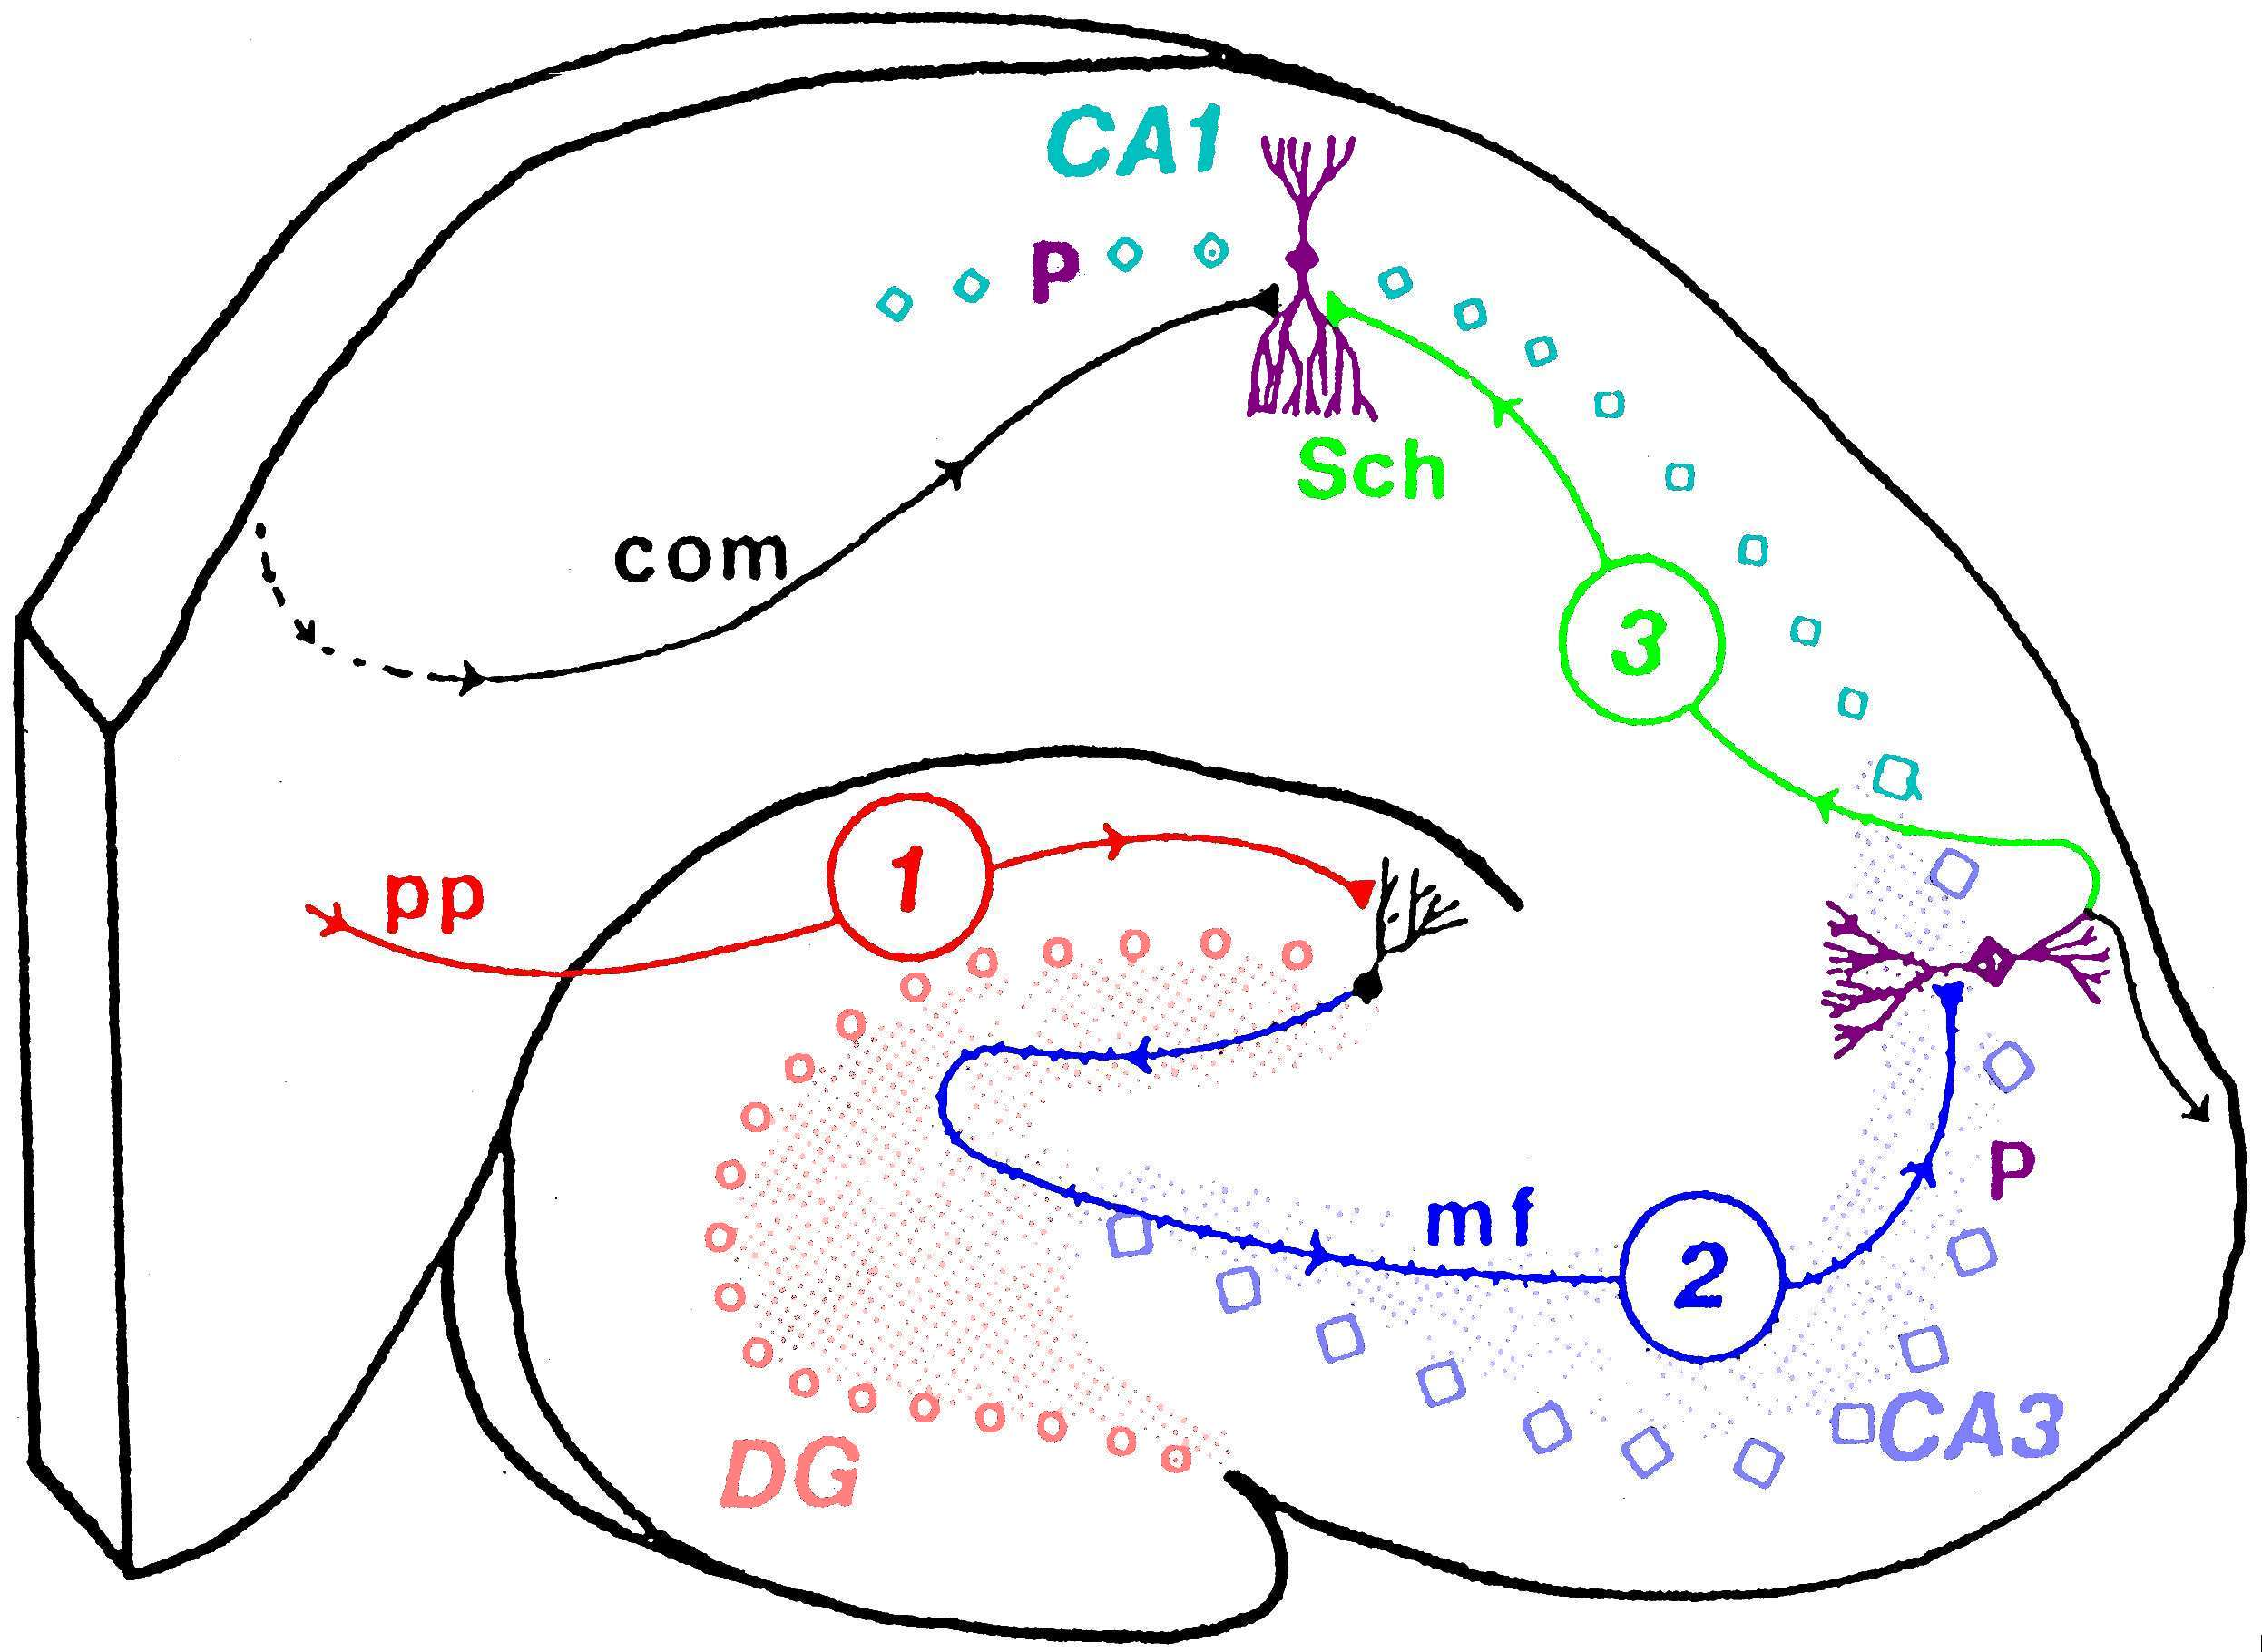
PP=Perforant path
mf=mossy fibers
SCh=collateral Schaffer
fibers

Figure 12.Trisynaptic circuit of the hippocampus showing 1) perforant path (pp) input to a granule cell in the DG (red); 2) mossy fiber (mf) input to a pyramidal cell in the CA3 region (blue); and 3) Schaffer collateral (Sch) input to a pyramidal cell in the CA1 region (green).

The circuit described thus far, includes a simple sequences of excitatory connections from one region to the next, forming a closed loop. The anatomy is actually more complicated, in fact there are several independent paths for the excitation of a “downstream” region by an “upstream” region. Thus each region projects not only to the next region in the sequence but also to one or two after. The only exception is the DG, which does not send projections beyond the CA3 region.

Synaptic plasticity, learning, memory and LTP

Eric R. Kandel stated about learning and memory:

“One of the most remarkable aspects of an animal’s behaviour is the ability to modify that behaviour by learning, an ability that reaches its highest form in human beings. For me, learning and memory have proven to be endlessly fascinating mental processes because they address one of the fundamental features of human activity: our ability to acquire new ideas from experience and to retain these ideas over time in memory….” From [Kandel, 2001 #261]

The ability of humans and other animals to remember past experiences, has long fascinated scientists and occupied a central position in the cognitive neuroscience.
Several studies involving patients with amnesia and animals with experimental lesion have consistently identified the medial temporal lobe and the prefrontal cortex as being crucial for memory [Aggleton, 1999 #262]. The medial temporal lobe comprises the fornix, the amygdale and the cortical structure described above, the hippocampus. The crucial role of these regions for memory processing became apparent with the first reports of patient HM [Scoville, 1957 #263][Corkin, 2002 #264], who became profoundly amnesic after bilateral surgical resection of the medial temporal lobes and partial removal of hippocampal structure to relieve epilepsy.
We will focus on the role of BDNF in hippocampus plasticity and on its implications for learning and memory.

Classically, memory is divided in two forms:
- Implicit or procedural memory that is memory for perceptual and motor skills and is expressed through performance, without conscious recall of past episodes
- Explicit or declarative memory that is memory that requires conscious recall and are concerned with memories for people, places, objects and events.

The hippocampus is involved in the explicit memory [Milner, 1998 #265][Bacskai, 1993 #266][Castellucci, 1978 #267].
Starting from the idea that, elementary forms of learning are common to all animals with an evolved nervous system and that there must be conserved features in the mechanisms of learning at the cell and molecular level, Kandel and collaborators identified in the sea slug Aplysia a suitable experimental animal to better understand these mechanisms. They discovered two possible phases for memory based on time: a short-term and a long-term phase.
The short-term memory involves changes in synaptic strength within minute and hours, involves covalent modifications of pre-existing proteins that lead to the strengthening of pre-existing connections and it does not require protein synthesis to occur. Instead, the long term memory modulates the structure, the number and the function of the synapses over the course of days and require protein synthesis to occur [Pinsker, 1970 #268][Pinsker, 1973 #269].
In the mammalian hippocampus, similar short- and long-term forms of plasticity have been found and the most studied model of learning is the long term potentiation or LTP.
BDNF in hippocampal plasticity
The term Long Term Potentiation is used to indicate an enduring increase in the amplitude of excitatory postsynaptic potentials as a result of high-frequency (tetanic) stimulation of afferent pathways.

LTP was discovered in the hippocampus by Bliss and Lomo in 1973 [Bliss, 1973 #271;Bliss, 1973 #272], in an in vivo preparation by stimulating with electrodes placed into the perforant path and recording in the dentate gyrus of an animal. In the CA1 region of the hippocampus, LTP is induced postsynaptically by activation of an NMDA receptor to glutamate. In the late 1980s Morris found that blocking the NMDA receptor pharmacologically, not only interfered with LTP but also blocked memory storage [Bliss, 1973 #271;Bliss, 1973 #272][Morris, 1986 #273].
The exiting thing was to discover, as Kandel predicted, that the LTP in the hippocampus shows time-phases like in the Aplysia model. In fact, LTP can be separated into an early phase (E-LTP) and a late phase (L-LTP). E–LTP is short lasting (1-3 hs) and is independent of new protein synthesis, whereas L-LTP requires activation of PKA, MAPK, CREB, new protein synthesis and appears to lead to the growth of new synaptic connections [Frey, 1993 #274][Nicoll, 1999 #275][Nguyen, 1994 #276][Bolshakov, 1997 #277] [Huang, 1995 #279][Impey, 1998 #280][Muller, 1997 #281][Yin, 1996 #282][Engert, 1999 #283]. Figure 16 shows a representation of the early and late LTP in the hippocampus from [Kandel, 2001 #261].

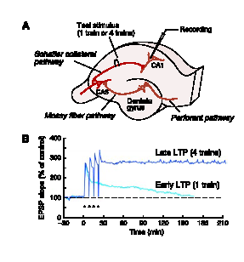
Figure 16. LTP in the hippocampus. A) The three major pathways of the hippocampus each of which gives rise to LTP.
B) The early and late phases of LTP in the Schaffer collateral pathway. A single train of stimuli for one second to 100 Hz elicits an early LTP, and four trains at 10-minute intervals elicit the late phase of LTP. The early LTP lasts about 2 hours, the late LTP more than 24 hours (from [Kandel, 2001 #261])

Kandel and colleagues further explored the role of the late phase of LTP in memory storage and thus also its link with the explicit memory. They generated a transgenic mice that express R(AB), a mutant form of the regulatory subunit of PKA that inhibits
enzyme activity [Abel, 1997 #284]. In these R(AB) transgenic mice, the reduction in hippocampal PKA activity was paralleled by a significant decrease in L-LTP, while basal synaptic transmission and E-LTP remained unchanged. Most interesting, this deficit in the late phase of LTP was paralleled by behavioural deficits in hippocampus-dependent long-term memory for spatial orientation, whereas learning, and short-term memory, are unpaired. Thus, in the storage of explicit memory of extrapersonal space in the mammalian hippocampus, PKA plays a critical role in the transformation of short-term memory into long-term memory.
Recently, Kandel and collaborators [Malleret, 2001 #285] and others [Bolshakov, 1997 #277] have found that the threshold between hippocampal plasticity and explicit memory is determinated by the balance between protein phosphorylation governed by PKA and dephosphorylation [Malleret, 2001 #285][Mansuy, 1998 #287]. To determine whether the endogenous Ca²⁺-sensitive phosphatase calcineurin acts as a constraint on this balance, they inhibited calcineurin and examined the effects on synaptic plasticity and memory storage. They found that a transient reduction of the activity of this enzyme resulted in facilitation of LTP both in vivo and in vitro [Malleret, 2001 #285]. This facilitation persisted for several days and was accompanied by enhanced learning and strengthening of short- and long-term memory on several spatial and non-spatial tasks requiring the hippocampus. So calcineurin can acts as a negative regulator of synaptic plasticity, learning and memory. The role of PKA and calcineurin in the L-LTP is summarized in the model in figure 17.

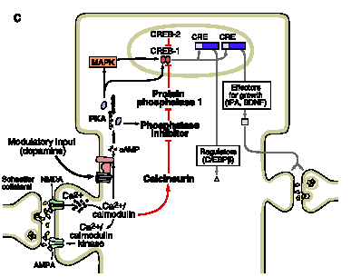
Figure 17. A model of the late phase of LTP in the Schaffer collateral pathway. A single train of action potentials initiates early LTP by activating NMDA receptors, Ca2+ influx into postsynaptic cell, and the activation of asset of second messengers. With a repeated trains of action potentials the CA2+ influx also recruits an adenylyl cyclase (AC), which activates the cAMP-dependent protein kinase. The kinase is transported to the nucleus where it phosporylates CREB. CREB in turn activates targets, as BDNF, that are thought to lead to structural changes. Mutation in mice that block PKA or CREB reduce or eliminate the late phase of LTP (from[Kandel, 2001 #261]).

Role of BDNF in synaptic plasticity

In addition to its classic effects on neuronal cell survival BDNF can also regulate neuronal proliferation, neuronal migration, axon pathfinding, dendritic growth, synapse formation and maintenance, synaptic competition and pruning, neuronal excitability, both inhibitory and excitatory synaptic transmission, neurotransmitter release, long-term potentiation (LTP) and synaptic plasticity.
BDNF and the other NTs with their receptors are attractive candidates for the roles mentioned before because they are expressed in areas of the brain that undergo plasticity, activity can regulate their levels and secretion, and they regulate both synaptic transmission and neuronal growth [McAllister, 1999 #151].
To play a role in synaptic plasticity, BDNF and NT in general, must satisfy the three following criteria:

- BDNF and its cognate receptor must be expressed in the right places at the right times for the form of plasticity being considered
- BDNF expression and secretion must be activity dependent
- BDNF must regulate aspects of neuronal function including synaptic function, neuronal morphology and connectivity.

The following sections will consider each of these requirements in turn.

- BDNF and TrkB are present in the CNS during periods of synaptic plasticity

Through the technique of the in situ hybridization it was possible to identify that BDNF and TrkB, as well as NT-3, NT-4/5 and TrkC, are widely and specifically distributed in the CNS, with BDNF and TrkB particularly highly expressed in the cerebellum, hippocampus, and cerebral cortex [Barbacid, 1994 #152]; [Lindsay, 1994 #153]. In addition, their expression is developmentally regulated [Davies, 1994 #154]; and in rats, mRNA levels for TrkB transiently peak between postnatal day 1 (P1) and P14 in several brain regions, correlating with maximal neuronal growth, differentiation, and synaptogenesis [Ernfors, 1990 #156][Dugich-Djordjevic, 1992 #157];[Ringstedt, 1993 #158][Altar, 1994 #159][Knusel, 1994 #160].
Although this specific spatial and temporal distribution indicates that BDNF, and NT in general, are in the right place at the right time, many basic questions about their expression remain unanswered. In fact, there may not be a predictable relationship between mRNA and protein levels, in fact BDNF mRNA and protein have been shown to be regulated independently following seizure activity in the hippocampus [Wetmore, 1994 #161] and during visual system development.

- Regulation of BDNF by electrical activity

As just mentioned before BDNF expression is regulated during development and persists at high levels in many parts of the adult brain, but perhaps the most interesting aspects of this expression is its sensitivity to electrical activity. Seizure activity induces a rapid increase in BDNF mRNA levels in the hippocampus and the cerebral cortex [Gall, 1989 #162][Zafra, 1990 #163]; [Ernfors, 1991 #164]. In addition, blockade of visual inputs results in a rapid downregulation of BDNF mRNA in the rat visual cortex and exposing animals reared in darkness, back to light reverses these changes [Castren, 1992 #130]. Similar effects of electrical activity have also been found in cultured neurons. Neuronal depolarization by glutamate or by high concentration of potassium increased the level of BDNF mRNA [Zafra, 1991 #165]; Berninger et al, 1995) and, in contrast, inhibition of neuronal activity by the γ-aminobutyric acid (GABA) decrease the level of BDNF mRNA [Berninger, 1995 #166]. Moreover in dissociated hippocampal neurons, depolarization elevates the dendritic localization of BDNF and TrkB mRNAs, and increases the apparent levels of the proteins [Tongiorgi, 1997 #167]. These findings indicate that the expression of BDNF may be modulated by neuronal activity which in turn regulates the secretion and the action of BDNF. In fact, in hippocampal slices or dissociated cell cultures, depolarization induced by glutamate, high potassium or by veratridine (an alkaloid that affects action potential generation by stabilizing sodium channel in the open state) results in an elevated level of secreted and/or surface-bound BDNF, as revealed by specific antibodies against BDNF [Goodman, 1996 #168][Balkowiec, 2000 #169]. Interestingly, the magnitude of BDNF release from cultured sensory neurons triggered by electrical stimulation was dependent on stimulus pattern, with high-frequency bursts being most effective [Balkowiec, 2000 #169].
One additional important aspect to remember is also the possibility for BDNF itself to modulate the electrical activity, acting as a classical excitatory neurotransmitter.
Kafitz and colleagues have demonstrated that BDNF can cause membrane depolarization within a few milliseconds, eventually leading to the firing of an action potential [Kafitz, 1999 #170]. They took slices from the hippocampus, cortex and cerebellum of juvenile rats, then puffed minute amounts of BDNF onto the cell bodies of various types of neurons while recording the membrane potentials. The authors observed that, in less than ten milliseconds, BDNF caused a rapid depolarization which was depending on the dose. The same type of response was seen when the authors applied puffs of glutamate, the main excitatory neurotransmitter at central synapses. However BDNF elicited the effect at much lower concentrations than glutamate, in the order of three magnitude, making BDNF the most potent natural neuroexcitant identified to date [Berninger, 1999 #171]
. Kafits and colleagues demonstrated that this type of response is mediated by TrkB, because when they blocked the receptor with the selective-Trk inhibitor K252a, they did not record the depolarization. They also found that the current induced by BDNF reversed at the sodium equilibrium potential, suggesting that BDNF can activate sodium channels via TrkB. The exact mechanisms for receptor-ion channel interaction are still unknown although it is conceivable that the two molecules may form a complex [Poo, 2001 #172]. Indeed, in 1999, Li and collaborators demonstrated a physical interaction between a NT receptor and an ion channel. They discovered that the transient receptor potential 3 (TRP3), a non-voltage-gated cation channel is highly expressed in brain regions were TrkB receptor are found and that TRP3 can be immunoprecipitated with TrkB protein extracts from neonatal rat brain.

BDNF in hippocampal plasticity

- Regulation of synaptic plasticity by BDNF: synaptic transmission, pre- and post-synaptic modulation, neuronal excitability, structural synaptic morphology, LTP and LTD

- Synaptic transmission. The efficacy of synaptic transmission can be modulated over a wide range of temporal scales, ranging from synaptic modulation on the order of seconds to minutes (e.g. paired-pulse facilitation and post-tetanic potentiation; [Zucker, 1989 #174] to alterations that persist for many hours (e.g. LTP or long term potentiation in the hippocampus and LTD or long term depression in cerebellum, [Madison, 1991 #175],[Lisberger, 1998 #176]. Concerning short-term modulation for example, it is known that BDNF has a strong effect on synaptic transmission at developing Xenopus neuromuscular synapses in culture [Lohof, 1993 #177]. Acute application of BDNF to these cultures increases the frequency but not the amplitude of spontaneous synaptic currents (mEPSCs) and the amplitude of nerve-evoked excitatory postsynaptic currents (EPSCs) [Lohof, 1993 #177];[Wang, 1995 #178].
Similar phenomena have also been reported for other CNS neurons; BDNF rapidly enhances spontaneous synaptic activity in dissociated cultures of hippocampal neurons [Lessmann, 1994 #179][Levine, 1995 #180][Levine, 1996 #181]. In biochemical measurements, BDNF enhances high potassium-induced release of acetylcholine and glutamate from hippocampal synaptosome [Knipper, 1994 #182] and the expression levels of several synaptic vesicle proteins [Takei, 1997 #183] and promotes phosphorylation of synapsin 1 [Jovanovic, 1996 #184]. Intriguingly, BDNF increases the phosphorylation of NMDA receptors [Suen, 1997 #185] and alter the functional properties of NMDA receptor channels [Jarvis, 1997 #186]. Finally BDNF can rapidly elevate intracellular calcium levels [Berninger, 1993 #187].
BDNF also appear to affect several other aspects of synaptic transmission. BDNF influences neuropeptides expression in cortical neurons [Nawa, 1994 #188] and in hippocampal interneurons [Marty, 1996 #189], enhances the GABAergic phenotype in striatal and cortical neurons, acutely inhibits GABAergic synaptic transmission in hippocampal slices, and affects activity-dependent regulation of GABAergic neurons in neocortical cultures [Rutherford, 1997 #133].
In hippocampal slices, acute application of BDNF potentiates synaptic transmission at Schaffer collateral/CA1 synapses but does not occlude LTP [Kang, 1995 #6], an effect that requires local protein synthesis [Kang, 1996 #190]. In contrast with these results, many groups have found that BDNF has no effects on excitatory transmission [Figurov, 1996 #191]; [Frerking, 1998 #192]. One possible explanation is that BDNF is a sticky molecule and its ability to penetrate into the slices may vary depending on the perfusion rate (Kang et al, 1996). However, when using exactly the same experimental conditions, one group found that BDNF had no effect on basal, excitatory postsynaptic currents (EPSCs), but elicited a small decrease in inhibitory postsynaptic currents (IPSPs) [Frerking, 1998 #192]. In other areas of the hippocampus such as CA3 and dentate gyrus, BDNF was able to potentiate excitatory synaptic transmission and neuronal excitability but in a much slower time course (30-90min) [Scharfman, 1997 #193];[Messaoudi, 1998 #194]. Thus, BDNF may modulate neuronal excitability by inhibiting GABAergic transmission, but whether or not it enhances basal synaptic transmission in CA1 synapses is questionable.

- Pre-synaptic modulation. Studies from a number of laboratories have revealed a pre-synaptic mechanism for BDNF-induced synaptic potentiation in cultured hippocampal neurons. The enhancement of excitatory synaptic transmission is accompanied by changes in paired pulse facilitation (PPF) and in the frequency of miniature EPSCs (mEPSCs). [Lessmann, 1998 #195]. Targeting of C-terminal truncated dominant negative TrkB into presynaptic, but not postsynaptic neurons, prevented the BDNF effects on both evoked EPSCs and mEPSCs [Li, 1998 #196]. Moreover, several lines of evidence suggest a presynaptic action of BDNF in CA1 synapses of hippocampal slices. First, the effect of BDNF on repetitive synaptic responses is dependent on the stimulation frequency. BDNF was found to be effective only when CA1 synapses had undergone severe synaptic fatigue elicited by high frequency stimulation (HFS > 50 Hz) but not low frequency (< 20 Hz). Because HFS-induced fatigue is a known presynaptic phenomenon [Zucker, 1989 #197]; [Larkman, 1991 #198][Dobrunz, 1997 #199], BDNF must act presynaptically to attenuate the fatigue. Second, treatment with BDNF alters the paired pulse facilitation (PPF), a simple and reliable measure of presynaptic properties with very few assumptions, especially in hippocampal CA1 synapses [Foster, 1991 #200][Dobrunz, 1997 #201]. This effect of BDNF is restricted to PPF elicited with interpulse intervals shorter than 20 msec. Finally, studies using BDNF knockout mice have also suggested a presynaptic impairments of CA1 synapses [Pozzo-Miller, 1999 #202]. Post-tetanic potentiation (PTP) and PPF at short (< 20 msec) interpulse intervals, for example, are significantly reduced in the mutant mice. These animal models have also been used to elucidate the cellular and molecular mechanism for BDNF modulation of high frequency transmission [Pozzo-Miller, 1999 #202], in fact electron microscopy have revealed a significant reduction in the number of vesicles docked at presynaptic active zones in both +/- and -/- BDNF mutant mice. Quantitative analysis has indicated that there are approximately 10.3 docked vesicles per active zone in +/+ CA1 synapses, but only 3-5 docked vesicles in the +/- and -/- synapses [Schikorski, 1997 #203]; [Pozzo-Miller, 1999 #202]. Biochemical experiments have demonstrated that hippocampal synaptosomes prepared from mutant mice exhibit a marked decrease in the levels of synaptophysin and synaptobrevin (VAMP-2), protein involved in vesicles docking and fusion [Pozzo-Miller, 1999 #202]. Treatment of the mutant slices with BDNF for a few hours can reverse the electrophysiological and biochemical deficits at the hippocampal synapses. Taken together, these results reveal a role of BDNF in the mobilization and /or docking of synaptic vesicles to presynaptic zone. In the figure 14 a tentative model that integrates currently available results for the modulation of BDNF at presynaptic site ([Lu, 1999 #204]).

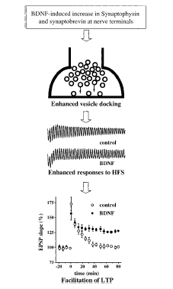
Figure 14. A schematic presentation of BDNF modulation of synaptic plasticity in hippocampal CA1 synapses. ABDNF induced increased in the vesicle proteins synaptophysin and synaptobrevin at nerve terminals may facilitate vesicle docking. Synapses with more docked vesicles in the presynaptic active zone will undoubtedly respond better to high frequency, titanic stimulation (HFS). An enhancement of synaptic responses to tetanus may contribute, at least in part, to BDNF modulation of long-term potentiation (from[Lu, 1999 #204]).

Synapses with more docked vesicles in the presynaptic active zone will undoubtedly respond better to high frequency, tetanic stimulation. An enhancement of synaptic responses to tetanus may contribute, at least in part, to BDNF modulation of LTP or long-term potentiation. Preferential potentiation of high frequency transmission by BDNF may have important physiological implications in activity-dependent synaptic modification, such as synaptic competition during development and synaptic plasticity in the adult. As a general concept, synaptic efficacy may be potentiated and synaptic connection stabilized by the synchronization of electric activities between pre- and postsynaptic neurons, conversely, asynchronized activities cause synaptic weakening and elimination [Stent, 1973 #205]; [Goodman, 1993 #206][Goodman, 1993 #206][Katz, 1996 #207]. Thus, more active synapses are favoured during synaptic competition. But how are active inputs selected among very adiacent, less active inputs to the same postsynaptic targets? Lu and Chao propose two possible mechanism represented in figure 15. The authors suggest that BDNF could mediate activity-dependent synaptic competition first, through an activity-dependent, localized secretion only near active synapses or, second, it could be that highly active presynaptic neurons/terminals may respond to BDNF better than less active ones.

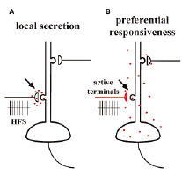
Figure 15. Two possible mechanisms to ensure synapse specificity of BDNF modulation. A) Local secretion model. BDNF is secreted only at or near active synapses. B) Preferential responsiveness model. Active presynaptic neurons/terminals respond better to widely diffused BDNF. Red dots represent BDNF molecules (from [Lu, 1999 #204]).
In fact, the effect of BDNF in potentiating synaptic efficacy is greatly enhanced by presynaptic depolarization at the neuromuscular synapses [Boulanger, 1999 #208], moreover it was demonstrated that BDNF preferentially enhances synapses that are stimulated at high frequency. The physiological consequence of the BDNF regulation of the responses to tetanic stimulation is relatively confined and does not spread to distant synapses [Gottschalk, 1998 #256], thus even if the secretion of BDNF is not restricted to the active synapses, it could still favour the more active synapses.

- Post-synaptic modulation. Although ample evidence supports presynaptic activation of BDNF, several studies have demonstrated that BDNF also exerts its effects postsynaptically. In cultured hippocampal neurons, the acute effect of BDNF on synaptic transmission has been attributed, at least in part, to an increase in postsynaptic responsiveness [Levine, 1995 #180]. This action is mediated by TrkB, in fact application of the specific TrkB inhibitor k252a into the intracellular recording pipette significantly decreased the amplitude EPSCs. In addition, application of okadaic acid, a phosphatase inhibitor, enhanced the BDNF effect, suggesting the role of protein phosphorylation downstream of TrkB activation [Levine, 1995 #180]. Moreover, BDNF increased the amplitude of EPSCs in the presence of the non-NMDA receptor antagonist CNQX, and the response to iontophoretically applied NMDA, but not AMPA or acetylcholine. These suggest that NMDA receptor responses are selectively enhanced by BDNF [Levine, 1998 #209];[Song, 1998 #210]. Consistent with this finding, TrkB is localized to the postsynaptic density and its activation leads to phosphorylation of the NMDA receptor subunits [Suen, 1998 #211].

- Neuronal excitability. Membrane excitability is a major determinant of the intrinsic electrical properties of neurons and is a key aspect on neuronal function involved in neuronal plasticity in both development and maturity. It is known that NT in general have different influences on ion channels; for example it is known that NGF increases excitability and ion channel density for all voltage-gated ion channel, instead BDNF and NT-3 have different and opposite effects on ion channel expression: BDNF increases excitability by selectively elevating sodium and calcium channel expression, while NT-3 decreases excitability by selectively elevating potassium channel expression. Results such as these strongly imply a central role for NT factors in regulating electrical excitability, but a major limitation is that most of the experiments discussed have been done with neuronal cell lines. It will be important that similar experiments be carried out with functional neural circuits band intact neural tissue to determine directly the functional consequences of trophic regulation of ion channel expression [McAllister, 1999 #151].

- Structural synaptic morphology. Structural changes in axonal and dendritic arbors are a hallmark of plastic rearrangements in developing system; these lead to significant changes in the number and locations of functional synapses [Katz, 1996 #207]. For example, the activity-driven rearrangements that result in eye-specific layers in the visual thalamus [Shatz, 1983 #212];[Sretavan, 1986 #213] and ocular dominance columns in visual cortex [Hubel, 1970 #214];[Katz, 1996 #207] involve the elaboration of synapses in one layer or column and the loss of synapses in other layers or column. BDNF application enhances axonal arborization of retinal axons cocultered with optic tecta from chicken [Inoue, 1997 #238]. In vivo infusion of BDNF, but not other NT, into optic tectum of Xenopus tadpoles elicits substantial increases in the branching and complexity of retinal ganglion cell axons [Cohen-Cory, 1995 #239]. These effects are rapid (within 2 h) and persist for at least 24 h. Conversely, injection of antibodies to BDNF prevents axon growth and reduces axon complexity [Cohen-Cory, 1995 #239]. In addition BDNF is involved also in the control of dendritic form. It noted that the location, branching pattern, and morphological specializations of dendrites (spines, for example) are modified by activity and experience. BDNF and NT in general play a central role in sculpting and modifying dendrites, both in the PNS first demonstrated by Snider and colleagues [Snider, 1988 #240];[Ruit, 1990 #241][Ruit, 1990 #241] and, as more recent findings have shown, in the CNS. In fact BDNF and also the other NT when applied to organotypic cortical slices for only 36hs, rapidly increases the length and complexity of dendrites of cortical pyramidal neurons [McAllister, 1995 #243][McAllister, 1997 #244]. Neurons in each cortical layer respond to subset of NT with distinct effects on basal and apical dendrites, and, within a single cortical layer, each NT elicits a unique pattern of dendritic changes [McAllister, 1995 #243]. The specifity of these effects suggests that NT do not act simply to enhance neuronal growth but, rather, act instructively to modulate particular patterns of dendritic arborization. Consistent with this is the observation that endogenous BDNF is required for the growth and maintenance of dendritic arbors of layer 4 neurons whereas endogenous NT-3 is required for the growth and maintenance of dendritic arbors of layer 6 neurons. Endogenous BDNF and NT-3 oppose one another in regulating dendritic growth: in layer 4, NT-3 limits dendritic growth caused by BDNF, while in layer 6, BDNF inhibits dendritic growth stimulated by NT-3 [McAllister, 1997 #135]. Thus, while NT have classically been considered to act as growth-promoting molecules, it appears that they can also act to inhibit dendritic growth. The opposing role of these two factors suggest that the well-documented overlap in NT signalling system may not represent simply redundancy but, rather, may represent the outline of a tightly regulated system for modulating dendritic growth.
Finally, it is important to remember how BDNF can modulate synapse number, size, maturity and thus remember its role in synapse development and maintenance. In one recent example involving transgenic mice selectively overexpressing BDNF in sympathetic neurons, electron microscopy counts of synaptic innervation of sympathetic ganglia showed a two- to four-fold increase in synapse number; in BDNF knock out mice, synapse numbers were correspondingly decreased [Causing, 1997 #245]. Moreover overexpression of BDNF in transgenic mice increase the number of synapses in sympathetic ganglia and accelerates the maturation of inhibitory pathways in the developing visual cortex [Huang, 1999 #121]. Indirect evidence that BDNF influences the maturation of functional synapses comes from studies on long-term effects on synapses in Xenopus nerve-muscle cultures. In fact Wang and collaborators have demonstrated that BDNF bias synaptic transmission and axon morphology toward more mature phenotypes. Furthermore BDNF up-regulates neuregulin expression in rat spinal motor neurons, which promotes the maturation of neuromuscular synapses [Loeb, 1997 #246]. About BDNF role in synapse development and maintenance it is noted that exogenous BDNF accelerates the maturation of quantal size and localization of the synaptic vesicle protein synapsin-1 at developing neuromuscular junction in cell cultures [Wang, 1995 #178] and inhibition of the BDNF-to-TrkB pathways by the expression of a dominant negative of TrkB in the muscle resulted in disassembly of Ach-receptor clusters at the neuromuscular junction. In addition in the CNS, exogenous BDNF was shown to elevate the expression of neuropeptides [Nawa, 1994 #188] and α-amino-3-hydroxy-5-methyl-4-isoxazole propionate (AMPA) subtypes of glutamate receptors [Narisawa-Saito, 1999 #247].

- Role of BDNF in LTP and LTD.
The term LTP or Long Term Potentiation is used to indicate an enduring increase in the amplitude of excitatory postsynaptic potentials as a result of high-frequency (titanic) stimulation of afferent pathways. It is measured both as the amplitude of excitatory postsynaptic potentials and as the magnitude of the postsynaptic-cell population spike. LTP is most often studied in the hippocampus and it is often considered to be the cellular basis of learning and memory in the vertebrates [Lu, 1999 #248].
Despite initial observations that the effects of NT in general do not occlude LTP [Kang, 1995 #6], LTP induction at the hippocampal Shaffer collateral-CA1 synapse was found to be compromised in BDNF knockout mice [Korte, 1995 #249]; [Patterson, 1996 #250][Korte, 1996 #251]. These defects could be rescued either by transfection of hippocampal slices with a BDNF expression adenovirus [Korte, 1996 #251] or by application of exogenous BDNF [Patterson, 1996 #250]. Moreover, in normal animals, inhibition of BDNF signalling with receptor bodies (TrkB-IgGs) or antibodies attenuates LTP in adult hippocampal slices [Figurov, 1996 #191]; [Kang, 1997 #252], while BDNF enhances LTP in visual cortex [Akaneya, 1997 #253]. One possible interpretation of these experiments is that BDNF signalling plays a permissive role in various aspects of hippocampal function including LTP. Further supporting this idea is the observation that exogenous BDNF promotes LTP in young hippocampal slices at ages when LTP is normally not inducible; it does so by improving the ability of synaptic fibers to follow tetanic stimulation, consistent with a permissive role for BDNF [Figurov, 1996 #191].
Experiments involving BDNF receptor TrkB have also indicated a role of this NT in LTP. Mutagenesis of the Shc and PLC-γ binding sites in the trkB gene shows that downstream activation of CREB and calcium/calmodulin-dependent kinase II is responsible for the ability of TrkB to modulate LTP; moreover a conditional mutation (mutation that can be selectively targeted to specific organ, or cell types or induced at a specific developmental stage) of the trkb gene results in deficit in memory acquisition and consolidation in several hippocampus-dependent tasks [Minichiello, 1999 #125][Xu, 2000 #126]. In these mutants, the observed reductions in synaptic plasticity probably reflect functional, not developmental, deficits. First, the hippocampi of these animals appear to be morphologically normal; second, a very similar inhibition of LTP can be seen following acute application of the BDNF scavenger TrkB-IgGs to hippocampal slices [Chen, 1999 #254]. The rescued LTP induced by application of BDNF in these deficit tasks is largely mediated by an NMDA receptor-dependent increase in AMPA receptor function [Malenka, 1999 #255]. Most evidence suggests, however, that BDNF-to-TrkB signalling is not directly involved in the biochemical changes underlying LTP within the postsynaptic cells but instead modulates the competence of presynaptic nerve terminals to generate the repetitive exocytotic events needed to modify the responses of these postsynaptic neurons. In one set of experiments, LTP was generated normally in a TrkB hypomorph by low-frequency-paired depolarization protocol that specifically assesses properties of postsynaptic cells and puts minimal demands on presynaptic terminal function [Xu, 2000 #126]; in addition, AMPA e NMDA receptor functions appeared to be normal in the postsynaptic neurons. In contrast, the ability of the presynaptic nerve terminals to respond to repetitive pulses of stimulation was clearly impaired. Consistent with a presynaptic deficit, BDNF has been shown to enhance synaptic vesicle release in response to titanic stimulation, possibly by promoting docking of synaptic vesicles to the presynaptic membrane [Gottschalk, 1998 #256], [Pozzo-Miller, 1999 #202].
The second well-studied model of synaptic plasticity is the decreases in synaptic strength or long term depression or LTD [Steward, 2001 #225]. Recent studies have underlined a possible role of BDNF in this model. In fact it is known that induction of LTD in cerebellar slices increases the expression of BDNF and, in visual cortex, the induction of LTD by low-frequency stimulation is prevented by pre-treatment with BDNF [Akaneya, 1996 #258]; [Huber, 1998 #257]

.
Although the literature about the role of BDNF in synaptic plasticity is very wide, the signal transduction pathways involved in its synaptic action remains poorly understood. Gottschalk and collaborators in a paper appeared in Learning & Memory in 1999, analyse one of the roles of BDNF in synaptic plasticity namely, the high-frequency transmission in the hippocampus. It is known that treatment of neonatal slices with BDNF enhance the synaptic responses to high-frequency (HFS) and attenuates synaptic fatigue in the CA1 synapses [Figurov, 1996 #191];[Gottschalk, 1998 #256]. The authors point out their attention upon the transduction pathways involved in this phenomenon considering the three possible pathways that are known to be downstream the BDNF activation: the PI3K pathway, the MAPK pathway and the PLC-γ pathway [Segal, 1996 #259]. Submitting slices from p12-13 animals (age at which the effects of exogenous BDNF on LTP and high-frequency transmission have been observed) to different technical approaches and using specific inhibitor for the three different pathways, Gottschalk and co-workers are able to demonstrate how the modulation of the high-frequency transmission by BDNF in the hippocampal slices requires MAPK and PI3K and not PLC-γ, and how it is independent of protein synthesis. Moreover they observed that independent and simultaneous activation of one of the two involved signalling pathways is not sufficient to mimic the BDNF modulation of synaptic fatigue. Thus, these two pathways alone are not sufficient to attenuate synaptic fatigue, so it is possible that in addition to MAPK and PI3K, BDNF modulation requires the activation of yet another unidentified signalling pathway. In this context, it is interesting to note that several new substrates of Trk receptor tyrosine kinase have recently been identified [Qian, 1998 #260].

Many findings have underlined how BDNF is involved in the process of LTP and thus in the phenomena of learning and memory. As decribed before, BDNF can modulate the basal synaptic transmission and has a role in presynaptic modulation and early LTP. Several line of evidence suggest that BDNF is involved also in the L-LTP. Tetanic stimulation used to induce L-LTP rapidly and selectively increased BDNF mRNA levels, with little or no effects on the other NT [Patterson, 1992 #288] [Castren, 1993 #289][Dragunow, 1993 #290][Kesslak, 1998 #291][Morimoto, 1998 #292]. The delay and sustained enhancement in BDNF synthesis in the hippocampus correlate well with the time course of the late, protein synthesis-dependent phase of LTP. A number of electrophysiological experiments have directly examined the role of BDNF in hippocampal L-LTP. BDNF knockout mice exhibit severe impairments in E-LTP, although some animals still show E-LTP with reduced magnitudes [Korte, 1995 #249][Patterson, 1996 #250][Pozzo-Miller, 1999 #202]. L-LTP can never be induced in the BDNF mutant mice, even in those that do exhibit E-LTP [Korte, 1998 #293]. Moreover, application of the BDNF scavenger TrkB-IgG 30-70 min after induction of LTP reverses the already established E-LTP, and prevents the occurrence of L-LTP [Kang, 1997 #252]. Conceivably, tetanic stimulation could induce a Ca²⁺ and CREB-mediate transcription and a translation of BDNF, which in turn elicits structural and functional changes in the hippocampal synapses.

