He was a stick, she was a leaf; Together they made history
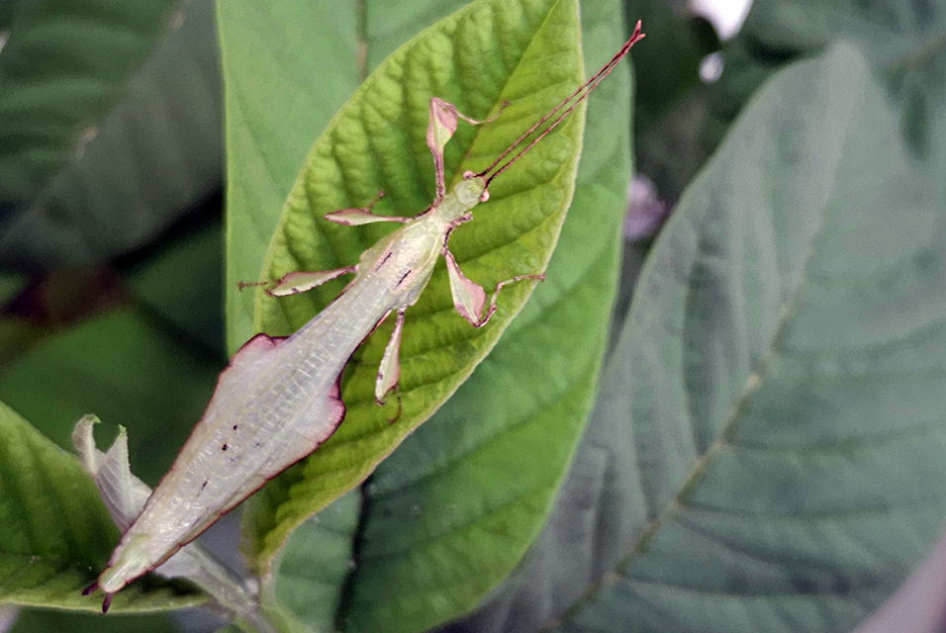
A male Phyllium asekiense. A surprise clutch of eggs has solved a century-old leaf insect mystery. Mario Bonneau via The New York Times.
by Sabrina Imbler

NEW YORK (NYT NEWS SERVICE).- In the spring of 2018 at the Montreal Insectarium, Stéphane Le Tirant received a clutch of 13 eggs that he hoped would hatch into leaves. The eggs were not ovals but prisms, brown paper lanterns scarcely bigger than chia seeds.
They were laid by a wild-caught female Phyllium asekiense, a leaf insect from Papua New Guinea belonging to a group called frondosum, which was known only from female specimens. Phyllium asekiense is a stunning leaf insect, occurring both in summery greens and autumnal browns. As Royce Cumming, a graduate student at the City University of New York, puts it, “Dead leaf, live leaf, semi-dried leaf.”
Le Tirant, the collections manager of the insectarium since 1989, specializes in scarab beetles; he estimates that he has 25,000 beetles in his private collection at home. But he had always harbored a passion for leaf insects and had successfully bred two species, a small one from the Philippines and a larger one from Malaysia. A Phyllium asekiense — rare, beautiful and, most important, living — would be a treasure in any insectarium.
In the insect-rearing laboratory, Mario Bonneau and other technicians nestled the 13 eggs on a mesh screen on a bed of coconut fibers and spritzed them often with water. In the fall, and over the course of several months, five eggs hatched into spindly black nymphs. The technicians treated the baby nymphs with utmost care, moving them from one tree to another without touching the insects, only whatever leaf they clung to.
“Other insects, we just grab them,” Le Tirant said. “But these small leaf insects were so precious, like jewels in our laboratory.”
The technicians offered the nymphs a buffet of fragrant guava, bramble and salal leaves. Two nymphs refused to eat and soon died. The remaining three munched on bramble, molted, munched, molted, and molted some more. One nymph grew green and broad, just like her mother.
But to Le Tirant’s befuddlement, the other two grew slender and sticklike and even sprouted a pair of wings. They bore a curious resemblance to leaf insects in Nanophyllium, an entirely different genus whose six species had been described only from male specimens.
Le Tirant emailed a picture to Cumming, who confirmed what had now become obvious: The two species in fact were one and the same. The hatchlings had solved a century-old mystery of the missing Nanophyllium female.
“Since 1906, we’ve only ever found males,” Cumming said. “And now we have our final, solid proof.”
Cumming and Le Tirant recently united the long-lost mates — broad-leafed females and slender males — in one species, Nanophyllium asekiense, in the journal ZooKeys.
It is actually quite common for leaf insects — which are a family in the broader order of stick insects — to be known from just one sex. Many stick insects display extreme sexual dimorphism, with females unrecognizable from their male companions.
In 2018, Paul Brock, a scientific associate at the Natural History Museum in London who edited a rough draft of the new paper, solved a similar mystery in stick insects. He and his colleagues described the first male Acanthoxyla, a genus of stick insect from New Zealand that was thought to be exclusively female, from a specimen found on a car in Cornwall, England.
“Leaf insects are a particular challenge as they are so infrequently found in the wild,” Brock said.
Leaf insects are almost impossible to see in nature, and scientists can’t study what they can’t see. Cumming, one of the world’s few experts on leaf insects, has never seen a leaf insect in the wild, only specimens in captivity or museums. Brock has seen wild stick insects, but never a wild leaf insect.
Le Tirant, who has gone on many insect-collecting trips, has seen only one leaf insect in the wild. While searching with a local collector in Malaysia, Le Tirant discovered it after hitting a tree with his large collecting net, which shook free many leaves and one leaf insect. “If I was alone, I would never have seen a single leaf insect,” he said, shaking his head at his fortune. Le Tirant took the insect back to Montreal, where it lived and died and still resides, in a drawer in the insectarium.
Even if someone could distinguish a leaf insect from its arboreal brethren, there is an almost zero chance the insect would be in the company of its mate, let alone in flagrante delicto. Whereas the winged males flit from tree to tree, the flightless females spend their entire lives high up in the canopy, out of reach and sight, swaying in the breeze as leaves will do. “By chance, one might be blown out of a tree,” Cumming said.
How, then, to match leaf insects to their mates? With field observation a nonstarter, entomologists resorted to hypothesizing. Two decades ago, Brock was the first to suggest that the female mate to Nanophyllium could be found in the frondosum group. He was examining a pair of male and female leaf insects from Papua New Guinea whose uneven legs looked curiously similar.
“This would be a simple task nowadays, by undertaking DNA bar coding,” Brock said. But he lacked enough evidence: The female was missing her forelegs, and only one species of Nanophyllium had been formally described.
In 2017, Cumming decided to see if he could prove Brock’s hypothesis. He and Le Tirant spent several years poring through museum specimens, which has resulted in 21 newly described leaf insect species. Cumming, Le Tirant and colleagues spent two years writing a paper identifying the shared morphology of frondosum females and Nanophyllium males. The similarities were small but certain — two nodes at the back of the head, and leaflike lobed legs.
Their paper had already passed peer review when Le Tirant’s nymphs grew up and unexpectedly provided unshakable proof. “We had to rewrite everything,” Cumming said. Brock is delighted the puzzle has been solved at last.
At the Montreal Insectarium, the two male Nanophylliums flew day and night for four months and died before their female sibling matured. She lived for nine months, laying 245 eggs in Easter egg pastels: blues, yellows and beiges. “To have eggs from one female in so many colors?” Le Tirant said. “That is something very special, something I have never seen in the past for a leaf insect.”
Very few of her eggs have hatched, and no nymphs survived. But Le Tirant has kept all of her eggs, hatched and unhatched, on pins and in jars.
Although the pandemic has prevented Cumming and Le Tirant from meeting in person, they have become fast friends and will soon finish a grander project revising the evolutionary history of leaf insects.
Le Tirant still marvels at his luck — of the eggs hatching, and of becoming acquainted with Cumming a few years before Le Tirant might have retired, giving Le Tirant the chance to study the alluring insects near the end of a long career devoted to beetles. “You could study rocks your whole life, or you could study diamonds,” he said. “What a fabulous insect.”
© 2020 The New York Times Company

