Survey su motore a combustione interna

<https://www.youtube.com/watch?v=OGj8OneMjek>

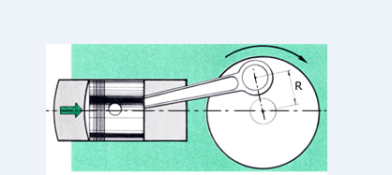

bilanciere

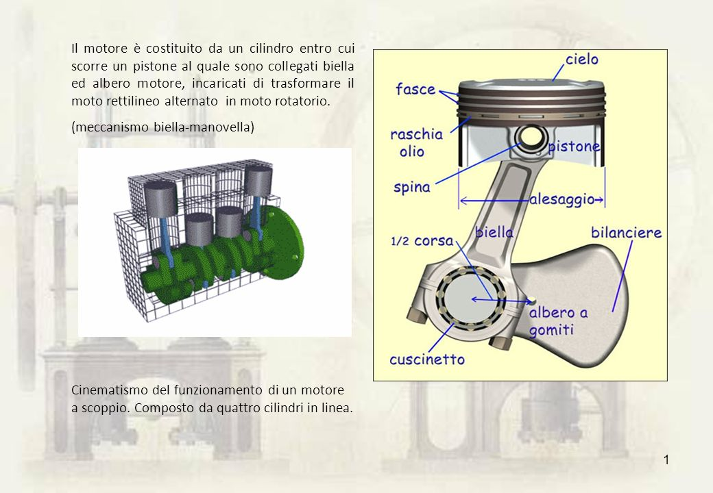

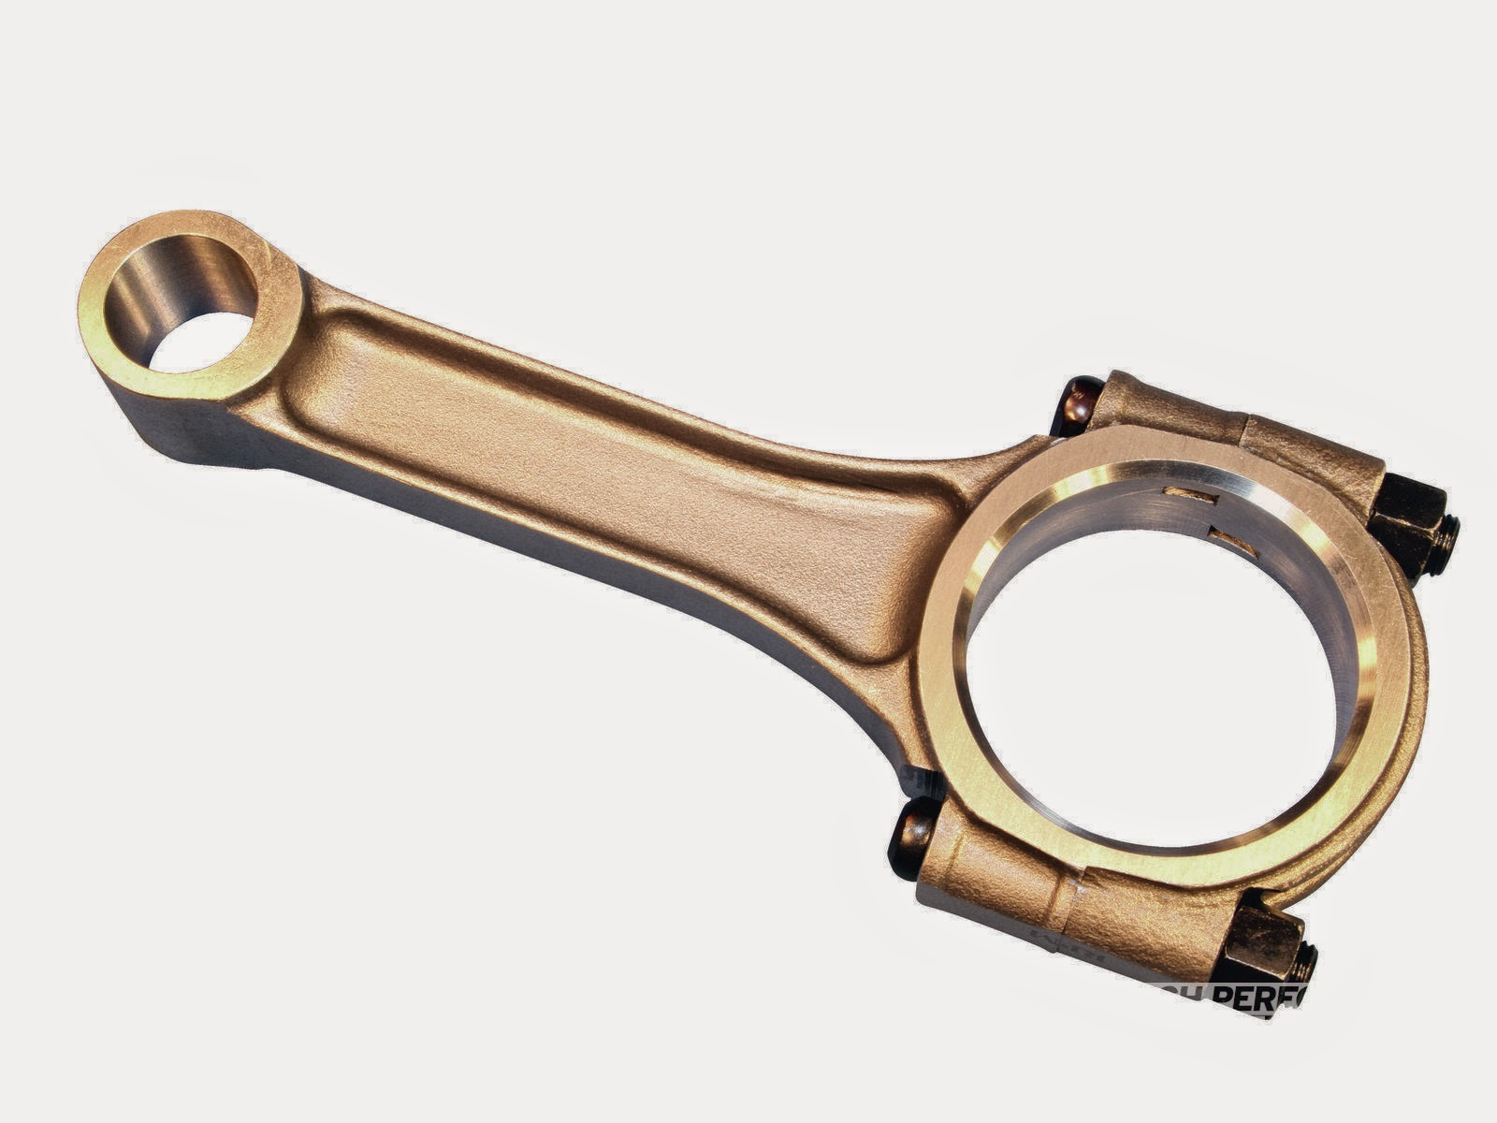

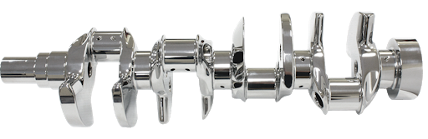

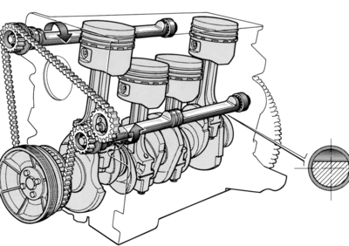

Video su albero controrotante

<https://www.youtube.com/watch?v=8mmvaNZwaI0>

6 cilindri in linea e 6V

<https://www.youtube.com/watch?v=u3XSfVPFM74>