Universal joints
https://www.youtube.com/watch?v=LCMZz6YhbOQ

Spherical joint
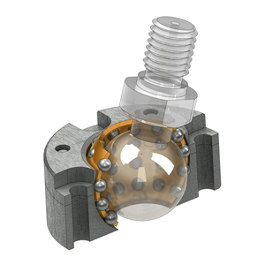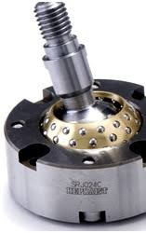

Stewart platform (machining)
https://www.youtube.com/watch?v=QcUsWwfRftY

VI grade (planar robot)
https://www.youtube.com/watch?v=mlfn6EpGA40&t=2s

Simulatore di guida (non Stewart)
https://www.youtube.com/watch?v=zNUBZfrOXUc

Delta robot
https://www.youtube.com/watch?v=fx0daoC_ECE

