https://www.nytimes.com/2021/02/24/us/politics/language-government-biden-trump.html

POLITICS|The Words That Are In and Out With the Biden Administration

The Words That Are In and Out With the Biden Administration
“The president has been clear to all of us — words matter, tone matters and civility matters,” said Jen Psaki, the White House press secretary.

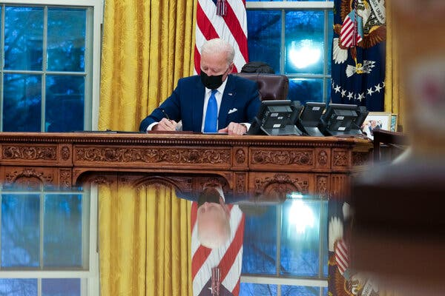
President Biden in the Oval Office this month. The rhetorical overhaul is underway across the government as executive orders are drafted, news releases are modified and scores of federal forms are tweaked. Credit...Doug Mills/The New York Times

By Michael D. Shear
Feb. 24, 2021
WASHINGTON — Days after President Biden took office, the Bureau of Land Management put a scenic landscape of a winding river at the top of its website, which during the previous administration had featured a photograph of a huge wall of coal.
At the Department of Homeland Security, the phrase “illegal alien” is being replaced with “noncitizen.” The Interior Department now makes sure that mentions of its stakeholders include “Tribal” people (with a capital “T” as preferred by Native Americans, it said). The most unpopular two words in the Trump lexicon — “climate change” — are once again appearing on government websites and in documents; officials at the Environmental Protection Agency have even begun using the hashtag #climatecrisis on Twitter.
And across the government, L.G.B.T.Q. references are popping up everywhere. Visitors to the White House website are now asked whether they want to provide their pronouns when they fill out a contact form: she/her, he/him or they/them.

It is all part of a concerted effort by the Biden administration to rebrand the government after four years of President Donald J. Trump, in part by stripping away the language and imagery that represented his anti-immigration, anti-science and anti-gay rights policies and replacing them with words and pictures that are more inclusive and better match the current president’s sensibilities.

“Biden is trying to reclaim the vision of America that was there during the Obama administration, a vision that was much more diverse, much more religiously tolerant, much more tolerant of different kinds of gender dispositions and gender presentations,” said Norma Mendoza-Denton, a professor of anthropology at the University of California, Los Angeles, and an author of “Language in the Trump Era: Scandals and Emergencies.”
Dr. Mendoza-Denton said Mr. Trump sought to “remake reality through language” during a tumultuous tenure. In her book, which she wrote with Janet McIntosh from Brandeis University, Dr. McIntosh wrote that the former president “changed some of the deepest expectations about presidential language, not just when it comes to style, but also the relationship between words and reality.”
Now, officials in Mr. Biden’s administration are using Mr. Trump’s own tactics to adjust reality again, this time by erasing the words his predecessor used and by explicitly returning to ones that had been banished.

“The president has been clear to all of us — words matter, tone matters and civility matters,” said Jen Psaki, the White House press secretary. “And bringing the country together, getting back our seat at the global table means turning the page from the actions but also the divisive and far too often xenophobic language of the last administration.”
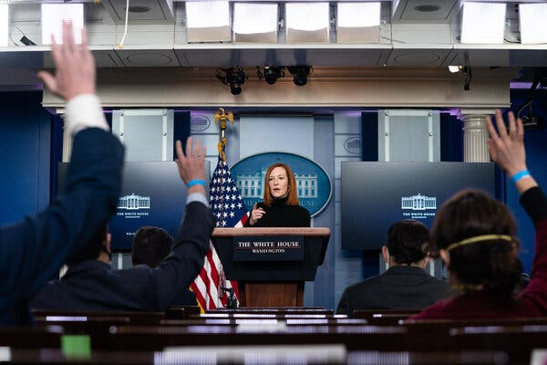

“Getting back our seat at the global table means turning the page from the actions but also the divisive and far too often xenophobic language of the last administration,” said Jen Psaki, the White House press secretary.Credit...Anna Moneymaker for The New York Times
Some shift in the language used by government agencies is not uncommon when a new administration arrives in Washington. In addition to their symbolic power, the revisions can help usher in new policies. Allowing the phrase “climate change” gives a green light to government scientists, while banning the use of “illegal alien” can alter the real-life engagements between immigrants and border agents.
But rarely has the contrast been quite so stark as it is between Mr. Biden and Mr. Trump. The rhetorical overhaul is underway in all corners of the government as executive orders are drafted, news releases are modified, scores of federal forms are tweaked and online portals are revamped.
Stephen Miller, who pursued similar changes at the beginning of the Trump administration as a top policy adviser, said the embrace of what he called politically correct language by officials in Mr. Biden’s government reflected the importance of framing important issues for the public.
In addition to the changes on websites, he noted that Mr. Biden’s executive orders had been filled with words and phrases that would never have come from Mr. Trump’s mouth, including “equity,” “environmental justice,” “pathway to citizenship,” “pro-choice” and “undocumented immigrant.”
“The struggle over the lexicon is actually the central struggle,” said Mr. Miller, who wrote many of Mr. Trump’s speeches and was the architect of his assault on the immigration system. “Equity is meant to harken to this idea that America is a nation that believes in everybody having this fundamental dignity of treatment. But the other side would say, ‘What you call equity, I call discrimination.’”

Trump administration officials like Mr. Miller sought to engineer similar shifts in language when they were in office. Mr. Miller fought in 2017 for the use of the phrase “radical Islamic terrorism” during that year’s presidential address to Congress, arguing that it conveyed a seriousness of purpose by Mr. Trump in fighting terrorism. Critics said that using the phrase falsely suggested that all Muslims are terrorists.
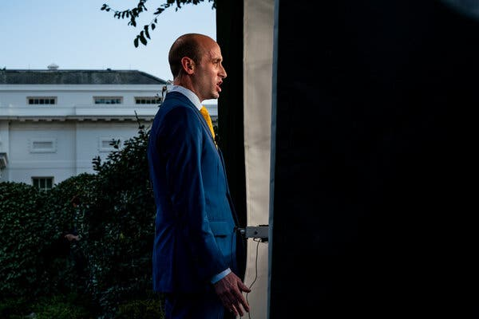

Trump administration officials like Stephen Miller, a top policy adviser, sought to engineer similar shifts in language when they were in office.Credit...Anna Moneymaker for The New York Times
And Ben Carson, Mr. Trump’s secretary of housing and urban development, proposed removing the phrase “inclusive and sustainable communities free from discrimination” from the department’s mission statement. He later backed down.
For the Biden administration, the vocabulary shift was immediate.
Hours after taking office, officials responsible for updating WhiteHouse.gov removed pages highlighting Mr. Trump’s 1776 Commission, which likened progressivism to fascism and attacked liberals who charge that the United States’ founding was tainted by slavery.
At the same time, the president’s aides restored the Spanish-language version of the website, which had been taken down by Mr. Trump’s digital team, and hired sign-language interpreters for the livestream of the press secretary’s daily briefing. References to presidents as “he” were changed to “they” on some parts of the site.
At the State Department, the incoming secretary, Antony J. Blinken, moved quickly to erase what Mike Pompeo, his predecessor, called an “ethos” statement for United States diplomats, which included a pledge to be a “champion of American diplomacy” and to work with “unfailing professionalism.” Many longtime members of the department saw it as an insulting warning to the so-called deep state who Mr. Pompeo and Mr. Trump believed were undermining their agenda.
In its place, Mr. Blinken issued a statement that said “the ethos of public service permeates the work force” and declared that State Department employees “do not need a reminder of the values we share.”
And officials at the Bureau of Land Management, in addition to overhauling their website, have restored boilerplate language at the bottom of all documents, including the assertion that the agency’s mission is “to sustain the health, diversity and productivity of America’s public lands.”
Melissa Schwartz, the Interior Department’s top communications official, said such changes were part of a new policy of encouraging voices that had not been heard during the Trump administration.
“The words we choose are critical and set the tone, whether it’s press releases or social media or all-staff messages,” she said. “At interior, that means not just acknowledging the disproportionate impact that the climate crisis is having on communities of color and Indigenous peoples but an embrace of the science and solutions that will help us tackle it.”
Biden administration officials say the effort to modify the language used by government officials recognizes the powerful messages that certain words and phrases send.
The term “alien” is written into immigration statutes and has been widely used in government for decades to describe foreigners, even showing up in memos from Obama-era officials. But it has increasingly been at the center of an ideological tug of war about whether it unfairly stigmatizes immigrants, and whether those in the United States without authorization should be called “undocumented” rather than “illegal.”
Three years ago, Attorney General Jeff Sessions ordered officials in his department to use the term “illegal alien” in all communications when describing someone who did not come to the United States through legal means. In a memo, Justice Department officials wrote that “the word ‘undocumented’ is not based in U.S. code and should not be used to describe someone’s illegal presence in the country.”

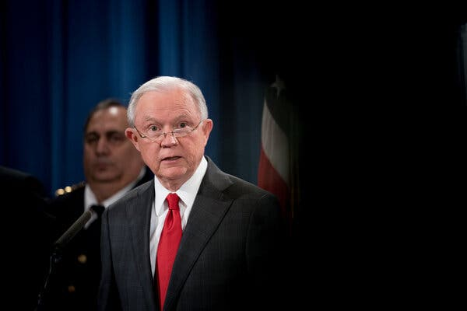
As attorney general, Jeff Sessions ordered his department to use the term “illegal alien” in all communications when describing someone who did not come to the United States through legal means.Credit...Erin Schaff for The New York Times
Now, the Biden administration is explicitly reversing that position. On Feb. 12, officials at Citizenship and Immigration Services, the agency that handles citizenship, said employees should not use the word “alien” in “outreach efforts, internal documents and in overall communication with stakeholders, partners and the general public.” The move, the agency’s acting director said, “aligns our language practices with the administration’s guidance on the federal government’s use of immigration terminology.”
A few days later, the White House went further. In his legislative proposal for a far-reaching immigration overhaul, Mr. Biden would strip the word “alien” from the 1965 Immigration and Nationality Act and substitute it with “noncitizen,” a suggestion that infuriates anti-immigration groups.
“It’s kind of Orwellian — that’s what it is, really,” said Mark Krikorian, the executive director of the Center for Immigration Studies, which favors limits on immigration. “The war against the word ‘alien’ is a continuation of this effort to destigmatize illegal immigration that started in the mid-1970s. This is in a sense the culmination of that process.”
Some changes are still pending.
The website of the Department of Homeland Security’s citizenship office, USCIS.gov, still bears the mission statement that Trump administration officials modified in 2018 to remove “America’s promise as a nation of immigrants” and replace it with “fairly adjudicating requests for immigration benefits.” That could soon switch course.
At the Environmental Protection Agency, Mr. Trump’s aides had taken down the part of the website devoted to climate change. As of mid-February, the site had not yet been restored. But given Mr. Biden’s embrace of the subject, officials said they expected that to happen soon.
But the Treasury Department is already moving ahead with plans to put Harriet Tubman on the $20 bill, a decision that had been delayed during the Trump administration.
And at the Interior Department, employees have been told that they can use phrases like “science-based evidence” again. In a call with the agency’s public relations officials on Jan. 21, Ms. Schwartz had a message for her colleagues.
“Climate change is real, and science is back, and you should feel free to talk about both in your press releases,” she said. “I release you!”
Lisa Friedman and Christopher Flavelle contributed reporting.

