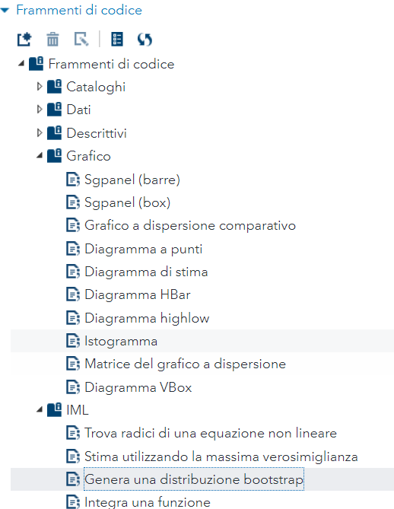

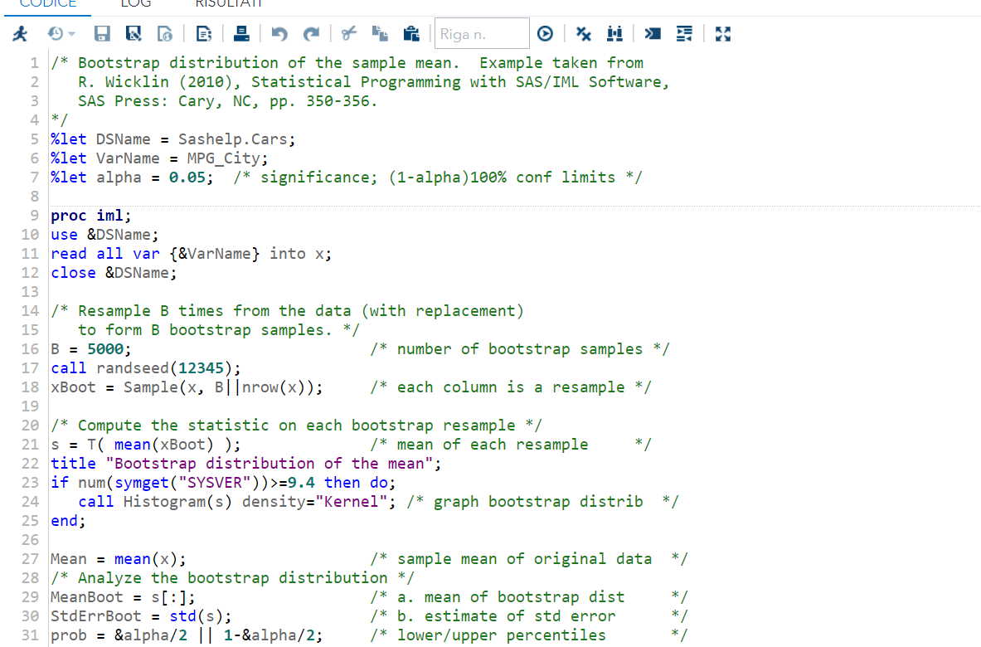

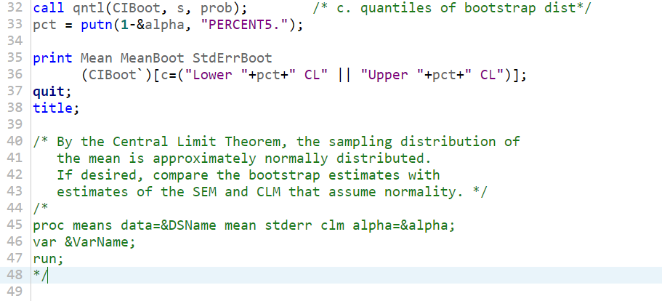

/* Bootstrap distribution of the sample mean. Example taken from

R. Wicklin (2010), Statistical Programming with SAS/IML Software,

SAS Press: Cary, NC, pp. 350-356.

*/

%let DSName = Sashelp.Cars;

%let VarName = MPG_City;

%let alpha = 0.05; /* significance; (1-alpha)100% conf limits */

proc iml;

use &DSName;

read all var {&VarName} into x;

close &DSName;

/* Resample B times from the data (with replacement)

to form B bootstrap samples. */

B = 5000; /* number of bootstrap samples */

call randseed(12345);

xBoot = Sample(x, B||nrow(x)); /* each column is a resample */

/* Compute the statistic on each bootstrap resample */

s = T( mean(xBoot) ); /* mean of each resample */

title "Bootstrap distribution of the mean";

if num(symget("SYSVER"))>=9.4 then do;

call Histogram(s) density="Kernel"; /* graph bootstrap distrib */

end;

Mean = mean(x); /* sample mean of original data */

/* Analyze the bootstrap distribution */

MeanBoot = s[:]; /* a. mean of bootstrap dist */

StdErrBoot = std(s); /* b. estimate of std error */

prob = &alpha/2 || 1-&alpha/2; /* lower/upper percentiles */

call qntl(CIBoot, s, prob); /* c. quantiles of bootstrap dist*/

pct = putn(1-&alpha, "PERCENT5.");

print Mean MeanBoot StdErrBoot

(CIBoot`)[c=("Lower "+pct+" CL" || "Upper "+pct+" CL")];

quit;

title;

/* By the Central Limit Theorem, the sampling distribution of

the mean is approximately normally distributed.

If desired, compare the bootstrap estimates with

estimates of the SEM and CLM that assume normality. */

/*

proc means data=&DSName mean stderr clm alpha=&alpha;

var &VarName;

run;

*/