FUNZIONE

Exp(-x\*x)- x/(1+x\*x)

proc iml;

/\* define a function that has one or more zeros \*/

start Func(x);

return (exp(-x##2)-x/(1+x##2));

finish;

if num(symget("SYSVER"))>=9.4 then do;

/\* plot the function to get an idea of how many roots there

are and approximately where they are located \*/

x = do(-4, 4, 0.1);

y = Func(x);

call Series(x, y)

grid="x" other="refline 0 / axis=y"; /\* reference line \*/

end;

/\* Specify three intervals to search for roots \*/

intervals = {-4 -1.5, /\* 1st interval [-4, -1.5] \*/

-1.5 1 , /\* 2nd interval [-1.5 1] \*/

1 4 }; /\* 3rd interval [1, 4] \*/

Roots = froot("Func", intervals);

print Roots;

quit;

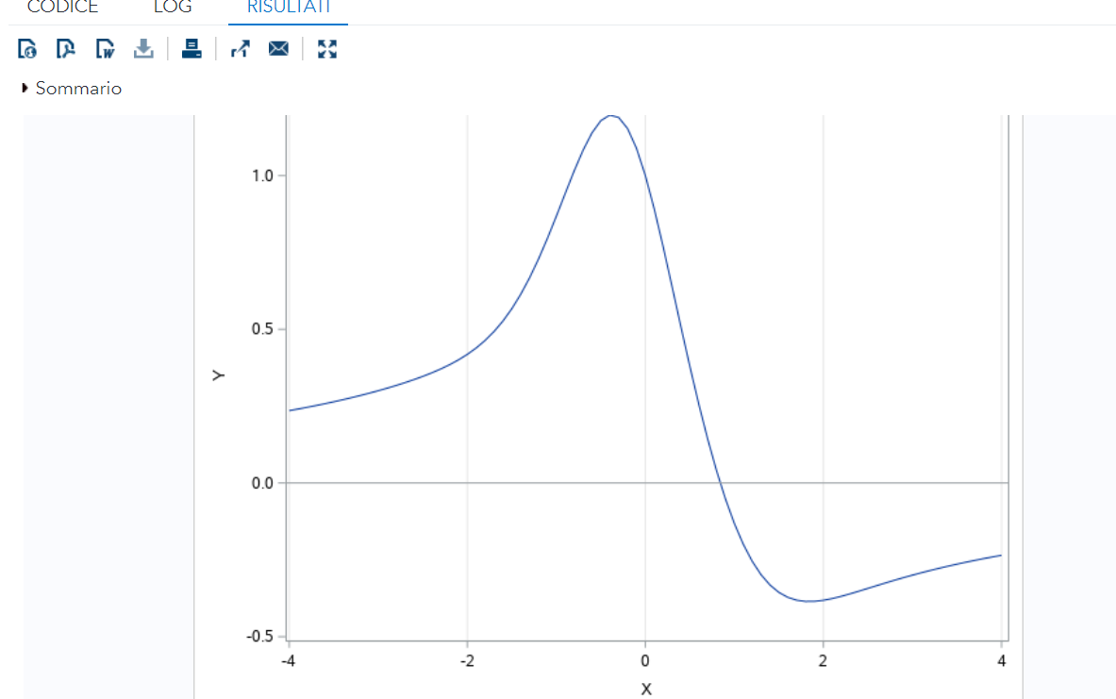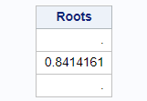

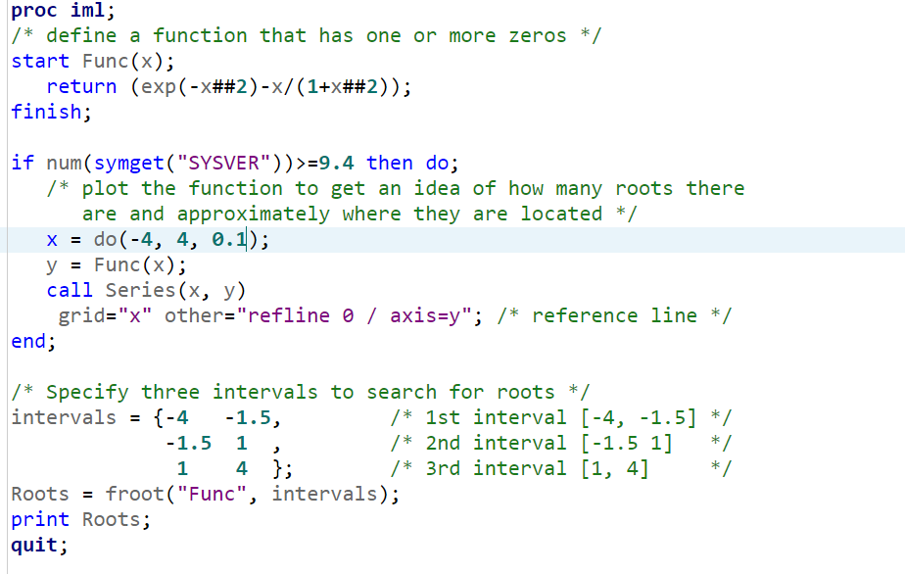

proc iml;

/\* define a function that has one or more zeros \*/

start Func(x);

return (exp(-x##2)-x/(1+x##2));

finish;

if num(symget("SYSVER"))>=9.4 then do;

/\* plot the function to get an idea of how many roots there

are and approximately where they are located \*/

x = do(-4, 4, 0.1);

y = Func(x);

call Series(x, y)

grid="x" other="refline 0 / axis=y"; /\* reference line \*/

end;

/\* Specify three intervals to search for roots \*/

intervals = {-4 -1.5, /\* 1st interval [-4, -1.5] \*/

-1.5 1 , /\* 2nd interval [-1.5 1] \*/

1 4 }; /\* 3rd interval [1, 4] \*/

Roots = froot("Func", intervals);

print Roots;

quit;

RADICE CUBICA DI 2

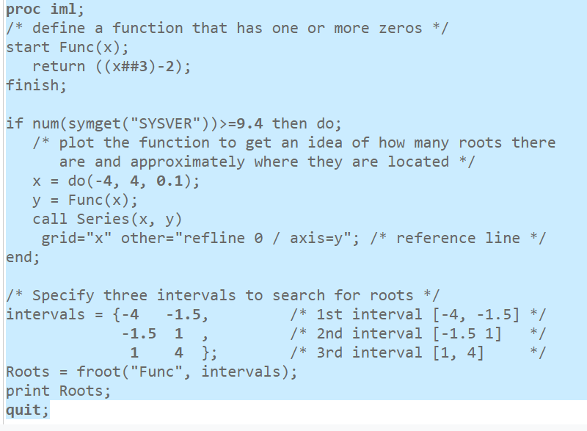

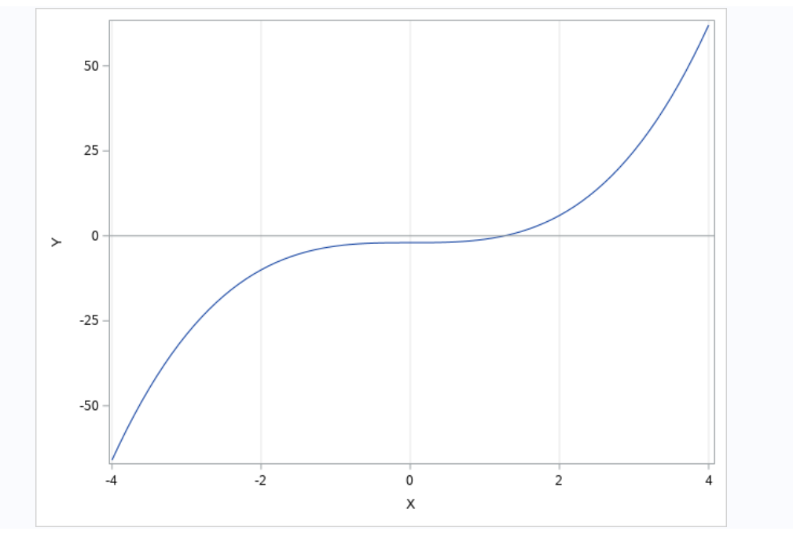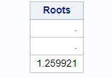

/\*FUNZIONE x=exp -x \*/

proc iml;

/\* define a function that has one or more zeros \*/

start Func(x);

return (x-(exp(-x)));

finish;

if num(symget("SYSVER"))>=9.4 then do;

/\* plot the function to get an idea of how many roots there

are and approximately where they are located \*/

x = do(-4, 4, 0.1);

y = Func(x);

call Series(x, y)

grid="x" other="refline 0 / axis=y"; /\* reference line \*/

end;

/\* Specify three intervals to search for roots \*/

intervals = {-4 -1.5, /\* 1st interval [-4, -1.5] \*/

-1.5 1 , /\* 2nd interval [-1.5 1] \*/

1 4 }; /\* 3rd interval [1, 4] \*/

Roots = froot("Func", intervals);

print Roots;

quit;

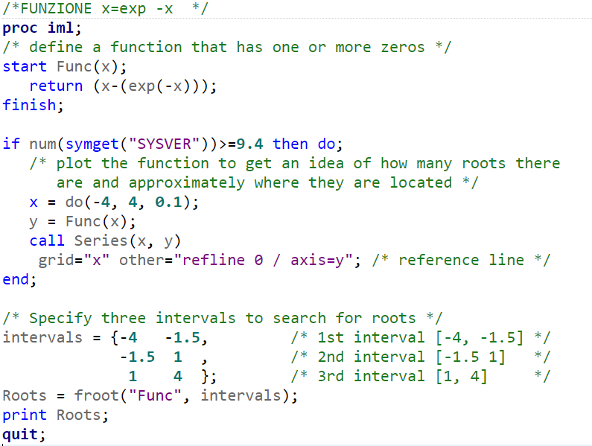

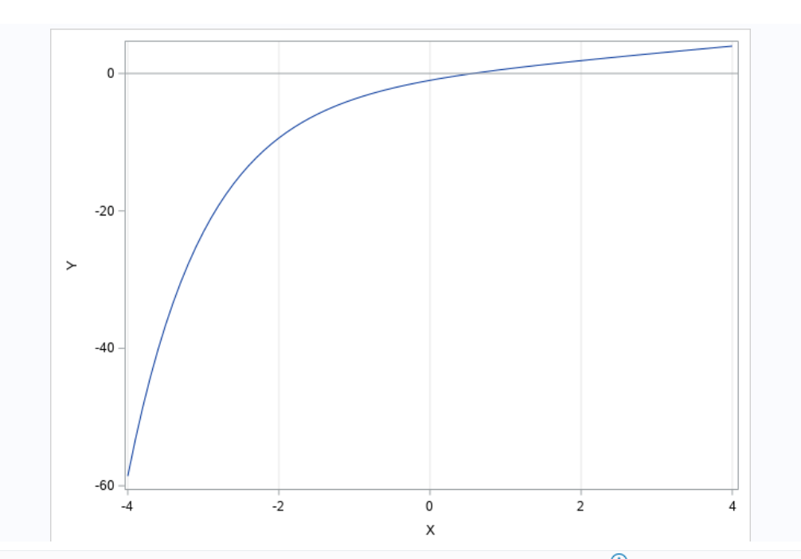 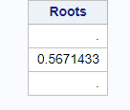

RIASSUMENDO

/\* Find the root of a function of one variable. Example taken from

R. Wicklin, "A simple way to find the root of a function of one variable",

The DO Loop blog, published Feb 4, 2014.

URL: http://blogs.sas.com/content/iml/2014/02/05/find-the-root-of-a-function/

\*/

/\* FUNZIONE Exp(-x\*x)- x/(1+x\*x) \*/

proc iml;

/\* define a function that has one or more zeros \*/

start Func(x);

return (exp(-x##2)-x/(1+x##2));

finish;

if num(symget("SYSVER"))>=9.4 then do;

/\* plot the function to get an idea of how many roots there

are and approximately where they are located \*/

x = do(-4, 4, 0.1);

y = Func(x);

call Series(x, y)

grid="x" other="refline 0 / axis=y"; /\* reference line \*/

end;

/\* Specify three intervals to search for roots \*/

intervals = {-4 -1.5, /\* 1st interval [-4, -1.5] \*/

-1.5 1 , /\* 2nd interval [-1.5 1] \*/

1 4 }; /\* 3rd interval [1, 4] \*/

Roots = froot("Func", intervals);

print Roots;

quit;

/\* RADICE CUBICA DI 2 x alla terza -2 = 0 \*/

proc iml;

/\* define a function that has one or more zeros \*/

start Func(x);

return ((x##3)-2);

finish;

if num(symget("SYSVER"))>=9.4 then do;

/\* plot the function to get an idea of how many roots there

are and approximately where they are located \*/

x = do(-4, 4, 0.1);

y = Func(x);

call Series(x, y)

grid="x" other="refline 0 / axis=y"; /\* reference line \*/

end;

/\* Specify three intervals to search for roots \*/

intervals = {-4 -1.5, /\* 1st interval [-4, -1.5] \*/

-1.5 1 , /\* 2nd interval [-1.5 1] \*/

1 4 }; /\* 3rd interval [1, 4] \*/

Roots = froot("Func", intervals);

print Roots;

quit;

/\*FUNZIONE x=exp -x \*/

proc iml;

/\* define a function that has one or more zeros \*/

start Func(x);

return (x-(exp(-x)));

finish;

if num(symget("SYSVER"))>=9.4 then do;

/\* plot the function to get an idea of how many roots there

are and approximately where they are located \*/

x = do(-4, 4, 0.1);

y = Func(x);

call Series(x, y)

grid="x" other="refline 0 / axis=y"; /\* reference line \*/

end;

/\* Specify three intervals to search for roots \*/

intervals = {-4 -1.5, /\* 1st interval [-4, -1.5] \*/

-1.5 1 , /\* 2nd interval [-1.5 1] \*/

1 4 }; /\* 3rd interval [1, 4] \*/

Roots = froot("Func", intervals);

print Roots;

quit;