Linux operative system
Version: 25.11.2020

Linux is a family of open-source Unix-like operating systems, first released in 1991, by Linus Torvalds. Unix is a family of multitasking, multiuser computer operating systems that derive from the original AT&T Unix, development starting in the 1970s at the Bell Labs research center.

What is an Operative System (OS)? An OS is a computer program, which acts as an interface between the hardware and the user. At the beginning the user must connect with the computer, working directly on the machine or by means of a ‘terminal’ connected via network. In our case we will connect via terminal to the remote server.
In order to open a terminal session on a windows computer to connect to the remote Linux server we shall use the bitvise program, which can be downloaded for free from www.bitvise.com (select “Bitvise SSH Client: Free SSH file transfer, terminal and tunneling”). In order to connect run the bitvise program, select the login from the menu and set the following data:

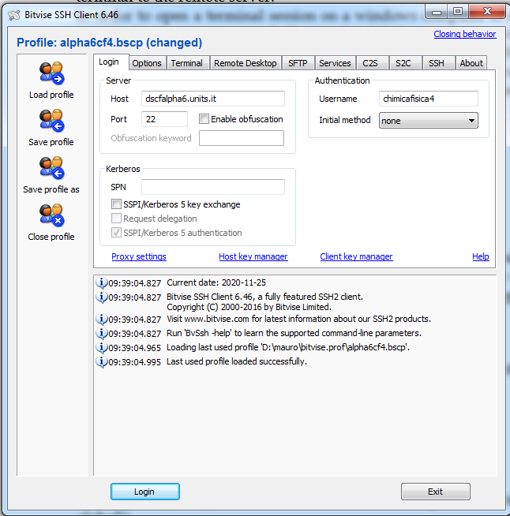
Host: dscfalpha6.units.it
Port: 22
Username chimicafisica4
Initial method: none.

Once the settings are ready, click the “login” box and a password will be asked, insert the password. Them two boxes will be opened: the terminal (with black background color) and the SFTP (a white background tool useful to transfer files from local computer and remote server).
In the terminal window the following text will appear:

------------------------------------
Last login: Wed Nov 25 07:56:18 2020 from dschforn6.univ.trieste.it
Welcome to the computational server

to use the Intel fortran compiler:

/opt/intel/bin/ifortvars.csh intel64
/opt/intel/bin/ifortvars.sh intel64

to enable mkl library paths:

/opt/intel/composer_xe_2011_sp1.6.233/mkl/bin/mklvars.sh

to submit job:

qsub -l nodes=1:ppn=XX where XX is the number of cores you want to use
[chimicafisica4@dscfalpha6 ~]$
Remember that Linux (Unix) is case sensitive (uppercase and lowercase characters are different!)
The prompt appears [chimicafisica4@dscfalpha6 ~]$ once the login has been successful, it means that Linux is waiting for a new command, and it appears once the previous command has been completed. In each computer the data, the programs, the mathematical libraries etc… consists of files, which lie in a specific directory, which in practice is a region of a physical hard disk. The directories are further organized in a tree structure, the user can move up and down in this structure. The directory in which the user is set just after the login is called the home.
When the user has finished to work, to close the session (logout) the command control d (^d) can be executed.

Short list of Linux commands

pwd
shows the current directory
ls
shows the content of the current directory (files and directories)
ls -l
like ls, ma con maggiori informazioni
cd [name-dir]
change directory, to go in name-dir, which becomes the current directory.

If only cd is given, you go back to the home directory. To go up by one level give cd ..
It is possible to concatenate the command with a / for example cd dir1/dir2 or cd ../..
------------------------

[chimicafisica4@dscfalpha6 ~]$ pwd
/home/chimicafisica4
[chimicafisica4@dscfalpha6 ~]$ ls
cf2017 cf2018 conf_data cq2018 cq2019 cq2020 dir_txt input KidOutput_1 KidOutput_2 KidOutput_3 logfile sem2019 sem2020 stener t21.C t21.O TAPE21
[chimicafisica4@dscfalpha6 ~]$ cd sem2020
[chimicafisica4@dscfalpha6 sem2020]$ ls
group1 group2 group3 group4
[chimicafisica4@dscfalpha6 sem2020]$ cd group1
[chimicafisica4@dscfalpha6 group1]$ ls
castellani cossettini demarchi fabbro fogar formaggio grassi guzzo panebianco pedroni piva stener trevisan
[chimicafisica4@dscfalpha6 group1]$ pwd
/home/chimicafisica4/sem2020/group1
[chimicafisica4@dscfalpha6 group1]$

Now everybody has his own directory so change directory going in the one with your name.

ls
benzene.input bredt2.input bredt2_plot.input bredt3.input bredt3_plot.input butano10.input butano60.input cicloesadiene.input cicloesano.input cicloesene.input esercizi h2.input
[chimicafisica4@dscfalpha6 stener]$ cd esercizi
[chimicafisica4@dscfalpha6 esercizi]$ pwd
/home/chimicafisica4/sem2020/group1/stener/esercizi
[chimicafisica4@dscfalpha6 esercizi]$ ls
adf bin coor.txt
[chimicafisica4@dscfalpha6 esercizi]$ ls -l
total 12
drwxr-xr-x 2 chimicafisica4 stener 4096 Nov 25 08:01 adf
drwxr-xr-x 2 chimicafisica4 stener 4096 Nov 25 08:01 bin
-rw-r--r-- 1 chimicafisica4 stener 126 Nov 25 08:01 coor.txt

[chimicafisica4@dscfalpha6 esercizi]$ cd adf
[chimicafisica4@dscfalpha6 adf]$ pwd
/home/chimicafisica4/sem2020/group1/stener/esercizi/adf
[chimicafisica4@dscfalpha6 adf]$ cd ..
[chimicafisica4@dscfalpha6 esercizi]$ pwd
/home/chimicafisica4/sem2020/group1/stener/esercizi

------------------------
cp name-file1 name-file2
copy file1 in file2. CAUTION! If file2 already exists il will be overwritten and the old content will be lost.
cp name-file1 name-directory
copy file1 in directory name-directory keeping file name file1
cp name-file1 name-directory/name-file2
copy file1 in directory name-directory changing the name of the file in name-file2
rm name-file
delete file name-file
cat name-file
visualize the content of file name-file (not practical for big files, see also commands vi and more)
cat file1>>file2
write the content of file1 at the end of file2
----------------------------
[chimicafisica4@dscfalpha6 esercizi]$ ls
adf bin coor.txt
[chimicafisica4@dscfalpha6 esercizi]$ cp coor.txt file2
[chimicafisica4@dscfalpha6 esercizi]$ ls
adf bin coor.txt file2
[chimicafisica4@dscfalpha6 esercizi]$ cp coor.txt adf/
[chimicafisica4@dscfalpha6 esercizi]$ cp coor.txt adf/file3
[chimicafisica4@dscfalpha6 esercizi]$ cd adf
[chimicafisica4@dscfalpha6 adf]$ ls
coor.txt file3
[chimicafisica4@dscfalpha6 adf]$ rm coor.txt
rm: remove regular file `coor.txt'? y
[chimicafisica4@dscfalpha6 adf]$ ls
file3
[chimicafisica4@dscfalpha6 adf]$ cat file3
coordinate di H2O in au

O 0.0 0.0 0.0
H 0.0 1.430900 -1.10900
H 0.0 -1.430900 -1.10900

[chimicafisica4@dscfalpha6 adf]$
[chimicafisica4@dscfalpha6 stener]$ cd
[chimicafisica4@dscfalpha6 ~]$ pwd
/home/chimicafisica4
[chimicafisica4@dscfalpha6 ~]$ cd sem2020/group1
[chimicafisica4@dscfalpha6 group1]$ cd stener/
[chimicafisica4@dscfalpha6 stener]$ cd esercizi/
[chimicafisica4@dscfalpha6 esercizi]$ cat coor.txt >> file2
[chimicafisica4@dscfalpha6 esercizi]$ cat file2
coordinate di H2O in au

O 0.0 0.0 0.0
H 0.0 1.430900 -1.10900
H 0.0 -1.430900 -1.10900

coordinate di H2O in au

O 0.0 0.0 0.0
H 0.0 1.430900 -1.10900
H 0.0 -1.430900 -1.10900

[chimicafisica4@dscfalpha6 esercizi]$

-------------------------------------------
The special character * is a jolly, it is interpreted as a whichever character or group of characters
rm *txt
delete all files ending with 'txt'
rm *txt*
delete all files containing 'txt'
mkdir name-dir
create a directory name-dir
rmdir name-dir
delete directory name-dir, must be empty
mv name-file1 name-file2
change the name of the file name-file1 in name-file2.
mv name-file1 name-dir
move file nome-file1 in directory name-dir
------------------------------
[chimicafisica4@dscfalpha6 esercizi]$ pwd
/home/chimicafisica4/sem2020/group1/stener/esercizi
[chimicafisica4@dscfalpha6 esercizi]$ ls
adf bin coor.txt file2
[chimicafisica4@dscfalpha6 esercizi]$ ls -l
total 16
drwxr-xr-x 2 chimicafisica4 stener 4096 Nov 25 14:34 adf
drwxr-xr-x 2 chimicafisica4 stener 4096 Nov 25 08:01 bin
-rw-r--r-- 1 chimicafisica4 stener 126 Nov 25 08:01 coor.txt
-rw-r--r-- 1 chimicafisica4 stener 252 Nov 25 14:37 file2
[chimicafisica4@dscfalpha6 esercizi]$ mv coor.txt adf
[chimicafisica4@dscfalpha6 esercizi]$ cd adf
[chimicafisica4@dscfalpha6 adf]$ ls
coor.txt file3
[chimicafisica4@dscfalpha6 adf]$ pwd
/home/chimicafisica4/sem2020/group1/stener/esercizi/adf
[chimicafisica4@dscfalpha6 adf]$ mv coor.txt file4
[chimicafisica4@dscfalpha6 adf]$ ls
file3 file4
[chimicafisica4@dscfalpha6 adf]$ cp file4 file5
[chimicafisica4@dscfalpha6 adf]$ ls
file3 file4 file5
[chimicafisica4@dscfalpha6 adf]$ rm f*
rm: remove regular file `file3'? y
rm: remove regular file `file4'? y
rm: remove regular file `file5'? y
[chimicafisica4@dscfalpha6 adf]$ ls
[chimicafisica4@dscfalpha6 adf]$ cd ..
[chimicafisica4@dscfalpha6 esercizi]$ ls
adf bin file2
[chimicafisica4@dscfalpha6 esercizi]$ rmdir adf
[chimicafisica4@dscfalpha6 esercizi]$ ls
bin file2
[chimicafisica4@dscfalpha6 esercizi]$ mv file2 coor.txt
[chimicafisica4@dscfalpha6 esercizi]$ ls
bin coor.txt
[chimicafisica4@dscfalpha6 esercizi]$ mkdir adf
[chimicafisica4@dscfalpha6 esercizi]$ ls
adf bin coor.txt
[chimicafisica4@dscfalpha6 esercizi]$
------------------

------------------

Useful command grep:
grep 'string' name-file
extract the rows containing the string from the file name-file

editor vi

vi name-file
The command vi correspond to a program called editor, such program allows to visualize, modify and create text files. Not all files are text files: some file are binary files and cannot be edited.
To visualize a file it is possible to fo up and down by page with commands ^f and ^b where ^ means control or ctrl. Using the arrows you can move by one row or chatarcter. To jump to row number 100 just digit 100G, G alone means the end of file, 1G is the first row of the file.
To modify the file content you can delete or create new text.
The current row is deleted by dd, the character by x.
If you need to delete many rows, for example from row 10 to row 20, just digit
:10,20d
To create new next you must enter the ‘insert mode’: if you need to insert new text below one row just digit o and insert the new text. To exit the ‘insert mode’ just press Esc.
To exit saving the changes:
:wq
To exit without saving the changes:
:q!

If you need just to check the content buit don’t need to modify it you can use the more name-file command.

