UCL SCHOOL OF PHARMACY:

LECTURE: ILLEGAL DRUGS OF ABUSE

Illegal drugs of abuse (street drugs) are a pharmacologically broad range of psychoactive active substances that are currently illegal to possess and/or distribute, that are taken by some individuals to produce short-term pleasurable effects, but on repeated long term use may lead to various forms of dependency (addiction), tolerance (adaptation, habituation) and possible withdrawal (abstinence) symptoms (or even physical harm) on abruptly stopping taking the drug. Alcohol and nicotine (in tobacco) may also be considered as drugs of abuse, but since their possession, use and distribution are not illegal, they will not be considered further in this lecture. Drugs taken illegally by athletes (e.g. anabolic steroids) to enhance physical performance will also not be considered here.

Drugs with an abuse potential all produce a common rewarding effect; this means that repeated use of the drug can lead to further self-administration in an attempt to increase the level of drug intake (positive reinforcement; the phenomenon may be readily demonstrated in animal studies of drug-seeking behaviour). In contrast, the sudden withdrawal of the drug may lead to negative reinforcement, when the subject endeavours to overcome the unpleasant withdrawal symptoms (cravings) by further self-administration of the drug.

The reward circuit system principally involves an increased activity of dopaminergic neurones in the mesolimbic dopaminergic pathway of the brain (plus other multiple neurotransmitter systems that contribute input and output circuits to this system). This is the natural reward system of the brain that is crucial for providing the fundamental emotional pleasure drives (euphoria) for eating, love and reproduction. Unfortunately, the same mesolimbic release of dopamine and production of pleasure sensations can be produced by ‘unnatural rewards’ i.e. drugs of abuse such as morphine, heroin, cocaine, amphetamine, ecstasy, cannabis, and also alcohol and nicotine, hence their common potential for abuse.

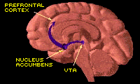
Mesolimbic dopaminergic reward system pathways and structures.
Common drugs of abuse
Opiates
Opiates are classed as ‘narcotic analgesics’, derived from the dried milky latex scraped from the ripening pods of the opium poppy Papaver somniferum. Raw opium contains morphine and codeine, which have strong analgesic properties without causing loss of consciousness, although morphine is more powerful, and more addictive. Opiates bind to specific opiate receptors in the brain and spinal cord (µ, δ and κ), which also interact with endogenous opiate peptides, enkephalins and endorphins, believed to be involved in setting natural pain thresholds, in mediating ‘emotional’ highs and in the process of addiction to opiates and development of alcohol dependency.

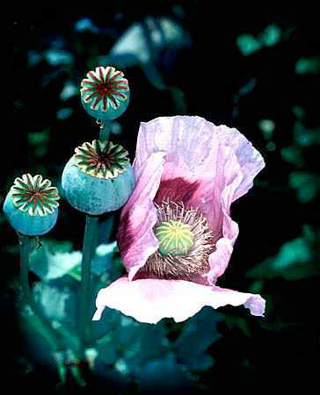

Opium poppy (Papaver Somniferum)
The euphoric, analgesic and sleep-inducing (narcotic) effects of opium have been known for ~6000 years. The isolation of morphine and codeine from opium, along with the invention of the hypodermic syringe and needle in the mid 19th century, greatly improved pain treatment, but also increased the incidence of opiate dependence. Opiate-based ‘elixirs’ such as laudanum, a mixture of opium, wine and spices, were once widely used for relieving aches, pains, nervousness, diarrhoea and coughing. Unfortunately, their highly addictive properties eventually led to opiates becoming prescription-only controlled drugs (Dangerous Drug Act: 1920).
Opiate dependency is now a major global public health and social problem. Opium itself appears as dark brown chunks or as a powder, usually smoked or ingested. The most common illicitly used opiate however, is heroin, a synthetic derivative of morphine (diacetylmorphine – diamorphine), first introduced in 1874 as a safe, non-addictive remedy for morphine addiction and as a cough suppressant!

Heroin (base) can be a white or brownish powder with a bitter taste, usually dissolved
in water and injected (mixed with citric acid to aid dissolution), or smoked (“chasing the dragon”) by heating vapour and inhaling. Street heroin is only ~ 40% pure, as it is diluted (‘cut’) with glucose, starch, powdered milk, or other agents e.g. flour, talcum
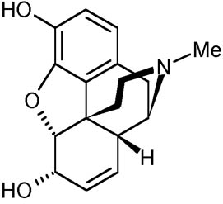
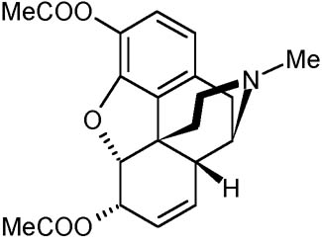
powder. Heroin accounts for 55% of the drug abuse in the UK.
Morphine Heroin
Methadone (Physeptone) is also a synthetic opiate, which is claimed not to produce the same “high” as heroin, now used in oral replacement treatment for heroin addiction. Abstinence is not however, an immediate outcome of such treatment, since the addict simply replaces an illegally obtained addiction with a legally prescribed one. Other synthetic opiates include Pethidine, Pentazocine, Dihydrocodeine (DF118), Buprenorphine and Fentanyl, all used widely to relieve moderate to severe pain (see BNF) after surgery and other medical procedures. Fentanyl is ~100 times more potent than morphine, has a more rapid onset of action and an effect of 1-2 hrs. It can be given i/v (during anaesthesia), orally (sublingual tablets/lozenges), intra-nasally, or as transdermal patches for chronic pain. Fentanyl is 10-50 times more potent than heroin and is now commonly found as an additive to illegally-sold heroin, which markedly increases the chance of an accidental overdose.

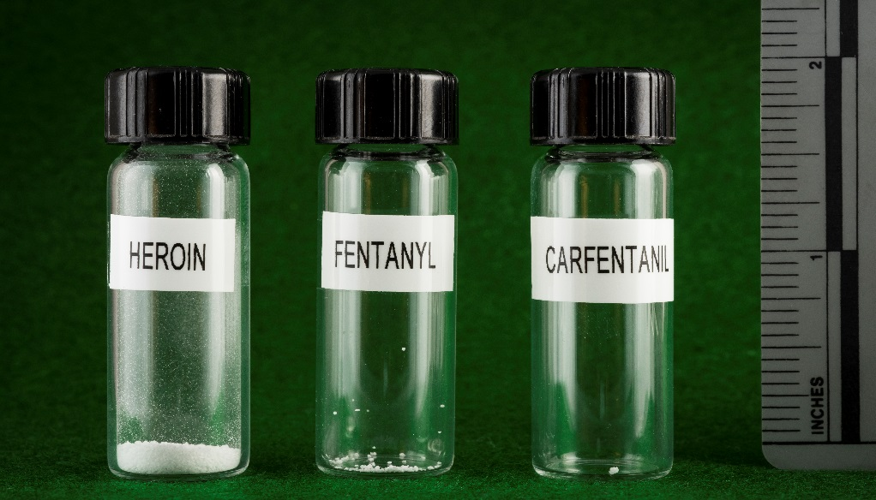

The photo above compares a lethal dose of heroin (~30 mg) with a lethal dose of fentanyl (~3 mg) and another even more potent opioid derivative carfentanil (~20 µg), used as a general anaesthetic agent for large animals. It is so dangerous that even an accidental touch or breath of the powder can be fatal (police, forensic labs). It is believed that the singer Prince died from an accidental overdose of Fentanyl.

Opiate receptor antagonists e.g. Naloxone, or Naltrexone are used for reversing potentially fatal respiratory depression following opiate overdose. Morphine is still used clinically for the treatment of chronic pain, particularly in terminal diseases (cancer), and codeine is used as a cough suppressant (the synthetic derivative dextromethorphan is now preferred). Diarrhoea is also treated with opiates, particularly in children (Kaolin and Morphine Mixture BP).

Routes of administration of opiates
The oldest route of opiate administration is oral, despite low bioavailability. Smoking opium was widespread in China for thousands of years. Powdered heroin can be ‘snorted’ and absorbed (poorly) through the nasal membranes. Morphine, heroin and other water soluble opiates can also be injected. Smoking and injection produce the quickest ‘rush’ and ‘high’. Once absorbed opiates are widely distributed throughout the body, including the CNS where they exert their psychoactive effects.

Effects of Heroin
Within seconds of injection, inhalation or snorting, heroin crosses the blood-brain barrier and is converted into morphine, binding to opiate receptors. This initiates intense feelings of pleasure (‘high’). Subjects become drowsy, with slow, slurred speech, dry mouth and cold skin. Extremities feel heavy. First time users may vomit. Pupils are constricted, pulse rate, temperature, respiration rate, coughing reflex and gut motility are all decreased.

Dependence, tolerance and withdrawal
Chronic addicts may develop both psychological and physiological dependence to opiates. Psychological dependence exists when a drug is so central to a person's thoughts, emotions, and activities that the need to continue its use becomes a craving or compulsion. Physical dependence is where the body has adapted to the presence of the drug, and uncomfortable withdrawal symptoms (similar to flu i.e. weakness, irritability, hypersensitivity, sweating, shivering muscle pain and runny nose) occur if use of the drug is reduced or stopped abruptly; positive pleasure is replaced by relief at simply taking the drug to maintain 'normality'. Although very unpleasant, opiate withdrawal is not life threatening. Tolerance means needing more and more of the drug to get the same intensity of effect. Tolerance to opiates (particularly the euphoric, analgesic and nausea effects) can develop within only a few days of use.

Treatment of opiate addiction

● Methadone maintenance: methadone 15-40 mg used as heroin substitute daily, coupled with gradual reduction of dose over several weeks/ months, until complete abstinence is achieved.

● Methadone-based programs substitute one addiction for another, enslaving patients to return day after day for their medication.

● Methadone has long-lasting effects and is one of the most difficult drugs to detox. from. Some methadone maintenance patients remain in these types of programs for 20-years.

Cannabis
Cannabis sativa is the specific name for the marijuana plant, which produces psychoactive cannabinoids (principally Δ⁹-tetrahydrocannabinol: Δ⁹-THC). The earliest documented reference to Cannabis is 2737 BC in China, where it was used to cure rheumatism, malaria, bowel disorders, menstrual cramps and absent-mindedness! It is now widely used recreationally for its psychoactive euphoric effects.
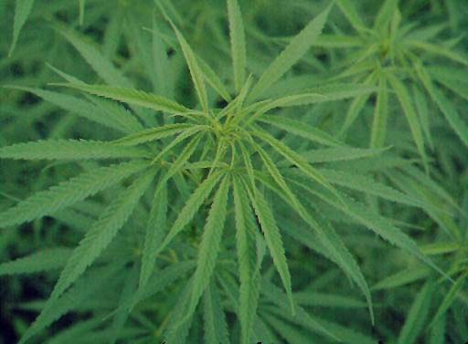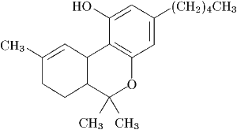
Cannabis sativa Δ⁹-THC
Cannabis use today: Recreational Cannabis use first became prevalent in the USA in the 1920’s, but was eventually made illegal in the 1930s. Use however continued, particularly during the “hippie” era of the 1960’s and 1970, and this remains the case today, with Cannabis being the most common illicit drug.

Routes of administration of Cannabis: Cannabis is usually smoked or eaten (less effective). When smoked, the effects are rapid in onset with THC entering the circulation almost immediately. When taken orally the time to peak is around 1-3 hrs.

Effects of Cannabis
There are over 400 constituent compounds in marijuana; ~60 of these are active cannabinoids. The most psychoactive is delta-9-tetrahydrocannabinol (Δ⁹-THC), which acts on specific brain cannabinoid receptors (CB₁) (particularly in cerebral cortex and hippocampus) to alter neuronal excitability and neurotransmitter release. The brain manufactures two endogenous cannabinoids with properties similar to Δ⁹-THC - anandamide and 2-arachidonylglycerol (2-AG), which bind to synaptic cannabinoid receptors, and are believed to be involved in the process of memory formation. It is not yet clear how cannabinoid receptor occupation leads to the complex behavioural effects observed, although regulation of dopamine neurones in the mesolimbic reward system is thought to be involved.
The main effects of smoking cannabis include: mood elevation, relaxation, creative thinking, heightened senses, pain relief, reduced nausea, increased appetite, tachycardia, vasodilation and short-term memory loss. Chronic use may lead to cognitive impairment, anxiety, schizophrenia-like psychosis, delusions, disorientation, or auditory/visual hallucinations, depression, apathy, social withdrawal, possible suicide, and cannabis use disorder (difficulty controlling cannabis use).
Cannabis smoke also contains bronchial irritants, tars and carcinogens in greater concentrations than in tobacco, therefore chronic cannabis smoking can cause bronchitis, emphysema and lung cancer. Smoking cannabis can also lead to decreased fertility (reduced sperm production, impaired ovulation). By comparison to other drugs, Δ⁹-THC is not very toxic, therefore no cases of lethal overdose from smoking Cannabis have been reported.
Medicinal uses of Cannabis
Medicinal use of herbal cannabis is still controversial. However, oral cannabinoid analogues (e.g. nabilone, and dronabinol) are currently used for the relief of:-

- Chemotherapy-induced nausea and vomiting-resistant to conventional anti emetics.
- Appetite stimulation in cases of severe weight loss in anorexia or patients with AIDS.
- Treatment of acute and chronic pain.

In Jan 2010, an extract of Cannabis - Nabixmols (Sativex) containing a 1:1 mixture of Δ⁹-THC and a non-psychoactive constituent Cannabidiol (CBD) given as a sublingual spray, was licensed in the UK for treatment of MS, neuropathic and cancer related pain. A single spray dose delivers 2.7 mg THC and 2.5 mg CBD. However, NICE (The National Institute for Health and Care Excellence) do not consider this to be cost-effective and do not recommend it’s use for MS treatment (£375 for 270 dose spray) (October 2014).

Cannabis and individual cannabinoids may also be potentially useful in treating:–

- Pain symptoms of fibromyalgia (chronic pain).
- MS and spinal cord injury, including spasticity.
- Bladder dysfunction in MS.
- Menstrual cramps, morning sickness, labour pain.
- ↑Intraocular pressure in late-stage glaucoma.
- Asthma (bronchodilation).
- Drug-resistant epilepsy [Dravet syndrome]; (Canabidiol: CBD).- Epidiolex
Now approved by the FDA (USA) for severe childhood epilepsy: Lennox-Gastaut and Dravet syndromes.
- Breast, prostate and colorectal cancer.
- Alcohol and opiate addiction.
- Tics in Tourette Syndrome; Dyskinesia in PD.
- Alzheimer’s and Huntington’s Diseases.

Dependence, Tolerance and Withdrawal
Although some mild psychological dependence to Cannabis may develop, there is no physical dependence syndrome, and withdrawal effects are mild, including mood changes, sleep disturbance, nausea and increased restlessness. Cannabis therefore has a low potential for abuse. Some Cannabis tolerance can also develop with prolonged use, most likely at the cannabinoid receptor level (downregulation), although this is controversial (chronic users paradox).

Cannabinoid hyperemesis syndrome
Cannabinoid hyperemesis syndrome (CHS) is a rare condition that causes repeated and severe bouts of vomiting and abdominal pain in some daily long-term users of marijuana. Apart from CNS effects, Δ9-THC can also affect the digestive tract, delaying stomach emptying. It also affects the oesophageal sphincter. Curiously, affected people take a lot of long hot showers during the day to ease their nausea (possible hot temperature effect on the hypothalamus, controlling temperature regulation and vomiting). Symptoms subside within 1-2 days after stopping cannabis use.

Hallucinogens (psychotomimetic or mind-expanding psychedelic drugs)
Hallucinogens are a class of drugs that alter thought, perception and mood, without producing CNS stimulation or depression e.g. lysergic acid diethylamide (LSD), a highly potent synthetic derivative of lysergic acid, found in the cereal fungus ergot, Mescaline (from a Mexican cactus), and Psilocybin (found in some poisonous mushrooms). These substances alter perception by creating vivid distortions of sight, sound and other sensations (touch, smell) (sensory hallucinations-“tripping”). Occasionally, “bad trips” are experienced, in which frightening images and extreme paranoid thoughts are produced, that have led to serious accidents and suicides. Depending on dose (~25-150 µg), LSD effects are usually felt within 30-90 min, last for 6-12 hours or even a few days. Insomnia may follow. “Flashbacks” of the LSD trip can also occur weeks, months or even years later. Other synthetic hallucinogens include phencyclidine (PCP or “angel dust”), originally developed as a general anaesthetic, and the amphetamine derivative MDMA (“Ecstasy”) (see below).

Lysergic acid diethylamide (LSD): LSD was discovered by the Swiss chemist Albert Hofmann in 1938, who actually tested the drug on himself. It was initially used by psychiatrists as a research tool in studies of mental illness. It was subsequently banned in the mid-60’s. Psychological effects of LSD (unpredictable) include perceptual distortion, sensory magnification and impaired time perception. Negative experiences can include extreme paranoia, delusions and personality disintegration. LSD is a powerful partial agonist of central neuronal 5-HT receptors (particularly 5-HT_{2A}) in cortex, limbic system and brainstem (areas involved in perceptual processing and effect). LSD (“acid”) is a white odourless powder, taken orally. The most common street form of LSD is paper blotter divided into about ¼” decorated squares called tabs, each containing ~30-100 µg LSD. Other forms include LSD liquid, gelatine sheets, sugar cubes or tablets (microdots)/capsules (uncommon).

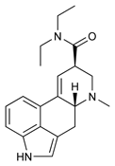

LSD tabs LSD
Dependence, tolerance and withdrawal: LSD does not cause physical dependence, however, psychological dependence can occur in some people. Tolerance can develop rapidly and dissipate equally rapidly without withdrawal symptoms or craving.

Ketamine
Induces effects similar to those of PCP (phenylcyclidine) -produces ‘dissociative’ anesthesia - catatonia (no talking or reacting), amnesia, analgesia; hallucinations and vivid dreams; emergence delirium. Price is ~£20/g. Rarely used in humans - has serious abuse potential. It stimulates the cardiovascular system, therefore good for emergency patients in shock. Chronic abuse can cause irreversible bladder damage. Blocks NMDAR-type glutamate channels at the ‘PCP site’ in use-dependent manner; also inhibits nAChRs and Na⁺ channels.

In small doses, ketamine has been used for the treatment of neuropathic pain and also for some chronic pain syndromes.
More recently, in sub-anaesthetic i/v doses, it has been found to exhibit rapid-onset antidepressant effects (within a few hours/days), therefore has been found useful in patients with treatment-resistant bipolar depression.

A new drug esketamine (Spravato) related to ketamine, was recently approved by the US FDA for the rapid treatment of depression in people unresponsive to traditional antidepressants (e.g. SSRIs: Prozac). The effects would be felt within hours or days, not weeks like traditional depression treatments.
To avoid potential abuse, esketamine (nasal spray) will have to be administered in an approved clinic, and patients will be required to stay there for at least two hours, twice a week (with possible boosters), and not to drive until after a night of rest. Cost is $4,720 - $6,785 per month!

5-MeO-DMT
A “new” psychedelic mind-altering drug is becoming popular in the USA – toad venom. It is comparable in its effects to LSD, psilocybin and mescaline, but far more potent and quicker acting. The drug comes from a rare species of Colorado river toad, Bufo alvarius, which produces a toxic venom containing 5-MeO-DMT (5-methoxy-N,N-dimethyltryptamine or O-methyl-bufotenin): an extremely potent natural psychedelic. 5-MeO-DMT is about 4-6 times more powerful than DMT (dimethyltryptamine|: see below) contained in the Amazonian psychedelic brew Ayahuasca. This nocturnal toad grows up to 7 inches in length and has dark leathery skin. It is found in Mexico and in the United States in Colorado, California, New Mexico, and Arizona.
The drug is extracted from the toad’s venom glands and then dried into a dust which is then smoked; users experience an intense trip that starts within 10-30 seconds and lasts for ~30-60 minutes during which time, vision, and sound become distorted. Users say the experience is “indescribable”: a greater feeling of awareness, being connected to “God” or feeling reborn. After the trip, users are left with an altered mood and perception, with some even making major life changes because of their new outlook. Some believe that experiencing a 5-MeO-DMT trip can cure their depression, anxiety and post-traumatic stress disorder (PTSD). Some users however, are rendered immobile and unresponsive, and can suffer intense emotional reactions, euphoria, convulsions, and vomiting. Nevertheless, some medical researchers see the use of psychedelics such as 5-MeO-DMT as gaining in popularity as another vital mental health tool. Its short duration of action may be advantageous for clinical interventions and for studying mystical-type experiences.


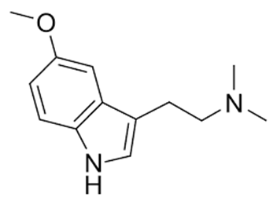

The Bufo alvarius toad, which secretes 5-MeO-DMT. 5-MeO-DMT

The drug has long been ingested by licking the poisonous amphibian’s back (dangerous, as the venom is toxic!) but is now more commonly consumed as a smokable “dust” (~50 mg/dose). The liquid is extracted by milking the toad’s toxic venom glands and then dehydrating it into a crumbly dry paste.

In the USA it is a Schedule 1 classified substance, carrying a 10-year prison sentence for possession. Users generally hire Shamans or “facilitators” to distribute the drug at parties ($200 to $500 a head). Toad venom however, is not really a recreational drug and smoking it (alone or otherwise) is risky and potentially dangerous.

Barsuglia, J et al (2018). Intensity of Mystical Experiences Occasioned by 5-MeO-DMT and Comparison With a Prior Psilocybin Study. Front. Psychol., https://doi.org/10.3389/fpsyg.2018.02459

DMT
N, N-dimethyltryptamine (DMT) itself is also considered an endogenous hallucinogen, since there is evidence that it is synthesised and metabolised in the brain and peripheral tissues, and it has been suggested that it may have possible physiological and therapeutic roles, as well as being a putative neurotransmitter. Interestingly, raised levels of DMT in CSF and urine have been detected in some cases of schizophrenia, suggesting that it may be a neuroregulatory agent which is responsive to stress or emotional reactions. It has even been speculated that DMT may play a role in events such as mystical states and near-death experiences as well as natural dreams. See: Barker SA. (2018). N, N-Dimethyltryptamine (DMT), an Endogenous Hallucinogen: Past, Present, and Future Research to Determine Its Role and Function. Front Neurosci. 12:536.

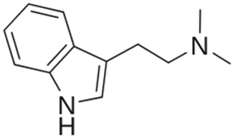

Ayahuasca brew DMT

Psychomotor stimulants: Cocaine and Amphetamine
Psychomotor stimulants produce effects similar to those produced by the sympathetic nervous system (sympathomimetics) - they increase heart rate and blood pressure, dilate the pupils and increase cortical and physiological arousal and behavioural excitement.

Cocaine is extracted from the leaves of the shrub Erythroxylum coca from Peru, Colombia and Bolivia. Coca leaves were chewed by South American Indians to produce psychoactive effects and to improve stamina. Cocaine was first isolated from the leaves in 1859. Cocaine is a white powdery crystal (hydrochloride); the pure freebase form of cocaine is called crack (so named because of the "crackling" sound it makes when smoked). Street prices vary from about £30-£60 per gram.

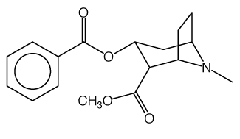
Leaves of the Coca plant Cocaine

In the 19th and early 20th Century Europe, cocaine was widely used by the wealthy and by academics to increase work rate and creativity and to suppress the appetite. In the US, cocaine was a component of Coca-Cola until it was classified as an illegal drug in 1914. Cocaine use is now on the increase, particularly in the young. It was once used clinically as a topical local anaesthetic for eye and minor nose and throat operations, but is now little used.

Routes of administration: ‘Snorting’ is the most common route of administration of cocaine. The powder is drawn up into the nose, and is absorbed through the nasal epithelium into the blood. It reaches the brain within about three minutes.
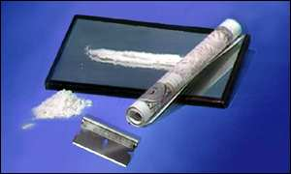
Snorting a ‘line’ of cocaine is the preferred mode of administration.
Cocaine hydrochloride is water soluble, therefore can be administered i.v. using a syringe, reaching the brain in ~ 15s, the effects lasting for about 15 min. Crack cocaine is smoked in a pipe, being absorbed rapidly in the lungs, then reaching the brain in about 5s, to produce a fast but shorter-lived “rush” of pleasure. Chronic use can lead to a perforated nasal septum, and injecting can lead to HIV, hepatitis and other blood borne infections if needles are shared.
It is claimed (Jan 2010) that every British banknote in circulation is contaminated by cocaine within weeks of entering circulation, indicating the spread of cocaine use in the UK.
Effects of Cocaine: Cocaine exerts its central effects by inhibiting the reuptake of noradrenaline, dopamine, and 5-HT into presynaptic terminals of the mesolimbic reward/pleasure pathway. Peripherally, it exerts sympathomimetic effects by blocking noradrenaline uptake into sympathetic terminals, and also exerts local anaesthetic effects by blocking axonal Na⁺ channels.

The pleasurable (but short-lived) effects of cocaine include: euphoria, increased self-confidence, sociability, energy and alertness, often followed by intense depression, irritability, exhaustion, and a craving for more of the drug, particularly in chronic and high dose users.

Other physiological effects include: tachycardia, ↑BP, pupil dilation, increased respiration rate, increased body temperature and local anaesthesia. After high dosage, tremors and seizures may result. Acute toxic effects include cardiac arrhythmias, stroke, heart attack and intracerebral haemorrhage.

Dependence, tolerance and withdrawal: Unlike heroin, cocaine does not produce a clear-cut physiological dependence syndrome, and the discontinuation of chronic cocaine use does not produce severe physical withdrawal symptoms (c.f. heroin and alcohol). There is however, a strong psychological dependence (craving, compulsive behaviour). Motor performance and learned behaviour may also be impaired. Over short periods, some physiological tolerance to cocaine can develop, whereas longer term, intermittent administration can lead to sensitization.

Amphetamine
Amphetamine (“speed”) is a synthetic compound, originally developed as an appetite suppressant and to fight fatigue and increase alertness among servicemen, but its general use became banned in 1959. Dexamphetamine is a potent analogue of amphetamine still used to treat narcolepsy and hyperactivity states (ADHD) in children (paradoxically!) (see also non-amphetamine derivative Methylphenidate (Ritalin)).
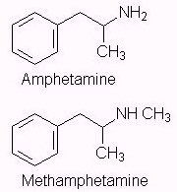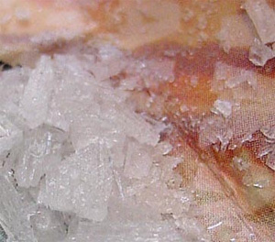

“Crystal meth” (methamphetamine)

Methamphetamine (“meth”, “ice”, “crystal”) is a very addictive stimulant, related to amphetamine, with more longer-lasting and toxic effects on the CNS. It has a high potential for abuse.
`
Routes of administration: Street amphetamine tends to be of low quality (~5-20% pure). Like cocaine, amphetamine (sulphate) can be administered orally, nasally, and i.v., the latter producing the most rapid and intense “high”. Some users mix amphetamine with heroin (speedballs). Amphetamine itself is not very effective if smoked (with tobacco). The powder sells at about £13 a gram. “Crystal meth” is a crystalline, smokable form of methamphetamine that is becoming increasingly popular, alongside alcohol and cannabis as a readily available drug of abuse.

Effects of Amphetamine: Amphetamine is an indirectly acting sympathomimetic amine; it enters neurones and acts presynaptically to release stores of noradrenaline, and dopamine from nerve endings; it also blocks noradrenaline and dopamine transporter reuptake and inhibits MAO.

Short term psychological effects of amphetamine include: euphoria, increased alertness, confidence and concentration, rapid talking, and hallucinations. Chronic use can cause insomnia, aggressiveness, irritability, confusion, panic or even delusions and paranoia (‘amphetamine psychosis’). Physiological effects include decreased appetite, increased stamina and physical energy (reduced fatigue-hence abuse by athletes), tachycardia, sweating, ↑BP and respiratory rate and tremor. Fatigue and depression can often follow amphetamine use.

Dependence, tolerance and withdrawal: As for cocaine, the mesolimbic dopamine system underlies the reinforcing effects of amphetamine. Strong psychological dependence can therefore develop with regular users (not as addictive as cocaine). There is no clear-cut physical dependence and withdrawal syndrome as with opiates, but mild withdrawal symptoms can include lethargy, poor concentration, hunger, anxiety, excessive sleep, and intense craving for the drug. Tolerance can develop rapidly to the euphoric, anorexic, and other physiological effects of amphetamine.

3,4-methylenedioxymethamphetamine (MDMA/Ecstasy)
MDMA (Ecstasy; ‘E’, Adam, Beans, Biscuit, Clarity, Disco Biscuit, Eve, Go, Hug Drug, Lover’s Speed, Peace, STP, X, XTC, Molly) is a synthetic psychoactive drug synthesized in 1912 as an appetite suppressant, that has both hallucinogenic and psychomotor stimulant amphetamine-like properties, now commonly used in dance clubs and all-night ‘raves’. It increases the activity of both 5-HT and dopamine neurones in the brain. At low doses, MDMA causes feelings of well-being, connection with others and heightened insight; effects can last 4-6 hours. Higher doses can produce severe anxiety, increases in heart rate and blood pressure, and hallucinogenic effects. MDMA can also interfere with body temperature regulation, producing hyperthermia, severe dehydration and possible liver, kidney, and cardiovascular system failure. Chronic use may also result in toxic damage to 5HT neurones, with ultimate depletion of 5HT in the brain and interference with memory function.
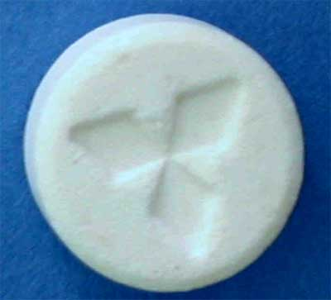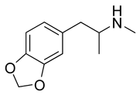
Ecstasy tablet MDMA

Ecstasy is usually taken in the form of tablets, each containing ~ 100 mg of MDMA, which can also be crushed and snorted or injected. Average price is ~£5 per tablet. Tablets may also contain e.g. ephedrine, caffeine or cocaine. Ecstasy overdose may result in tachycardia, ↑BP, faintness, muscle cramping, panic attacks, and possible loss of consciousness or seizures. Another unusual side effect is increased jaw muscle tension and involuntary teeth grinding.

Dependence, tolerance and withdrawal: Psychological dependence can develop with prolonged usage, though probably not physical dependence; withdrawal symptoms can include depression, anxiety, panic attacks, sleeplessness and paranoid delusions. Some tolerance following repeated usage can develop.

MDMA and Serotonin Syndrome
Serotonin syndrome (SS) - is a serious drug reaction, caused by medications that build up dangerously high levels of serotonin in the body- e.g., SS may occur if you take an antidepressant with a migraine medication. Symptoms include: mild (shivering and diarrhoea) to severe (muscle rigidity, arrhythmia, high fever and seizures)- could be fatal if not treated.
SS can also occur in people exposed to MDMA, who have also taken one or more substances with serotonergic properties e.g., amphetamines, cocaine, serotonin reuptake inhibitors (SSRIs) and opioids (some opioids- [tramadol, methadone]- inhibit the reuptake of serotonin by inhibiting SERT).

Ecstasy is still a dangerous drug to experiment with- In March 2017, four schoolgirls aged 13, were taken to hospital after "taking pink teddy bear ecstasy pills" in Manchester. MDMA, is also now sold in powder form, and is at its purest in years, (sometimes >80% purity): this means that pills sold nowadays can contain triple the typical dose found in the 80s or 90s. In 2021 there were 67 deaths linked to ecstasy in the UK; in 2022 there were 51.
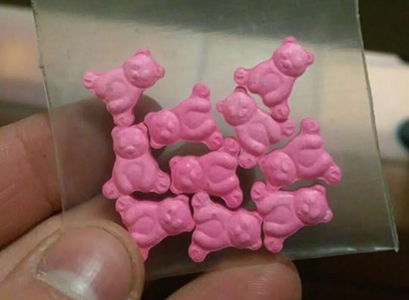

Tusi (Pink cocaine)- A new drug concoction called tusi has emerged in Latin America and in Europe and is now becoming popular in the US (~$100/g) as a euphoria-producing stimulant/hallucinogen. The concoction typically comes in the form of a nice smelling coloured pink powder containing MDMA mixed with ketamine, methamphetamine, opioids (fentanyl), caffeine, LSD and/or new designer psychoactive substances, 2C/2C-B. Snorting tusi is apparently quite painful; also taken as a pill, capsule or suppository! Can be extremely addictive/harmful- overdose can be fatal.
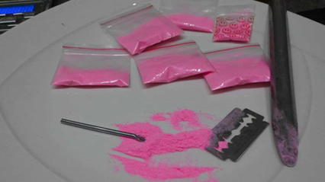

“Legal Highs” (now referred to as New Psychoactive Substances: NPS)
These are substances originally designed with stimulant or mood-altering properties to produce the same or similar effects to illegal drugs such as cocaine, ecstasy, cannabis or LSD. Up to May 2016, when the Psychoactive Substances Act 2016 came into effect, their sale or use was not banned by the current legislation regarding the misuse of drugs. Manufacturers therefore aimed to produce psychoactive substances that allowed them – and users – to evade the law, hence “Legal Highs”.
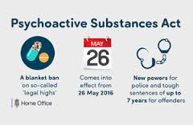

Psychoactive Substances Act 2016
The act applies across the UK and came into force on 26 May 2016. The act:
- makes it an offence to produce, supply, offer to supply, possess with intent to supply, possess on custodial premises, import or export psychoactive substances; that is, any substance intended for human consumption that is capable of producing a psychoactive effect. The maximum sentence will be 7 years’ imprisonment.

- excludes legitimate substances, such as food, alcohol, tobacco, nicotine, caffeine and medical products from the scope of the offence, as well as controlled drugs, which continue to be regulated by the Misuse of Drugs Act 1971.

New Psychoactive Substances
- Stimulant-type drugs- mimic substances such as amphetamine, cocaine and ecstasy: mephedrone, BZP, MPDV, NRG-1, benzo Fury, Gogaine (3-FPM), MDAI and ethylphenidate.

- Downers’/tranquiliser-type/sedative-type drugs - have inhibitory/relaxant effect on brain - mimic benzodiazepines/alcohol/opiates: etizolam, pyrazolam and flubromazepam, AH-7921.

- Hallucinogenic drugs - mimic substances like LSD-make users hallucinate, feel relaxed and happy or agitated and confused: 25i-NBOMe, bromo-dragonfly, BK-2CB, AMT, LSZ.

- Dissociative drugs - mimic substances such as PCP (phencyclidine) and ketamine – cause detachment, hallucinations: Methoxetamine (MXE), 2-MDP, 8A-PHQ.
- Synthetic cannabinoids - synthetic drugs that mimic Δ⁹-THC: Spice/K2, Clockwork Orange, Black Mamba, Annihilation, Mojo, Scooby Snax and Exodus Damnation.
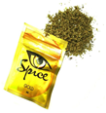
►Spice Gold/K2, one of the former so-called “legal highs”, is herbal smoking mixture, used as a cannabis substitute, which proved as powerful as some strains of strong ‘skunk’ cannabis. It was once freely available on the internet and specialist ‘head shops’ – and was originally banned in the UK (class B; Dec 2009). Now comes under the Psychoactive Substances Act 2016 which came into force in the UK on 26th May 2016.

►Cloud 9 vaping spice: “vaping” using an e-cigarette is now becoming a popular way to ingest a wide range of new synthetic drugs including synthetic cannabis sold as Cloud 9, Hookah Relax, Crown, Bizzarro, Shisha and Mad Hatter.

►Mephedrone (“meow meow”, “meph”, “drone”) is another former “ legal high”; it is a synthetic amphetamine-like stimulant (4-methyl-β-keto-N-methylamphetamine), related to the naturally occurring alkaloid (-)cathinone, that occurs naturally in the leaves of the “khat” (miraa) plant, found in East Africa. The leaves are chewed to produce an amphetamine-like euphoric effect. The pure synthetic mephedrone is a white powder that users either snort, swallow or inject (also found in capsules or tablets; 75-200 mg dose). It is reported to produce effects that are a cross between those of methamphetamine and MDMA → euphoria, stimulation, empathy. It was initially freely available on the internet, described as a “plant food” – and was banned in the UK (class B; April 2010), now also comes under the New Psychoactive Substances Act 2016.
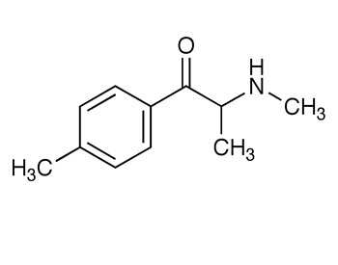
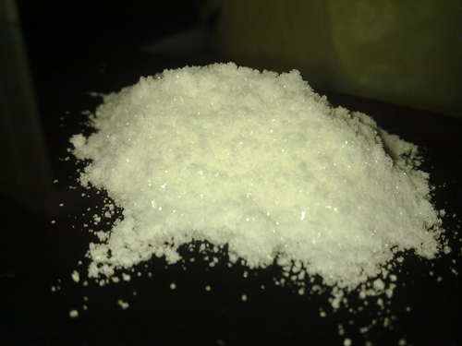
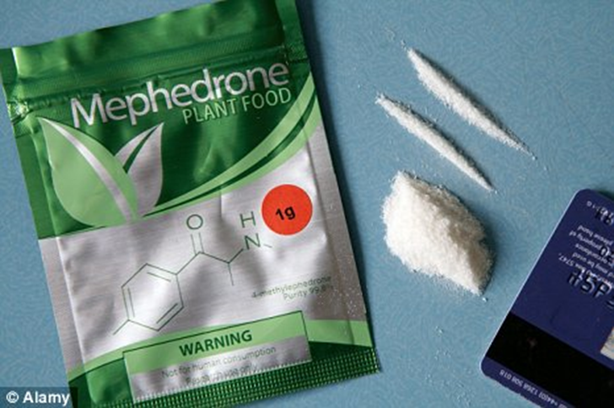
Mephedrone powder

REVIEW QUESTIONS
- What is the name of the main brain pathway involved in pleasure/reward? What are the two main brain nuclei and neurotransmitter involved?
- What plant does opium derive from?
- Opiates bind to three main types of receptor. What are they?
- Name two active opiates derived from opium.
- What is the chemical name for heroin?
- List the type of things that can be used to “cut” illegally-sold heroin.
- How is heroin usually administered by drug users?
- What would you regard as classic signs of an opiate overdose? What would be the antidote?
- What is fentanyl? How potent is it?
- What is the therapeutic principle of methadone replacement therapy for opiate addiction called?
- What is the main psychoactive constituent of Cannabis?
- What is the main mechanism by which endogenous cannabinoids are released? Name two examples of endocannabinoids.
- Name three cannabinoids that are licenced for use in medicine and the conditions they are used for.
- LSD is derived from which natural substance, found where? What receptors is LSD believed to interact with in the brain? What are “flashbacks”?
- What is ketamine? What was it originally designed to act as? Chronic ketamine abuse can irreversibly damage which part of the body? What brain receptors is it believed to interact with?
- Cocaine derives from which natural source?
- What is the mechanism by which cocaine produces its central euphoric effects?
- What was amphetamine originally used for medicinally? What is its mechanism of euphoric action in the brain?
- What is Ecstasy and what is its main mechanism of action in the brain?
- What is Tusi? What does it contain, what are its effects and how is it taken?
- What were “legal highs”? What are the main features of the new Psychoactive Substances act 2016? What are Spice Gold and Mephadrone? How dangerous are they? What “Legal highs” can be bought legally on the internet nowadays? What do they usually contain and how dangerous are they?
AC/Illegal Drugs of Abuse lecture 2025.doc/March 2025

