UCL SCHOOL OF PHARMACY

LECTURE: PLEASURE/REWARD/REINFORCEMENT PATHWAYS AND DRUG ADDICTION MECHANISMS
Introduction
Pleasure is a complex, subjective neurobiological phenomenon, which may be described as “a state or feeling of happiness and satisfaction resulting from an experience that one enjoys”. During the course of evolution, the survival of the human species has depended upon the development of so-called pleasure/reward pathways in the brain, which on activation [by touch, sight, smell, hunger, thirst etc] lead to strong emotional feelings of satisfaction and well-being. Basic essential survival activities such as eating, drinking, having sex and engaging in maternal behaviour or other social interactions, thus create pleasurable sensations which we learn to enjoy during life, and the evolution of central reward circuits has ensured that these pleasurable behaviours are repeated (positive feedback), to meet basic needs. Unfortunately, in some individuals, these pleasure/reward pathways function abnormally (anhedonia - either due to intrinsic pathological losses or chronic ingestion of psychoactive drugs of abuse which are capable of directly acting on reward pathways), resulting in serious emotional disorders associated with negative adverse behaviour such as depression, schizophrenia or drug addiction [see below].

Pleasure/reward/reinforcement circuits in the brain
At the heart of this central reward circuit is the ventral tegmental area (VTA) of the midbrain [an evolutionarily primitive brain area lying close to the substantia nigra - along with its various complex neural inputs and outputs], and the nucleus accumbens (NAcb) – forming part of the mesolimbic system; the principal neurotransmitter connection between these two areas involves dopamine-releasing neurones (A10 dopamine cells) running in the ascending mesolimbic dopamine pathway; dopaminergic axons also project from the VTA to the amygdala, hippocampus, septum, prefrontal cortex, bed nucleus of stria terminalis (BNST) [involved more in negative reinforcement mechanisms] and lateral hypothalamus. A descending medial forebrain bundle of myelinated fibres running though the lateral hypothalamus, connects the NAcb to the VTA. The VTA and NAcb also receive strong glutamatergic inputs from the prefrontal cortex, amygdala and hippocampus. Endogenous endorphins and endocannabinoids also influence the VTA dopamine neurones.
[It should however, be noted that there still remains a considerable debate about the precise role of dopamine in reward processes (see reviews by Berridge & Kringelbach, 2008); also there is evidence that the NAcb may also be involved in aversive states – see Carlezon & Thomas, 2009].
It is now well recognized that various psychoactive drug dependencies (e.g. opiates, cocaine, amphetamines, nicotine, alcohol, cannabis, phencyclidine, ecstasy) also produce their pleasurable effects by (over)stimulating these natural pleasure circuits directly, releasing dopamine (or increasing extracellular dopamine levels) in the NAcb (acting on dopamine D2-type [inhibitory] and D1 [excitatory] receptors) and thereby generating a long-lasting positive reinforcement effect that motivates the individual to repeat the pleasurable experience, and so begin the deleterious cycle of events that leads to persistent drug-seeking behaviour and dependency. Recent research suggests that the phenomenon of synaptic neuroplasticity, which is believed to underlie the process of learning and memory, is significantly modified by drugs of abuse and may therefore contribute to the eventual development of addiction. Finding new drugs that could directly target these drug-induced changes in the brain reward circuits could offer a novel means of treating and preventing drug addiction, and possibly other mood disorders.
[It is also suggested that the placebo response experienced by some individuals, after taking medication containing no active principle, in the belief that a beneficial effect will result, also induces pleasure phenomena and subjective feelings of well-being involving stimulation of the reward circuitry].
The reward pathway also connects with several other important brain areas, to allow the gathering of sensory information from surroundings, to reinforce the brain circuits that control desirable/beneficial behavior. Connection is also made with brain regions involved in memory storage, so that memory of a pleasurable stimulus (e.g. eating food) making you feel good is retained for future reference. This increases the likelihood that the pleasurable stimulus will be repeated.
For optimal emotional, mental and physical function, we need a certain amount of pleasure and rewards from our daily activities, otherwise a pleasure/reward deficiency is created which could ultimately lead to depression, anxiety and poor performance.
It is now believed that when drugs of abuse induce their positive reinforcing effects, a counter-regulatory mechanism is also initiated (including upregulation of brain stress systems) that decreases mood, in an attempt to maintain ‘emotional homeostasis’. After repeated cycles of intoxication and withdrawal, the opposing processes predominate so that on withdrawal, negative emotional symptoms and enhanced stress responses emerge.
Other important dopaminergic pathways in the brain:
Nigrostriatal pathway (arising in the complex part of the substantia nigra to the striatum - important for motor control; death of SN neurones results in Parkinson’s disease.

The mesocortical pathway projects from the VTA to sensory (e.g. visual), motor, limbic and prefrontal association cortices – thought to be involved in motivation and emotional response; dysfunction of this pathway can cause hallucinations and schizophrenia.

Tuberoinfundibular pathway runs from hypothalamus to anterior pituitary gland; involved in hormonal regulation of milk production, maternal behaviour and pregnancy.

Reward circuit identified by direct electrical brain stimulation
Both human and animal brains are known to have similar hard-wired pleasure/reward/reinforcement pathways. Since reward pathways are also activated strongly by various drugs of abuse in animals, many animal drug addiction models have been established over the years. In recent years, transgenic animal models have also been introduced (e.g. monoamine transporter knockouts) in order to better understand the target sites for drugs such as morphine, cocaine and amphetamine.

The critical involvement of the NAcb in mammalian pleasure/reward mechanisms was first demonstrated in 1954 by the classic experiments of Olds & Milner, who chronically implanted stimulating electrodes in the NAcb of a rat’s brain, and the rat was then trained to press a lever in the cage. On pressing the lever, a brief stimulus was delivered to the NAcb, which presumably released local dopamine causing a pleasurable effect in the animal. The lever pressing thus provided a measure of the motivation to obtain the drug. In due course, the rat learnt to stimulate itself repeatedly (>6,000 times per hour), in order to receive the pleasurable effect, with a clear lack of satiation. It did this to the exclusion of other basic activities like eating, drinking or sex. The rats eventually passed out from hunger or exhaustion. This type of endless reward-seeking activity is essentially what is happening in an individual suffering from a drug addiction.
Comparable electrical brain stimulation of reward pathways in humans (although ethically limited) has also been found to produce intensely pleasurable effects, akin to intense sexual orgasm. It is this type of ‘high’ that is compulsively sought after by individuals abusing drugs.
Another effective means of studying brain reward systems in animals is to use either systemic or intracranial administration of certain addictive reinforcing drugs (e.g., amphetamine, cocaine, opiates) through surgically implanted catheters. Animals are trained to press a lever to obtain various i/v or intracranial drug rewards, in a similar manner to electrical stimulation. This provides another useful experimental animal model of human compulsive drug-taking behaviour.
Subsequent abstinence from reinforcing drugs like cocaine or morphine after repeated administration has been shown to decrease dopamine levels in the brain reward system; a similar decrease in dopamine function in humans may well be related to the intense craving associated with drug withdrawal.
Other neural pathways and neurotransmitters involved in pleasure/reward system
Although the VTA and NAcb are fundamental components of the basic brain reward circuitry, other brain areas and neurotransmitters also have an important function e.g. the ventral pallidum, parabrachial nucleus, thalamus and limbic areas: amygdala, hippocampus and olfactory tubercle. The brainstem pedunculopontine nucleus (PPT), raphe nucleus (5HT system) and locus coeruleus (noradrenaline system) also regulate the reward circuit. Other neurotransmitters include: GABA, glutamate, acetylcholine and endogenous opioid peptides.
The ascending mesolimbic dopaminergic pathway consists of the VTA in the ventral portion of the midbrain (contains mainly dopamine [A10 group] – but also inhibitory GABA and excitatory glutamate-releasing neurones).
NAcb –ventral part of striatum in the basal forebrain (contains medium spiny GABAergic neurones also cholinergic, enkephalinergic and dynophinergic neurones). A limbic-motor interface. Effects of dopamine here are mediated by D2-like receptors, which appear to play a major role in encoding reward. Electrophysiologically, dopamine produces a transient decrease in the firing of NAcb neurones, and this decreased activity is related to reward. In contrast, an increased activity of NAcb neurones encodes information about aversive stimuli. A decreased number of dopamine D2 receptors are also found in chronic drug addicts, which could contribute to the eventual decreased response to natural rewards and engage the addiction cycle.
Amygdala (in temporal lobe – associated with emotions – fear/anxiety; emotional coding of environmental stimuli); Hippocampus (in medial temporal lobe – associated with memory function).
Associated cortical areas also have an important processing/memory storage function: Prefrontal cortex – sensory integration of stimuli, emotional processing and hedonic experience; orbitofrontal (insular), and anterior cingulate cortex – pleasure coding, learning/memory.
Interestingly, whereas successful behaviours increase the activity of the mesolimbic system, unsuccessful behaviours have the opposite effect, thought to be mediated via connections from the lateral habenular complex (LHb). Accordingly, electrical stimulation of the LHb in animals blocks neuronal activity in the VTA.
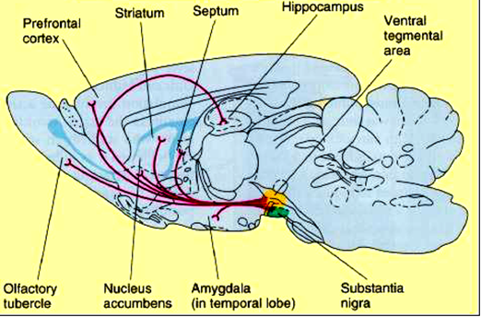

Mechanisms of addiction
Drug addiction (dependence) may be defined as “the complex series of behaviours that start with casual/recreational use of a drug and ultimately lead to compulsive drug taking (craving), loss of control over drug intake, tolerance, withdrawal, and continued use despite adverse consequences”. Addiction thus represents a loss of control over pleasurable and biologically useful events, and a gradual move over to behavioural abnormalites that can persist well after drug use is discontinued [motivational toxicity].

The mechanisms by which various drugs of abuse artificially modulate the mesolimbic dopamine signal are complex as are the processes involved in the progression from initial (casual) drug-taking to overt addiction.

Craving – this could be a consequence of deteriorated dopamine function in the reward pathway: repeated use of drugs may eventually deplete dopamine stores in the mesolimbic reward circuitry leading to the intense craving effect. So initially –casual/incidental drug use leads to increased dopamine and increased pleasure; over time – the reward function collapses and decreased dopamine levels result leading to depression + other negative affective states.

Evidence form human studies and animal models of addiction have also revealed enduring adaptations in excitatory glutamate transmission in the projection from the prefrontal cortex to the NAcb, associated with the processes of craving and relapse.

Repeated use of drugs that affect the reward system will inevitably lead to tolerance – more of the drug being required to produce the same effect. This may be a reflection of a moving ‘set-point’ level for neurotransmitter release/receptor sensitivity in the reward circuitry, so that prolonged exposure to a psychoactive compound will cause a semi-permanent adjustment of the reactivity of the circuit to a different higher homeostatic level.

A second indication of addiction is withdrawal – a manifestation of physical changes in the brain in response to prolonged drug exposure [change in brain equilibrium – metabolism, receptor availability/sensitivity, gene expression, responses to environmental stimuli - a form of drug-induced neural plasticity.]; morphological changes are also apparent – [VTA neurones are smaller in brains of chronic addicts]. At this point, addicts are not abusing drugs to create pleasure, but to prevent painful/uncomfortable side effects of not using them. The expression of withdrawal symptoms reflects the fact that the brain equilibrium takes times to readjust back to pre-addiction level and perhaps in some individuals, ‘normality’ may never be fully achieved.

How do drugs of abuse act?

Opiates (morphine, heroin [+ endorphins]) and cannabis (tetrahydrocannabinol [Δ⁹-THC] [+ endocannabinoids]), act on μ-opioid and CB₁ receptors respectively, located on local GABAergic interneurones in the VTA. When μ-opioid receptors are activated, the interneurones are hyperpolarized through activation of so-called GIRK (G protein-coupled inwardly-rectifying potassium) channels in the cell membrane, while activation of presynaptic CB₁ receptors inhibits GABA release through inhibition of presynaptic Ca²⁺ channels; the VTA dopaminergic projection neurones are therefore indirectly disinhibited, so their excitability increases and more dopamine is released in the NAcb. Activation of μ-opioid and CB₁ receptors on GABAergic neurones in the NAcb accumbens can also cause some local disinhibition at the dopaminergic nerve terminals.

Amphetamines and cocaine amplify the mesolimbic dopamine signal through different mechanisms. Cocaine increases extracellular dopamine levels in the NAcb by blocking the presynaptic dopamine transporter (DAT). Amphetamines act indirectly in the NAcb by releasing dopamine from presynaptic terminals.

The positive reinforcing effects of nicotine are also believed to be due to activation of the mesolimbic dopamine projection, acting via cholinergic nAChRs located somatodendritically on dopaminergic VTA neurones to increase their firing rate and to release dopamine directly. The normal cholinergic input to the VTA derives from the pedunculopontine tegmental nucleus (PPT). Chronic nicotine use unusually increases the number of neuronal nAChRs in humans, possibly because nAChRs rapidly pass into desensitized, then long-term inactivated states following prolonged activation.

Alcohol (ethanol) also affects the mesolimbic pathway to ultimately release dopamine in the NAcb, but its mechanism of action is more complex: Alcohol has 8 principal molecular targets in the brain (concentration dependent):

- GABA_{A} receptor (+ve allosteric modulation)
- NMDA receptor (-ve allosteric modulation)
- Glycine receptor (+ve and –ve allosteric modulation)
- AMPA/kainite (glutamate)receptor(-ve allosteric modulation)
- nACh receptor (+ve and –ve allosteric modulation)
- 5-HT3 receptor (+ve allosteric modulation)
- L-type Ca²⁺ channel blocker
- GIRK (K⁺) channel opener

By facilitating GABA_{A}R function directly, it inhibits GABAergic interneurone transmission in the VTA thereby dis-inhibiting (i.e. exciting) VTA neurones. It also inhibits glutamate inputs from the cortex to the NAcb most likely through inhibition of NMDA receptors.

It has also been suggested that it activates a neuronal loop in the NAcb involving anterior VTA nAChRs, which then increases the firing rate of dopaminergic VTA neurones, and elevates dopamine levels in the NAcb [NAcb-anteriorVTA-NAcb].

Alcohol may also activate endogenous opioid and endocannabinoid pathways converging on the NAcb.

Phencyclidine (PCP) and ketamine principally block NMDARs, but their effect to release dopamine in the NACb is mediated indirectly. PCP and ketamine activate the mesolimbic pathway through a mechanism in the prefrontal cortex. Due to blockade of NMDA receptors on local inhibitory GABA interneurones, this results in disinhibition of the local cortical circuit, thereby activating descending excitatory glutamate release in the VTA.
Ecstasy (MDMA) (being an amphetamine derivative) increases release of dopamine into the reward circuit by indirectly causing excitement of dopamine neurones in the VTA through 5HT receptors. 5HT neurones connect with the VTA from the raphe nucleus, and ecstasy ↑5HT release in the VTA directly by binding to the serotonin transporters, causing them to work in reverse, thereby releasing 5HT into the synapse and also by inhibiting reuptake. Ecstasy also releases dopamine (and 5HT) directly in the NAcb; over a long period, ecstasy damages 5HT terminals.

Central opioid receptors and addiction
It is now clear that although dopamine is a key neurotransmitter in the central pleasure/reward system, it is not the only neurotransmitter that is involved. In particular, the endogenous opioid system is believed to be significantly involved in the central processes of motivation and reward, and in the modulation of the reward circuits. Opioid receptors and peptides are abundantly expressed the reward pathways: VTA, nACb, PFC, hypothalamus and amygdala. Thus, it is considered likely that common opioid mechanisms may be involved in mediating the addictive properties of the various DOAs.

This therefore opens the possibility of the central endogenous opioid receptor system being a useful target for DOA addiction medication in the future. There is already some therapeutic benefit in using opioid receptor antagonists e.g. naltrexone and nalmefene in the management of not only opiate addiction per se, but also in reducing craving in alcohol addicts that drink more than 7.5 units a day.
See: http://www.dailymail.co.uk/health/article-2849801/The-pill-help-stop-drinking-Treatment-reduces-urge-alcohol-available-today-people-regularly-consume-7-5-units-day.html. What about possible use for other addictions?

Cocaine and amphetamine
With regard to cocaine (and amphetamine), there are conflicting experimental data relating chronic drug administration to long-lasting changes in endogenous opiate and opioid receptor levels in various reward system brain regions. Nevertheless, opiate receptor blockers (naloxone, naltrexone) have also been shown to block cocaine-induced reward in rodents, thus recruitment of endogenous opioid systems subsequent to cocaine administration may therefore be relevant to treatment of cocaine addiction. In limited clinical studies, the mixed partial agonist opiate buprenorphine or buprenorphine together with naltrexone has been shown to reduce cocaine use in addicts. A recent report also showed significant reduction in cocaine cravings in a human patient treated over 5 months with nalmefene. Naltrexone has also been shown to attenuate the craving for dexamphetamine in human subjects, suggesting similar common central opiate systems may be recruited. Reference: Grosshans, M. et al., (2015). Treatment of cocaine craving with as-needed nalmefene, a partial kappa opioid receptor agonist: first clinical experience. Int Clin Psychopharmacol. 30(4):237-238.

Alcohol
The experimental evidence for opiate system recruitment following acute or chronic alcohol administration is also controversial. An increase in dynorphin levels in the reward system has been clearly demonstrated after alcohol, in particular in the nACb and the amygdala. However, enkephalin and endorphin levels appear to serve a minor role in alcohol addiction. Variable effects are also seen on opiate receptor levels. Blockade of κ-opiate receptors in rats has been shown to reduce alcohol intake and re-enforcement. Therapeutically, naltrexone and nalmefene are now licenced on an ‘as-you-need’ basis for treatment of alcohol addiction, to reduce craving symptoms. Apparently though, their effects fade over time; thus, therapy is usually restricted to a period of ~6 months along with counselling (CBT). New opioid antagonists are also being investigated.

Nicotine
Smoking (nicotine) also induces changes in endogenous opioid systems. Accordingly, it has been shown experimentally that naloxone reduces nicotine self-administration in rodents. In experiments on genetically-modified mice lacking µ-opiate receptors, the rewarding effects of nicotine were attenuated. It thus seems that endogenous enkephalins and β- endorphins are required for nicotine’s rewarding effects. The high rate of smoking in heroin addicts also points to a commonality in the central addiction mechanisms for the two drugs. Interestingly, clinical trials with naloxone/naltrexone were not however conclusive on long-term smoking abstinence. Some positive data were however obtained when naltrexone was combined with standard NRT.

Cannabis
Although cannabis addiction is one of the most common forms of addiction across the word, a surprisingly few number of studies have been conducted on possible pharmacological treatments for cannabis addicts. Experimentally, there is some (though limited), evidence that endogenous opioids do play an important role in modulating the addictive properties of cannabinoids.
Reference: Fattore L et al., (2004). Cannabinoids and reward: interactions with the opioid system. Crit Rev Neurobiol. 16(1-2):147-158.
A study of 59 patients in Israel in 2011 found that naltrexone was surprisingly effective in reducing cannabis craving, compared with bupropion. Nevertheless, naltrexone or other opioid antagonists are not currently licenced for treatment of cannabis addiction.

Thus in conclusion, despite the variable experimental and clinical data, there is a distinct potential for the use of opioid ligands either alone or in combination with other existing therapies (together with counselling) in management of addictions to the common DOAs other than opiates; in particular, alcohol and nicotine. Their potential for managing addictions to other DOAs clearly needs further investigation.

Reference: Noble et al., (2015) .The opioid receptors as targets for drug abuse medication. Brit J Pharmacol., 172, 3964-3979.

Molecular mechanisms of addiction - altered gene expression
Chronic drug administration is linked in particular, to increased production of two nuclear transcription factors in the NAcb - CREB (cAMP response element-binding protein) and ΔFosB.

CREB is upregulated by an increase in i.c. cAMP and PKA activation (CREB phosphorylation at ser 133) [also CAMK IV and MAP kinase] – after CREB dimerization and movement to the nucleus (binding to DNA cAMP response element – CRE) it codes for proteins that suppress the reward circuit (e.g. upregulation of the opioid peptide dynorphin released from NAcb (GABAergic) projection neurones – causes inhibition of VTA neurones, acting via κ –opiate receptors on nerve terminals and cell bodies) and thus ultimately reduces the rewarding effects of drugs such as opiates or cocaine.

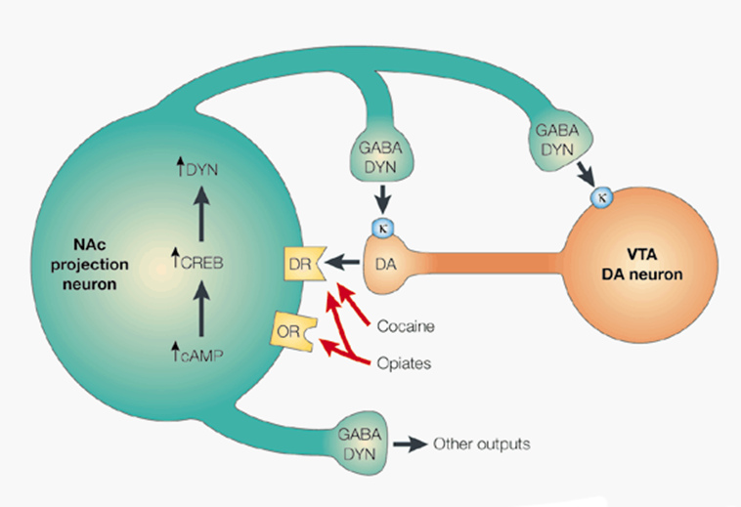

Upregulation of CREB protein by drugs of abuse or infusing a modified herpes simplex viral vector [HSV-CREB] into the brains of rats or mice - also contributes to depressive-like and aversive states.

Conversely, downregulation of CREB using a mutated vector [HSV-mCREB] has the opposite effect. CREB activation could thus contribute to the mechanism of tolerance induction. However, the activation of CREB is not long lasting, therefore unlikely to mediate more stable behavioural abnormalities of addiction. The function of CREB in other brain regions involved in addiction is currently less clear.

ΔFosB, a highly stable member of the Fos family of transcription factors, dimerizes with jun-D to form AP-1 (activator protein-1) which then reacts with AP-1 sites on DNA to alter transcription. It may be involved in more longer-lasting biochemical changes in the NAcb and dorsal striatum, persisting well after cessation of drug taking – development of a state of drug hypersensitivity and increased compulsion towards rewarding behaviour – thus easy relapse after period of abstention.

Elevated GluR1 and GluR2 expression (glutamatergic plasticity) in the NACb also occurs following repeated drug (morphine/cocaine) exposure – may be linked with drug hypersensitivity and ΔFosB upregulation [see review by Nestler, 2004]. Another possible target gene: Cdk5 (cyclin-dependent kinase) – involved in long-term morphological changes in NACb and PFC - increased number of dendritic spines –behavioural drug sensitization? Again, the behavioural consequences of ΔFosB upregulation in other brain regions is not clear.

Drugs of abuse also induce ERK (extracellular signal-regulated kinase) within the mesolimbic circuit, which is also involved in the regulation of many cellular processes of drug reward, particularly in structural remodeling of neuronal dendrites and spines (in the striatum).

Other proteins that have been associated experimentally with aspects of craving and relapse include – the cystine-glutamate exchanger, the activator of G protein signaling 3 (AGS3), and Homer (a synaptic scaffolding protein).

Effectiveness of deep brain stimulation (DBS) in treatment of addiction
It was reported back in the 80’s that high frequency electrical stimulation of the thalamus relieved tremors in Parkinson’s disease (PD) sufferers. In later years, DBS of the subthalamic nucleus (STN) was also identified as a useful target for treatment of advanced PD symptoms. Subsequently, DBS has gained in popularity for treating a range of other CNS disorders e.g. Tourette’s syndrome, OCD, epilepsy and also major drug-resistant depression. The discovery that DBS was useful also in treating addiction was accidentally made in some PD patients who were ‘addicted’ to their dopamine replacement therapies (L-dopa). DBS of the nucleus accumbens shell (NAcbs) was later shown to be effective in alcohol addiction and also reducing craving in nicotine, heroin and cocaine addicts respectively, with minimal associated side effects (although post-surgery bleeding sometimes occurred). DBS is therefore now preferred as a mode of treatment for chronic addiction compared to more acute methods such as direct stereotactic lesion of the NAcbs which is also effective, but is more risky and irreversible.

How is DBS applied in patients?
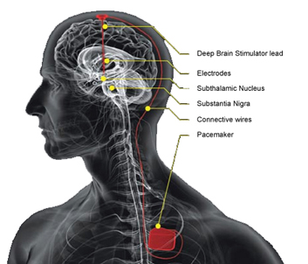
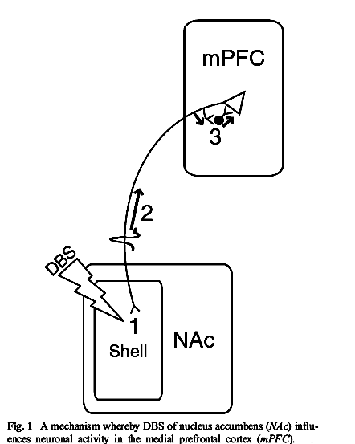Chronic DBS is usually applied through bilateral stereotactically-guided implantation of

fine stimulation electrodes ~1.3 mm in diameter into the brain of the patient under general anaesthesia; the electrode position can then be confirmed intra-operatively using X-rays and finally by postoperative CT-scans. Chronic stimulation is then commenced ~two weeks after surgery through a lead passed under the skin behind the ear and neck and connected to a pulse generator implanted under the skin below the collarbone or in the abdomen. Typical stimulation parameters are: frequency: 130 Hz, pulse width: ~60-90 µs, amplitude: ~3-5V for 3-52 weeks, and patient assessments of quality of life can be made 1, 6, and 12 months post-surgery.

Mechanism of action of DBS
Despite the increasing evidence of its effectiveness in these conditions, the underlying mechanism(s) involved in DBS remain uncertain. Based on rodent DBS experiments, it has been suggested that NAcbs stimulation antidromically activates GABA interneurons in the medial prefrontal cortex (mPFC) which then inhibit cortico-accumbal glutamatergic projection neurones; how this equates to a decrease in addiction however, is still unclear.

References
Adinoff, B. (2004). Neurobioogic processes in drug reward and addiction. Harv Rev Psychiatry 12(6) 305-320.

Berridge KC, Kringelbach ML (2008). Affective neuroscience of pleasure: reward in humans and animals. Psychopharmacology (Berl). 199(3):457-80.
Carlezon WA Jr, Thomas MJ (2009). Biological substrates of reward and aversion: a nucleus accumbens activity hypothesis. Neuropharmacology. 56 Suppl 1:122-32.
Chen BT, Hopf FW, Bonci A. (2010). Synaptic plasticity in the mesolimbic system: therapeutic implications for substance abuse. Ann N Y Acad Sci. 1187:129-39.

Esch T, Stefano GB (2004). Neuro Endocrinol Lett. 25(4):235-51. The neurobiology of pleasure, reward processes, addiction and their health implications.

Haber SN, Knutson B. (2010). The reward circuit: linking primate anatomy and human imaging. Neuropsychopharmacology. 35(1):4-26.

Kalivas PW (2004). Recent understanding in the mechanisms of addiction. Curr Psychiatry Rep. 6(5):347-51.

Nestler EJ (2004). Molecular mechanisms of drug addiction. Neuropharmacology.47 Suppl 1:24-32.

Nestler EJ (2008). Review. Transcriptional mechanisms of addiction: role of DeltaFosB. Philos Trans R Soc Lond B Biol Sci. 363(1507):3245-55.
Olds J, Milner P. (1954). Positive reinforcement produced by electrical stimulation of septal area and other regions of rat brain. J Comp Physiol Psychol. 47(6):419-27.
Pandey SC, Chartoff EH, Carlezon WA Jr, Zou J, Zhang H, Kreibich AS, Blendy JA, Crews FT (2005). CREB gene transcription factors: role in molecular mechanisms of alcohol and drug addiction. Alcohol Clin Exp Res. 29(2):176-84.

Russo SJ, Dietz DM, Dumitriu D, Morrison JH, Malenka RC, Nestler EJ (2010). The addicted synapse: mechanisms of synaptic and structural plasticity in nucleus accumbens. Trends Neurosci. 33(6):267-276.

Addiction and reward circuit:
http://serendip.brynmawr.edu/bb/neuro/neuro00/web3/Webster.html
The rewarding system:
http://www.druglibrary.org/schaffer/heroin/ase/chap_4.htm

Deep Brain Stimulation:
Vassoler FM et al., (2013). Deep brain stimulation of the nucleus accumbens shell attenuates cocaine reinstatement through local and antidromic activation. J. Neurosci. 33(36):14446-54.

Pierce RC1, Vassoler FM. (2013). Deep brain stimulation for the treatment of addiction: basic and clinical studies and potential mechanisms of action. Psychopharmacology (Berl). 229(3):487-91.

AC/Pleasure reward pathways and addiction lecture 2025.doc/March 2025

