Structuring a 3 presentation effectively involves organizing your content into a clear and concise format. Here's a simple structure to follow:

### **1. Introduction (30 seconds)**

* **Greeting and Introduction:**
  + Begin with a greeting and introduce yourself.
  + State the topic of your presentation clearly.
* **Hook:**
  + Capture the audience's attention with a relevant fact, quote, or question.
* **Purpose:**
  + Explain why the topic is important or relevant to the audience.

### **2. Main Body (2 minutes)**

* **Key Point 1:**
  + Present your first main point.
  + Provide supporting details or examples.
* **Key Point 2:**
  + Present your second main point.
  + Provide supporting details or examples.
* **Key Point 3:**
  + Present your third main point (if time permits).
  + Provide supporting details or examples.

### **3. Conclusion (30 seconds)**

* **Summary:**
  + Summarize the main points you covered.
* **Restate Importance:**
  + Reinforce why the topic is significant.
* **Closing:**
  + End with a strong closing statement, a call to action, or a thought-provoking remark.
  + Thank the audience for their attention.

Presentation Preparation Sheet

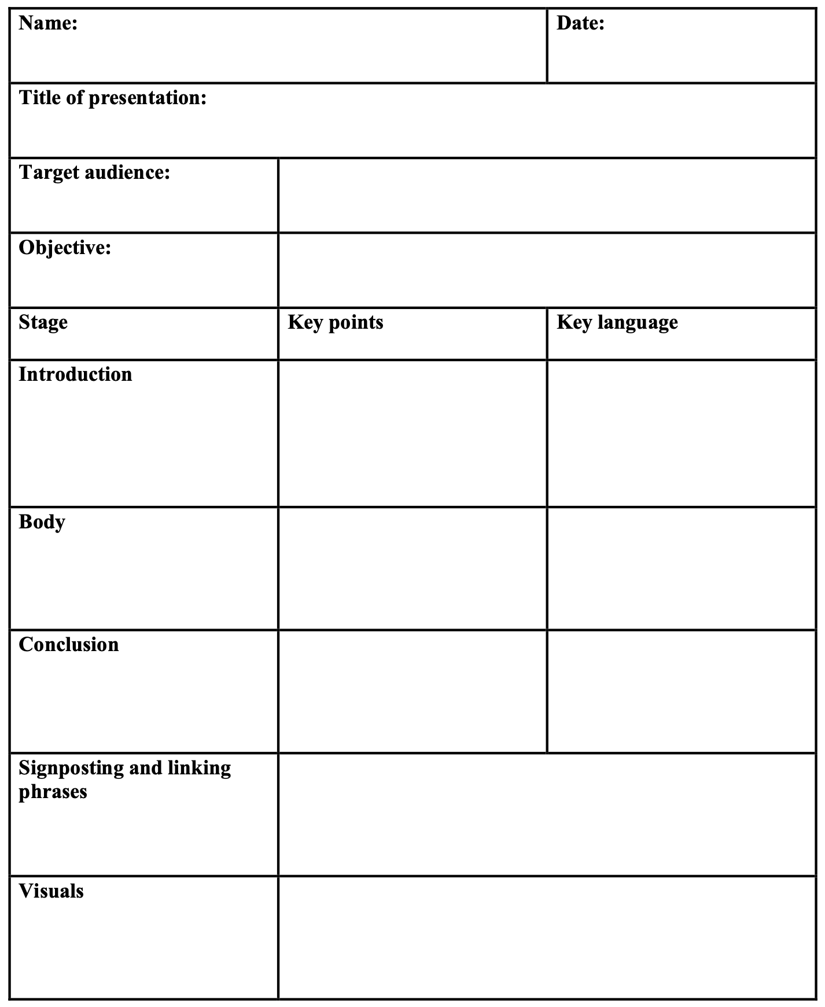

**Language for presentations**

***Introducing yourself***

Good morning, everyone.

Let me introduce myself. My name is…

I’m a specialist in…

***Objective/purpose***

I’m going totalk about ...

present ...

give you an overview of ...

inform you about ...

The subject of my presentation/paper/speech is ...

***Length***

I’ll take about ... minutes of your time.

I plan to be brief. I’ll only take ... minutes of your time.

This should only last/take ... minutes.

My presentation will take/last…

(about/roughly) ... minutes.

***Outline/overview***

Let me give you an idea of what I’m going to talk about....

I’ll be speaking about these/the following main points ...

My presentation will focus specifically on ...

***Questions during presentation***

I’d be glad to take your questions while I’m speaking/

at the end.

Please ask questions and comments at the end of the

presentation.

Please interrupt/stop me if something isn’t clear/you need

clarification.

***Structuring the presentation***

I’m going to divide my talk into four parts.

First, I’ll give you; after that;

To start with, / then, I'd like to consider…

First of all, I'd like to look at…

Finally, …

***Giving background information***

I’ll give you some background information.

Let s start with the background.

***Referring to existing knowledge***

As you know, …

As you are aware, …

As you may be aware, …

***Finishing a point***

Those are the main points on…

That’s all I have to say about…

Now we've looked at/dealt with…

***Starting a new point***

Now let’s turn to/move on to…

I'd like now to consider/examine…

Next, we come to…

Turning now to…

The next point I’d like to make is…

That brings me to…

***Referring to what you have said***

As I said at the beginning, …

I told you a few minutes ago that…

In the first part of my talk, I said…

As I mentioned earlier, …

***Referring to what you will say***

I’ll come to that later.

I’ll return to this point in a few minutes.

I’ll talk about this in the next part of my presentation.

***Referring to visuals*** If you look at the graph, …

Could I draw your attention to the figures/chart/graph?

If you take a look at the figures in chart one,

you'll see…

I’d like you to look at this, …

***Concluding***

To sum up, …

So, to summarise, …

So now I’d just like to summarise the main points.

That concludes my talk.

I think that covers most of the points.

To conclude/wrap up/summarise, I've just described ...

I'll just recap on the highlights of this presentation.

As you can see ...

Briefly ...

Thanks for your attention.

***Inviting questions***

If you have any questions, don’t hesitate to ask.

I’ll be glad to answer any questions (at the end of my talk).

Does anyone have any questions?

Any questions?

***Responding to comments/questions***

That's an interesting comment. Let me say that ...

I'd be glad to clarify that point ...

Thanks for your query. I'll have to check on that and get back

to you.

I'll be interested in finding out more about this ...

### **Example Outline**

**Introduction:**

* "Good afternoon, everyone. My name is [Your Name], and today I will be talking about the importance of renewable energy."
* "Did you know that renewable energy sources could power the entire world by 2050? This fact highlights the potential and necessity of transitioning to renewable energy."
* "Understanding renewable energy is crucial for addressing climate change and ensuring a sustainable future."

**Main Body:**

* **Key Point 1: Types of Renewable Energy**
  + "Firstly, let's look at the different types of renewable energy: solar, wind, hydro, and geothermal."
  + "Solar energy is harnessed from the sun, wind energy from wind turbines, hydro energy from water flow, and geothermal energy from the Earth's heat."
* **Key Point 2: Benefits of Renewable Energy**
  + "Secondly, renewable energy sources are environmentally friendly. They produce little to no greenhouse gases, reducing our carbon footprint."
  + "Additionally, renewable energy is sustainable. Unlike fossil fuels, it won't run out as long as the sun shines and the wind blows."
* **Key Point 3: Challenges and Solutions**
  + "Lastly, there are challenges to renewable energy, such as the high initial cost and storage issues."
  + "However, technological advancements and government incentives are making renewable energy more accessible and affordable."

**Conclusion:**

* "In conclusion, renewable energy is essential for a sustainable future. We have explored the types, benefits, and challenges of renewable energy."
* "Embracing renewable energy is not just beneficial but necessary for combating climate change."
* "Thank you for your attention. I hope you found this presentation informative and inspiring."

<https://www.youtube.com/watch?v=pFCnys2iIkc>

[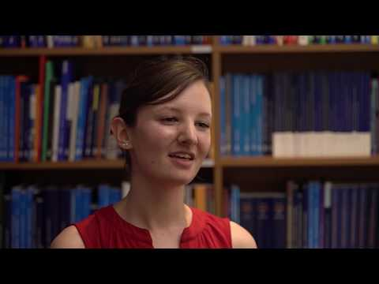](https://www.youtube.com/watch?v=pFCnys2iIkc)

<https://www.youtube.com/watch?v=Hp7Id3Yb9XQ>

[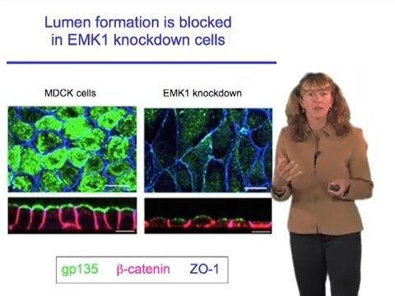](https://www.youtube.com/watch?v=Hp7Id3Yb9XQ)

<https://www.youtube.com/watch?v=VBzQrac6lUE>

[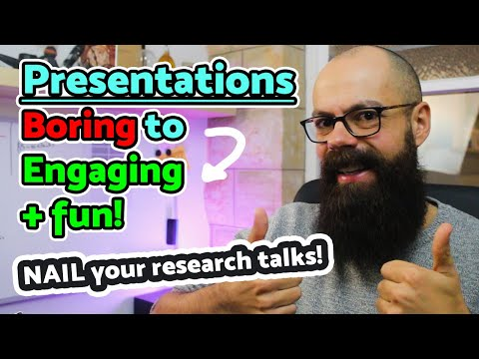](https://www.youtube.com/watch?v=VBzQrac6lUE)