LUCA The Last Universal Common Ancestor of all Life

Bath Royal Literary and Scientific Institut

https://www.science.org/content/article/our-last-common-ancestor-lived-4-2-billion-years-ago-perhaps-hundreds-millions-years

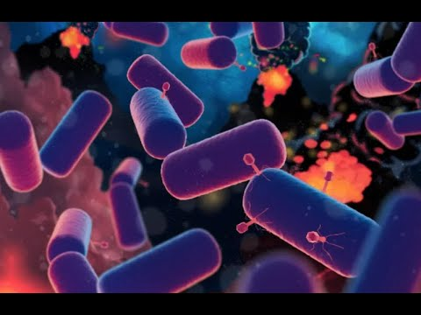
https://astrobiology.nasa.gov/news/looking-for-luca-the-last-universal-common-ancestor/

