Ricette su carta semplice
Gruppo no.___
Studente 1: ________________________________
Studente 2: ________________________________
Studente 3: ________________________________
Studente 4: ________________________________
Studente 5: ________________________________

ESERCIZIO FS2
Considerate queste ricette come presentate in farmacia da un paziente.
Caratterizzare ciascuna delle ricette come “nota paziente”, RR o RNR. Inoltre, Indicare se le seguenti ricette risultano spedibili o meno, indicando per ciascuna ricatta l’eventuale/i errore/i.

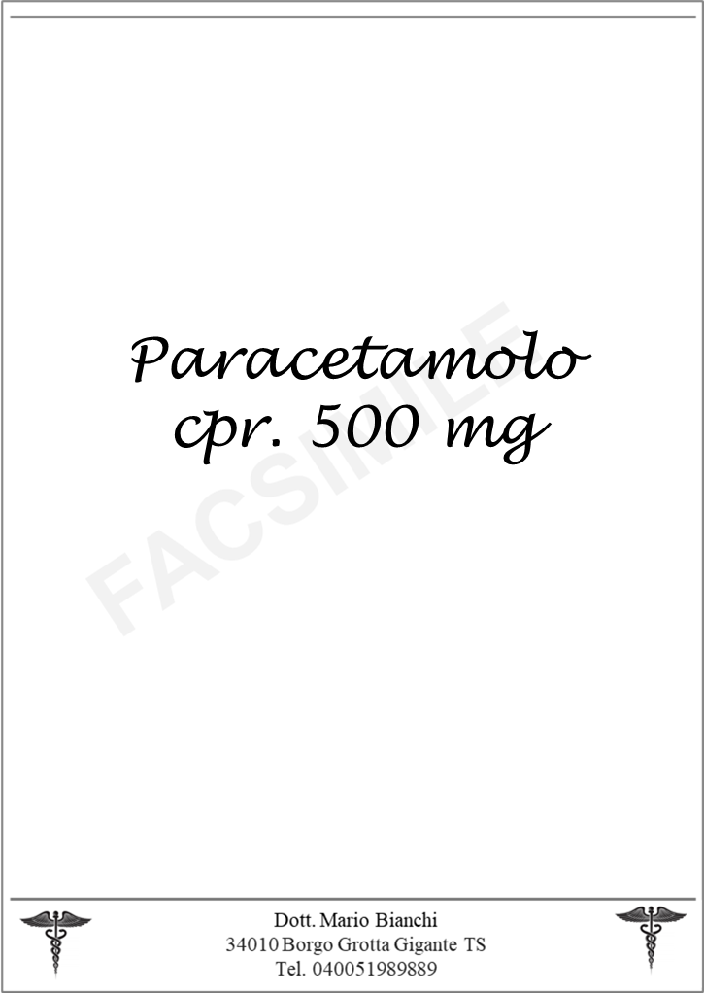

________________________________________________________________________________________________________________________________________________________________________________________________________________________________________________________________________________________________________________________________________________________________________
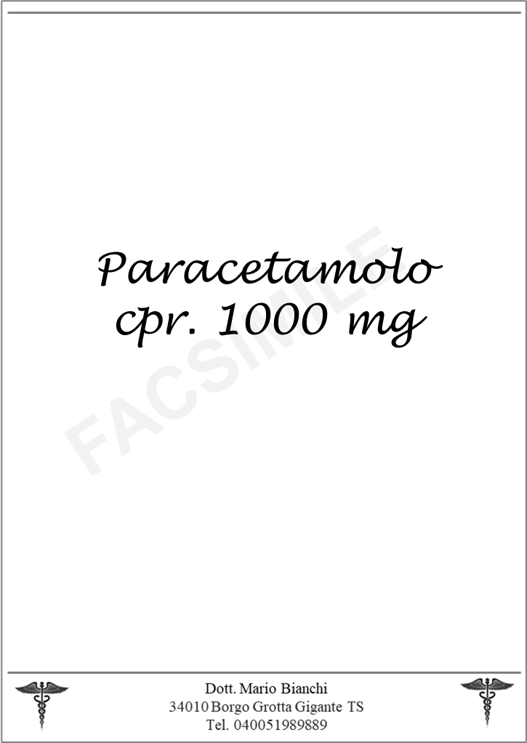

________________________________________________________________________________________________________________________________________________________________________________________________________________________________________________________________________________________________________________________________________________________________________

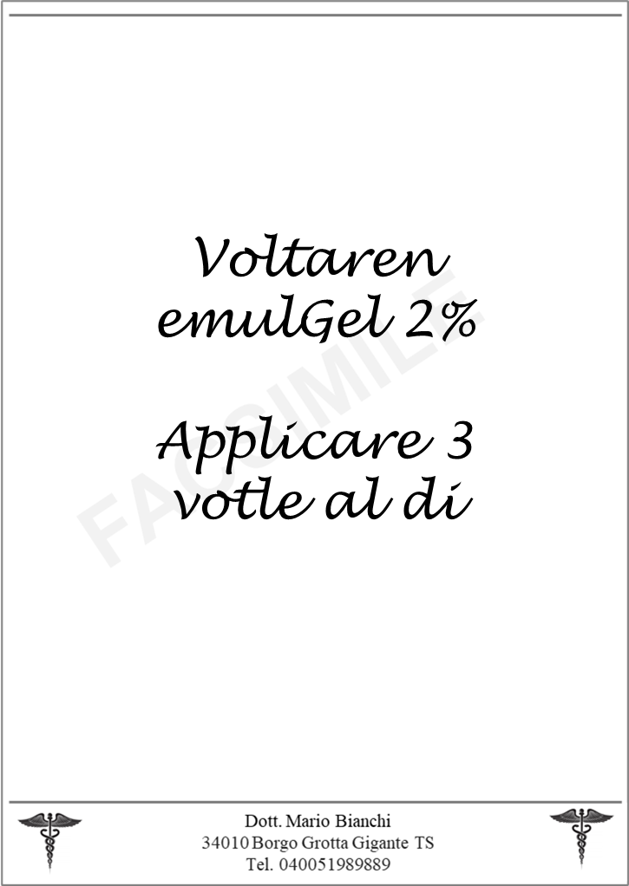
________________________________________________________________________________________________________________________________________________________________________________________________________________________________________________________________________________________________________________________________________________________________________

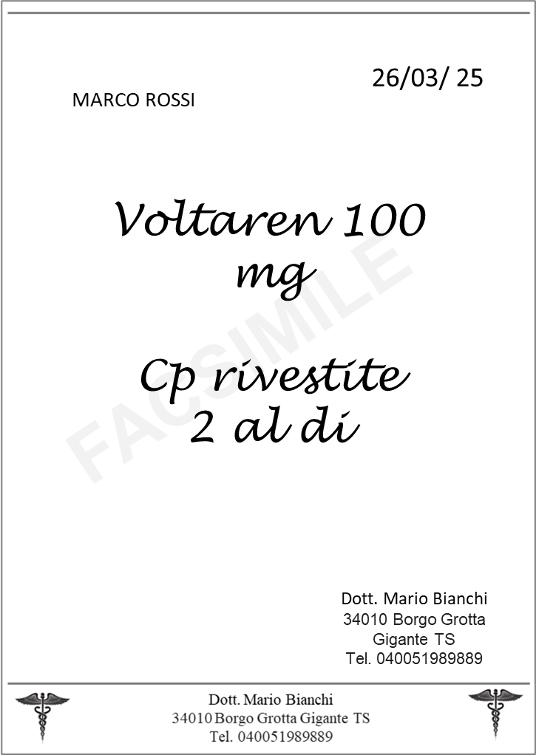
01/10/2025
________________________________________________________________________________________________________________________________________________________________________________________________________________________________________________________________________________________________________________________________________________________________________

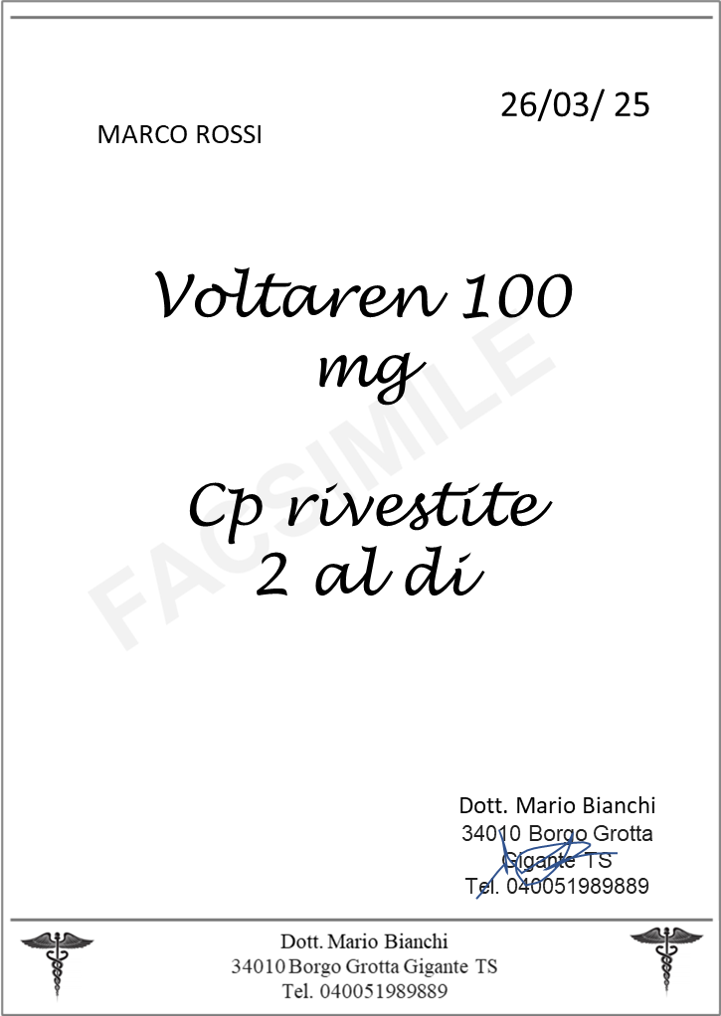
01/10/2025
________________________________________________________________________________________________________________________________________________________________________________________________________________________________________________________________________________________________________________________________________________________________________

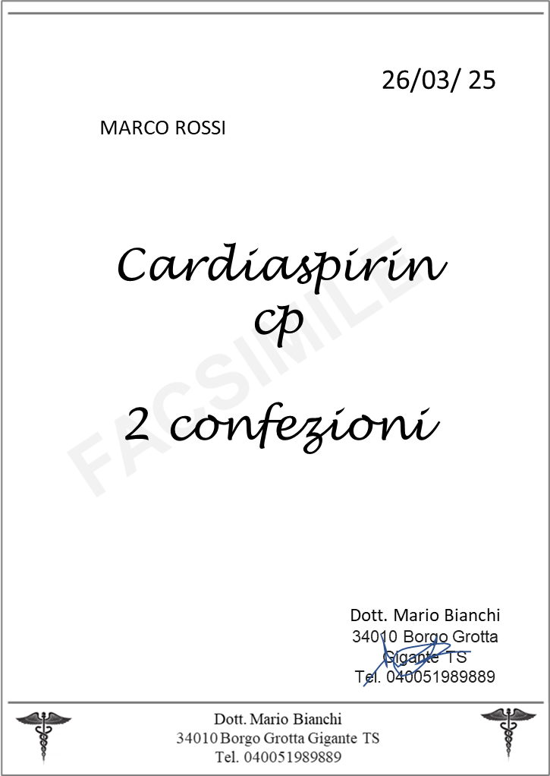
01/10/2025
________________________________________________________________________________________________________________________________________________________________________________________________________________________________________________________________________________________________________________________________________________________________________
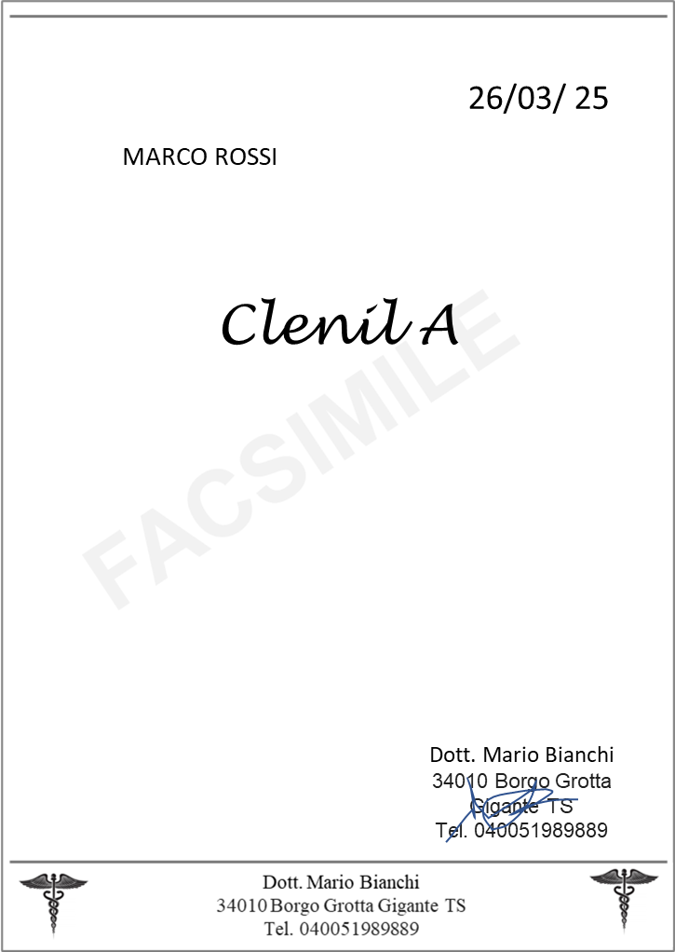
01/01/2025
________________________________________________________________________________________________________________________________________________________________________________________________________________________________________________________________________________________________________________________________________________________________________

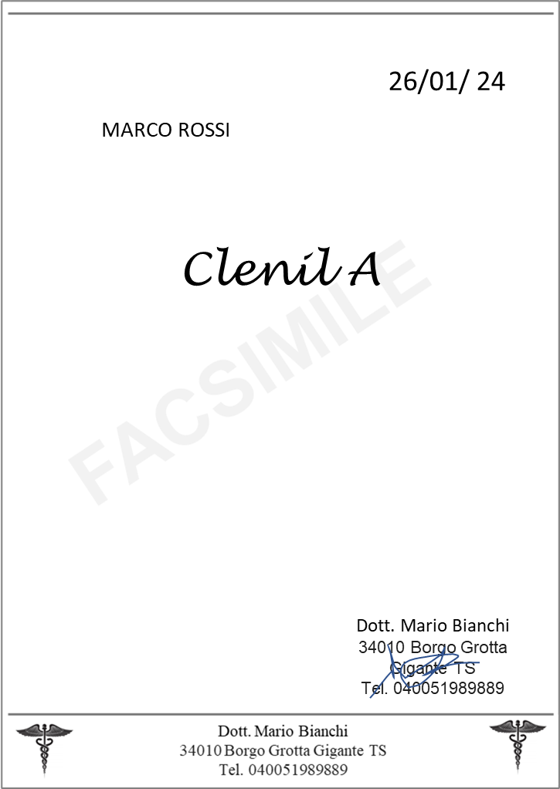
01/10/2024
________________________________________________________________________________________________________________________________________________________________________________________________________________________________________________________________________________________________________________________________________________________________________

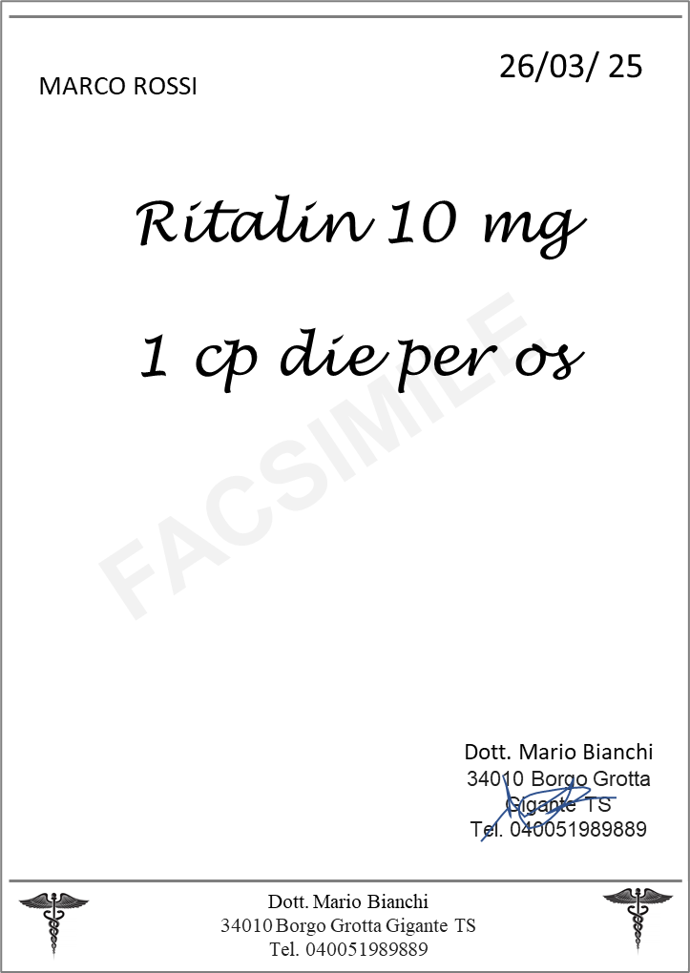
01/10/2025
________________________________________________________________________________________________________________________________________________________________________________________________________________________________________________________________________________________________________________________________________________________________________

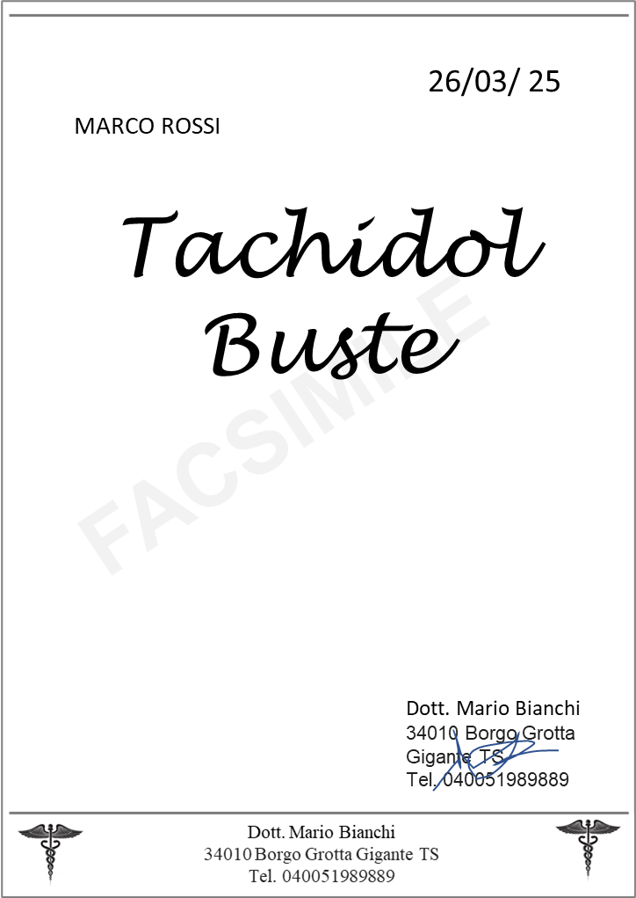
1x10,90 euro
02/10/2025
Farmacia Simulata
Piazzale Europa 1
34127 Trieste
01/10/2025
________________________________________________________________________________________________________________________________________________________________________________________________________________________________________________________________________________________________________________________________________________________________________

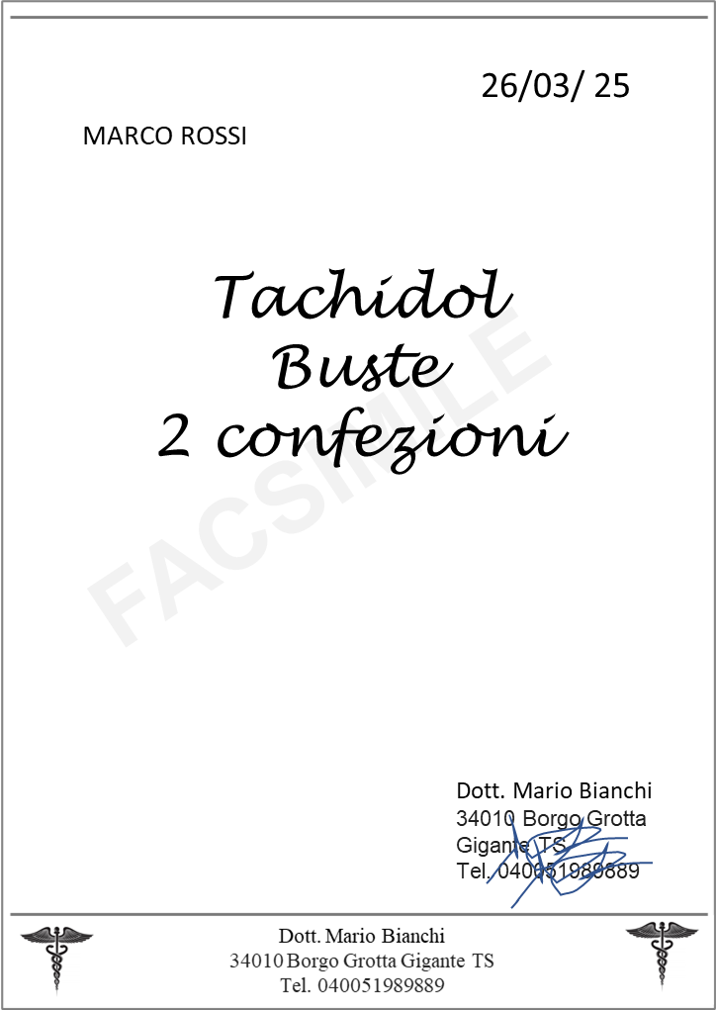
01/10/2025
________________________________________________________________________________________________________________________________________________________________________________________________________________________________________________________________________________________________________________________________________________________________________

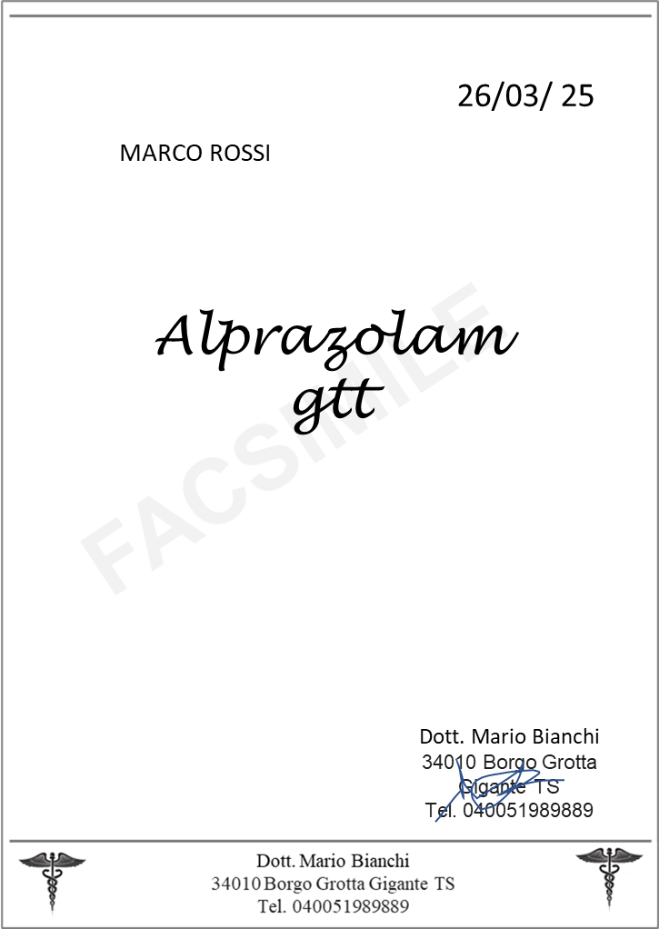
3x8,60 euro
25/09/2025
Farmacia Simulata
Piazzale Europa 1
34127 Trieste
01/09/2025
________________________________________________________________________________________________________________________________________________________________________________________________________________________________________________________________________________________________________________________________________________________________________
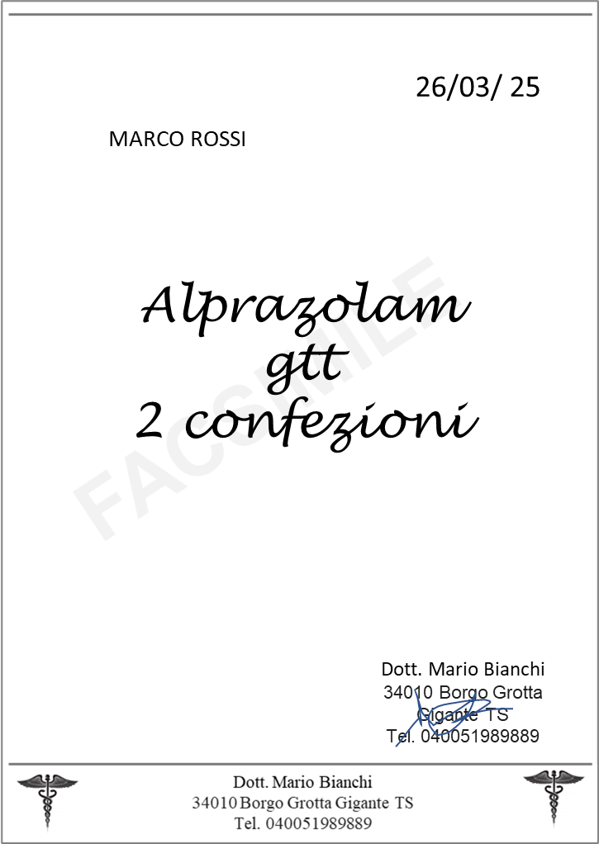
01/10/2025
________________________________________________________________________________________________________________________________________________________________________________________________________________________________________________________________________________________________________________________________________________________________________

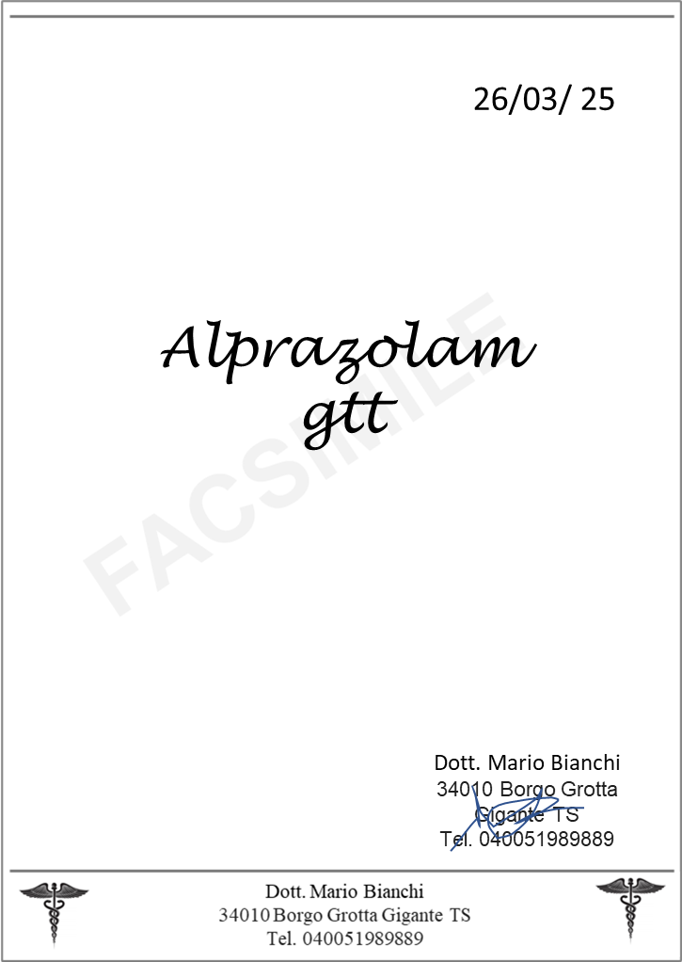
01/10/2024
________________________________________________________________________________________________________________________________________________________________________________________________________________________________________________________________________________________________________________________________________________________________________

