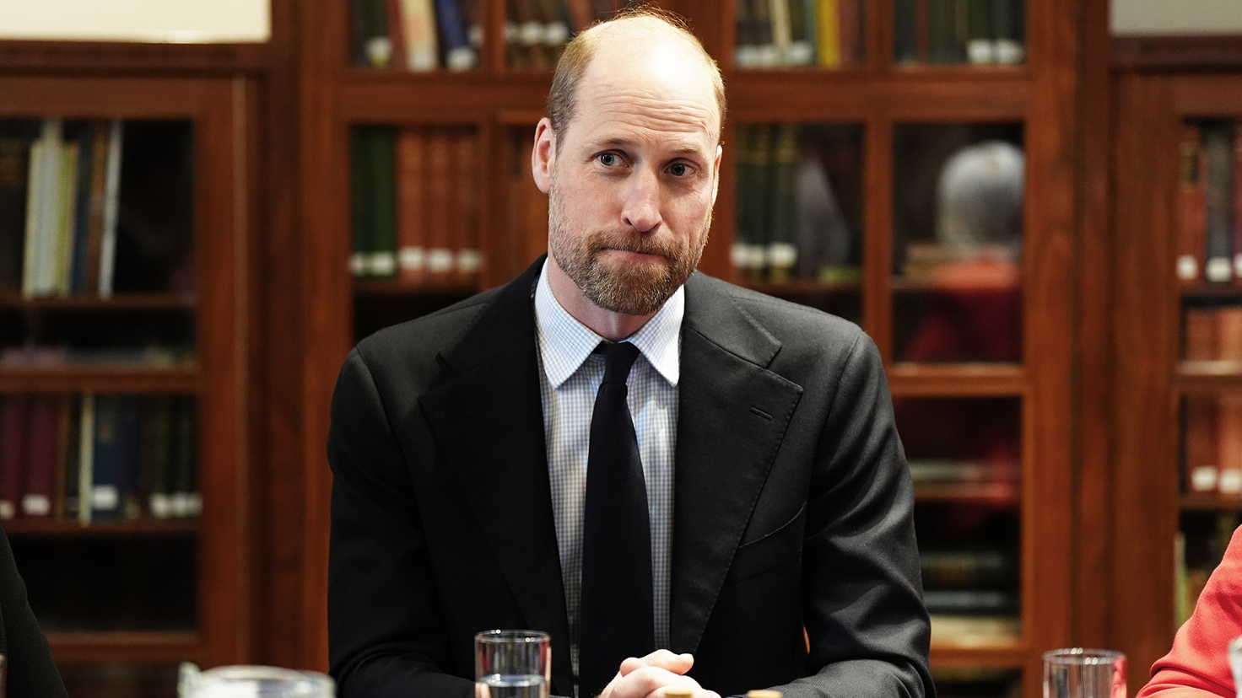

Who is this person?
Who are his parents?
What university did he attend?
What is his wife’s name?
What is his main charitable focus?
Why is he a voice to listen to?
What mental health initiative did he launch?

