Jeffrey Sachs Brands Trump’s Trade Policies ‘Childish and Dangerous,’ Warns of $10 Trillion Loss in Global Wealth

https://www.arise.tv/jeffrey-sachs-brands-trumps-trade-policies-childish-and-dangerous-warns-of-10-trillion-loss-in-global-wealth/
Global
Renowned US Economist Sachs has (criticize) 1 c____________________ Trump’s tariffs, warning of $10 trillion global wealth loss and authoritarian risk.
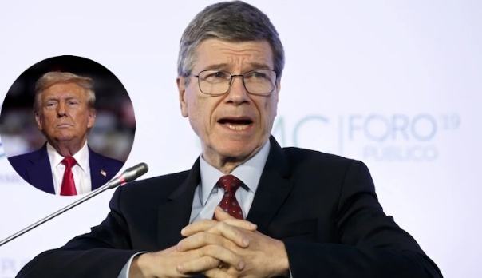
Speaking during a panel discussion on the topic: “Protectionism: The End of Globalisation”, at the 4th Antalya Diplomacy Forum in the resort city of Antalya, in Turkey, Sachs (contended) 2 ____________________ that Trump’s trade policy agenda remains one of the worst in history.
The United States recently announced what it termed (corresponding) 3 “____________________ tariffs” affecting trade with countries across the world, including Nigeria and China, close to 100 nations globally.
Rather than (point a finger at) 4 ____________________ trade imbalance, Sachs maintained that the United States trade deficit was because of (rash) 5 r____________________ government spending that has (exceeded) 6 s____________________ national income.
“If you pick up a credit card and you go shopping and you end up with a large credit card debt, you’re running a trade deficit with all those shops. It will be strange if you then blamed all the shop owners for having sold you all those things.
“That’s the level of understanding of the President of the United States. All that is happening is the United States is out-7____________________ its national income. We have a big credit card in the United States, it’s called the government,” said Sachs.
World leaders were (convened) 8 ____________________ at the forum, including heads of state, (scholars) 9 a____________________, diplomats, youth leaders and lawmakers to reevaluate diplomacy and find solutions to (relevant) 10 p____________________ global issues affecting the world. It was held with the theme: “Reclaiming Diplomacy in a Fragmented World”.
But Sachs delivered a (severe) 11 ____________________ critique of Trump’s trade policies, declaring that Trump’s understanding of trade is so fundamentally (faulty) 12 f ____________________ that “he wouldn’t pass a basic economics class.”
He condemned the president’s (obsession) 13 ____________________ on trade deficits as both “childish and dangerous.”
Sachs attributed a (astounding) 14 s____________________ $10 trillion loss in global wealth to Trump’s economic strategies and cautioned that the United States is (creeping) 15 e ____________________ toward authoritarianism, characterised by “one-man rule by emergency decree.”
Rejecting Trump’s accusations that other countries are “cheating” the US, Sachs argued that the real (problem) 16 i ____________________ is not trade but excessive US government spending.
According to Sachs, overnight, Trump’s team then (moved with urgency or panic) 17 s____________________ to create a formula to impose tariffs on countries as small as Lesotho based purely on the trade imbalance.
“They made some absolutely stupid 18 f____________________ that you would not accept in a first-year, third-week economics class. It came out of the US Trade Representative’s office. They probably were told, ‘Do it overnight, the boss wants it,’” he said.
Sachs described the result as a list of tariffs calculated on a country-by-country basis, an approach he deemed (completely and totally) 19 u ____________________ senseless. “You cannot make this stuff up,” he said. “This used to be not a Mickey Mouse country, my country.
“But this is Mickey Mouse. And I (say sorry) 20 ____________________ to Mickey Mouse—he would not do this. Mickey Mouse is smarter than this,” the Columbia University Professor stated.
The (ex) 21 ____________________ Special Adviser to the United Nations Secretary General, and long-time critic of both major US political parties’ (lack of success) 22 ____________________ to tackle inequality, accused Trump of selling “a pseudo explanation” and “a pseudo remedy” for economic discontent.
“What Trump is doing is giving a story to (toss-up) 23 ____________________ states like Michigan and Ohio—it’s China’s fault, it’s Mexico’s fault, it’s Lesotho’s fault,” he explained.
He also pointed out that the loss of (blue-collar) 24 m ____________________ jobs in the American Midwest was driven more by automation than trade. “Now if you go to an automotive plant, it’s all robots,” Sachs said. “That’s not because the jobs went (abroad) 25 ____________________ —it’s because the assembly line itself became an automated phenomenon,” Sachs argued.
Speaking on broader global challenges, Sachs expressed alarm at Trump’s decision to pull out of the (name of the city) 26 ____________________ Climate Agreement and promote coal, characterising it as “wilful destruction of wellbeing.”
Earlier this month, Trump announced (comprehensive) 27 sw ____________________ new tariffs on almost all trading partners, only to reverse most of them a week later after a market downturn. But the professor argued against the strategy.
Although Trump has said the US is making $2 billion a day from the new tariffs, official figures from US Customs and Border Protection, puts it at just over $260 million per day.

