Characterization of the spatial response of an X-ray imaging detector: measurement of CTF, MTF, LSF, ESF

Teacher: Luca Brombal
Email: lbrombal@units.it
When: 17th - 22nd - 24th February 2023
Duration: 3 hours per group
Where: Medical Physics Lab, Room 227, Department of Physics

Aim and scope
To measure the spatial resolution of an imaging system through 3 different techniques, namely:
- Contrast Transfer Function (CFT) measurements by using a bar pattern test object
- Line Spread Function (LSF) measurement and subsequent Modulation Transfer Function (MTF) estimation, by using a slit camera
- Edge Spread Function (ESF) measurement and subsequent LSF and MTF estimation, by using a sharp edge

Short theoretical recap
- Intuitive (naïve) definition of spatial resolution: the ability of an imaging system to distinguish small details in an imaged sample.
- Less intuitive (still not very rigorous) definition of spatial resolution: how close can two points be to each other before they become indistinguishable (Rayleigh criterion).
- More rigorous: the spatial resolution of an imaging system is determined by how the system transfers the input spatial frequencies to the output images. For linear systems with real and even response functions (see lecture Prof. Rigon), spatial resolution is fully characterized by the Modulation Transfer Function (MTF)
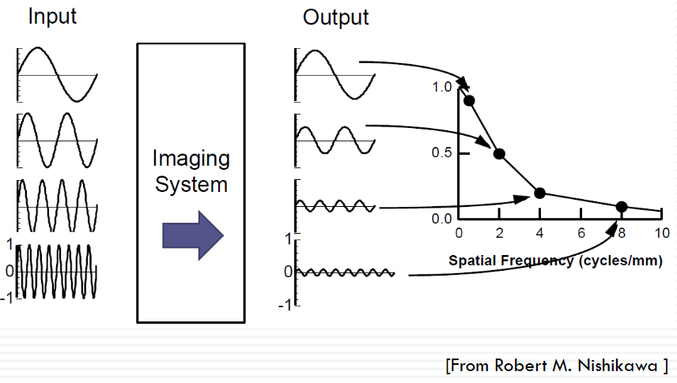
MTF
In practice it is hard to measure directly the MTF in X-ray imaging because it is hard to produce objects with sinusoidally varying opacity to X-rays.
- A practical and way for measuring spatial resolution is to use a bar pattern, i.e. an absorbing object with squared aperture/absorbing pairs providing an input of square waves with known spatial frequencies. The measured modulation as a function of the spatial frequency is called Contrast Transfer Function (CTF). This is similar but not equivalent to MTF (see slides prof Rigon)
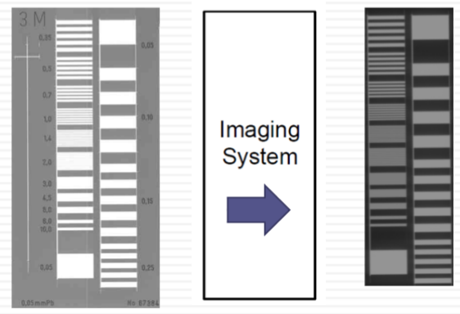
- A more rigorous procedure is to measure the LSF, i.e. the system’s response to “infinitesimally thin” line input. From the LSF, the MTF can be computed via the Fourier Transform (FT)
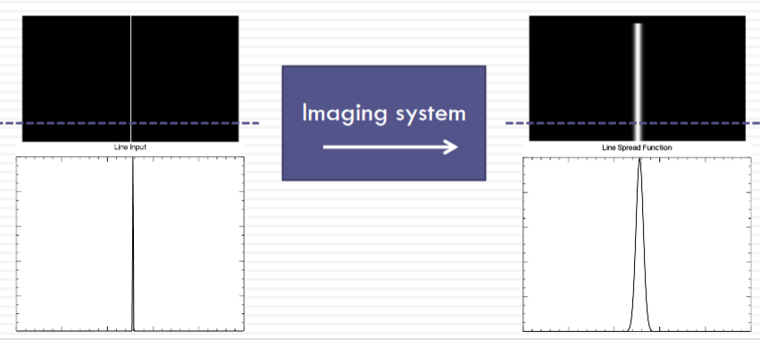
FT
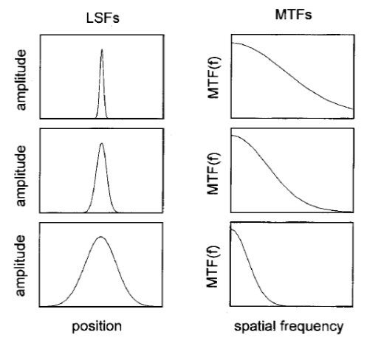
- LSF measurement is at times unpractical because the (“infinitesimally”) thin slit absorbs almost all the X-ray few X-rays detected high image noise. For this reason LSF is typically computed starting from the measurement of the ESF. The ESF is the system’s response to a step function-like input (i.e. an absorbing object with a straight edge with “infinite” sharpness). By computing the derivative of the ESF, LSF is obtained, hence the MTF through Fourier Transform.
Theoretical summary table
Test object/sample | Measured quantity | Relationship with MTF
Bar pattern | CTF | MTF ≈ CTF
Slit camera | LSF | MTF = $|FT(LSF)|$
Absorbing edge | ESF | MTF =$\left|FT\left(\frac{d}{dx}ESF\right)\right|$

Description of the activity

Instrumentation
X-ray tube Rigaku CN4037A1 (external panel in the picture below)
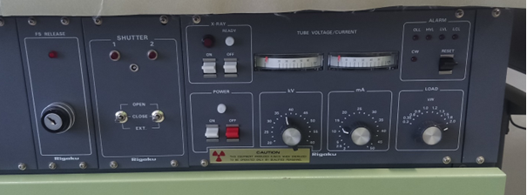
CCD detector Hamamatsu: sensor S10811 (Datasheet) - signal processing unit C9266-03 (Datasheet)
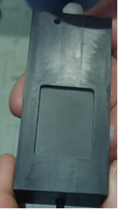 | 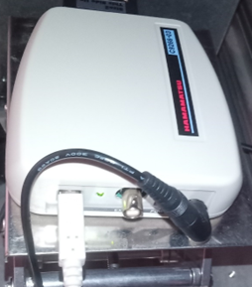

ORTEC 871 Timer and Counter (with power supply)
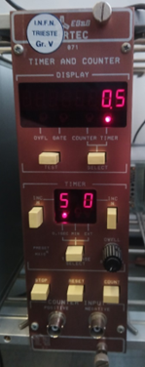 | 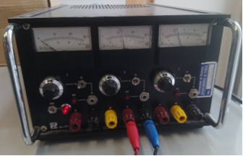
Bar pattern test object from 0.05 to 10 lp/mm
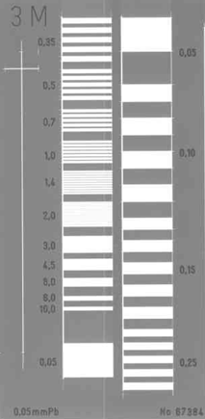
Slit camera Nuclear Associates Model 07-624-1, width 10 µm
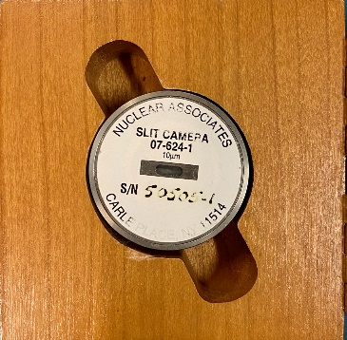
Computer software:
- Hamamatsu C9266DCamAPL software
- Fiji - ImageJ

SETUP scheme

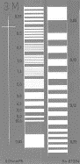
X-ray tube

X-ray shielding
Detector power and control
CCD
detector
Sample
Computer: storage, visualization, analysis

Acquisitions
- Bar pattern measurements
  - Acquire an image without X-ray – Dark current image
  - Acquire an image without sample – Flat field image – Voltage 30 kV, current 15 mA
  - Position the bar pattern close to the dector with apertures perpendicular to the detector’s long side and acquire an image
  - Move the bar pattern and repeat c)
Note: acquisition must all be performed with the same exposure through the Timer/counter module!
Note: The shutter (triggered via timer counter) must be open and close within the frame duration (set via exposure time in the Hamamatsu software) – manual synchronization is require
- Slit camera measurements
  - Acquire an image without X-ray – Dark current image
  - Acquire an image without sample – Flat field image
  - Position the slit camera close to the detector and make sure it is well aligned with the pixel matrix.
  - Acquire the image
- Edge measurement
  - Acquire an image without X-ray – Dark current image
  - Acquire an image without sample – Flat field image
  - Image the bar pattern at its smallest spatial frequency. Take care that the edge is perpendicular to the detector’s long side and acquire an image.

Analysis
In the following a scheme for the analysis of lab data.
You can develop your own tools to do it or, alternatively, use an Excel spreadsheet that is uploaded on Moodle within the topic: Estimation of spatial resolution of an X-ray imaging detector. (see description on Moodle)
- Bar pattern:
  - Perform dark-current subtraction (to compensate for readout structured noise) and flat-field normalization (to compensate for X-ray beam structure and detector response inhomogeneity)
$${im}_{corr}=\frac{image-dark}{flat-dark}$$
  - Measure the intensity profile across each line pair value in the test object
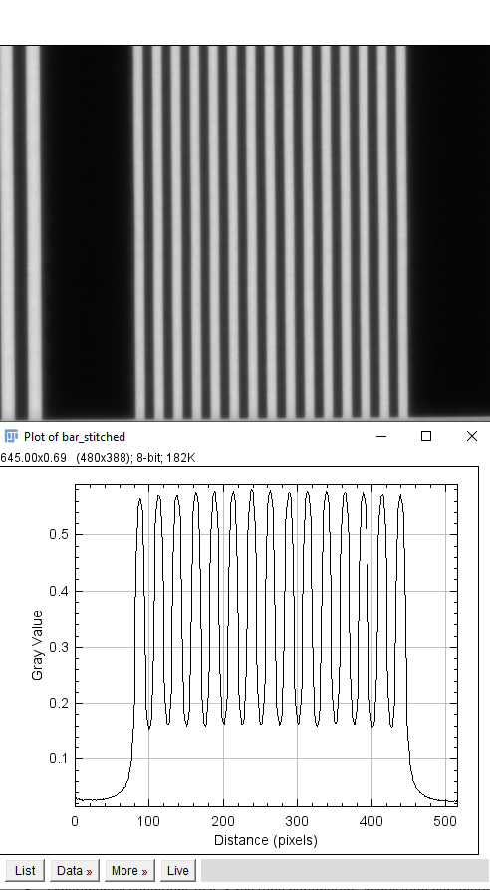

  - Measure the modulation of each intensity profile
$$m=\frac{\max\left(im_{corr}\right)-min⁡(im_{corr})}{\max\left(im_{corr}\right)+min⁡(im_{corr})}$$
  - Plot the modulation as a function of the spatial frequency (i.e., lp/mm) where it was measured
- Slit camera measurements:
  - Perform dark-current subtraction (to compensate for readout structured noise) and flat-field normalization (to compensate for X-ray beam structure and detector response inhomogeneity) – see previous case
  - Measure the intensity profile across the slit, making sure the measuring line is perpendicular to the slit. This is the LSF.
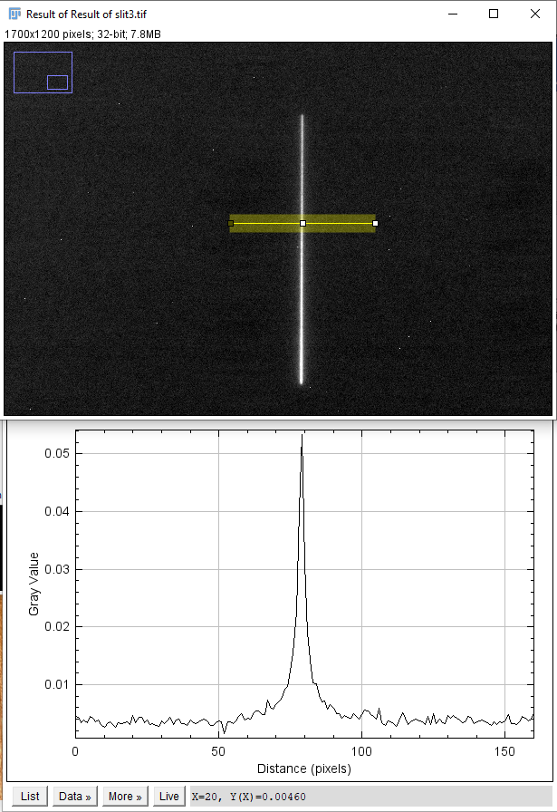

  - Compute the MTF by Fourier Transforming the LSF and using the appropriate transformation of pixel units in spatial frequency

  - Plot the MTF as a function of the spatial frequency
- Edge measurement
  - Perform dark-current subtraction (to compensate for readout structured noise) and flat-field normalization (to compensate for X-ray beam structure and detector response inhomogeneity) – see previous case
  - Measure the intensity profile across the edge, making sure the measuring line is perpendicular to the edge. This is the ESF.
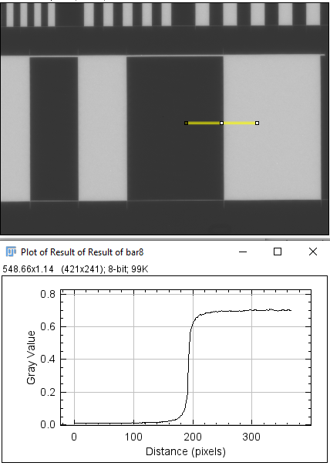

  - Derive numerically (finite differences) the ESF to obtain the LSF

  - Repeat points c) and d) of the previous case.

How to structure the lab report:
- Title
- Authors
- Short introduction: aim of the experiment + (short) background
- Materials and methods:
  - Instrumentation and setup (Detector, X-ray tube, software, test objects, block diagram)
  - Experimental conditions (e.g. X-ray tube parameters, acquisition parameters, acquisition geometry)
- Analysis and results (tables and plots):
  - Estimation of CTF (description of the analysis, data and plot)
  - Estimation of LSF and MTF from LSF (description of the analysis, plot)
  - Estimation of ESF, LSF from ESF, MTF from LSF from ESF (description of the analysis, plot)
- Discussion and conclusions
  - Do results make sense?
  - What do they imply?
  - How do they compare with each other?
  - How do they compare with the sensor specs?
  - Final considerations
- Bibliography
  - Cite only relevant sources

Deadline
March 22nd, upload on the moodle webpage. Filename: “GroupA/B/C/D/E_MTF.pdf”

Notes
Theoretical counterpart of this activity is mainly contained in Lecture 6 – Applied linear-systems theory by Prof. Luigi Rigon

