Objectif grammatical : poser des questions
1. Faire connaissance
1. Grammaire : la phrase interrogative
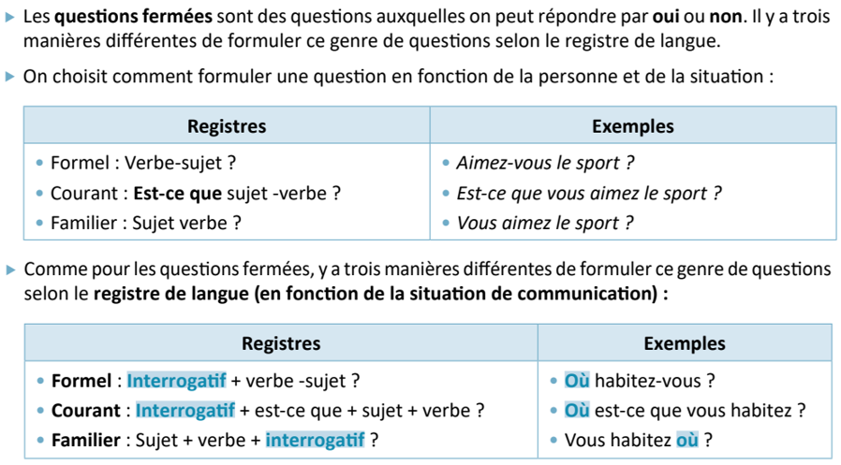
Quelles questions peut-on poser quand on veut connaître quelqu’un ?
…………………………………………………………………………………...........................................................................………………………………………………………………………………..............................................................................
…………………………………………………………………………………...........................................................................………………………………………………………………………………...........................................................................…
…………………………………………………………………………………........................................................................…
………………………………………………………………………………...........................................................................…
…………………………………………………………………………………........................................................................…

Posez les questions à votre voisin(e) et présentez-le/la.

3. Compréhension orale. Écoutez les présentations et prenez des notes.

- Thomas :
------------------------------------------------------------------------------------------------------------------------------------------------------------------------------------------------------------------------------------------------------------------------------------------------------------------------------------------------------------------------------------------------------------------------------------------------------------------------------------------------------------------------------------------------
- Valérie :
------------------------------------------------------------------------------------------------------------------------------------------------------------------------------------------------------------------------------------------------------------------------------------------------------------------------------------------------------------------------------------------------------------------------------------------------------------------------------------------------------------------------------------------------------------------------------------------------
- Pascal :
------------------------------------------------------------------------------------------------------------------------------------------------------------------------------------------------------------------------------------------------------------------------------------------------------------------------------------------------------------------------------------------------------------------------------------------------------------------------------------------------------------------------------------------------

4. Dictée : Pascal se présente
-----------------------------------------------------------------------------------------------------------------------------------------------------------------------------------------------------------------------------------------------------------------------------------------------------------------------------------------------------------------------------------------------------------------------------------------------------------------------------------------------------------------------------------------------------------------------------------------------------------------------------------------------------------------------------------------------------------------------------------------------------------------------------------------------------------------------
----------------------------------------------------------------------------------------------------------------------------------------------------------------------------------------------------------------------------------

5. Expression écrite : Écrivez un texte de présentation

…………………………………………………………………………………...........................................................................………………………………………………………………………………..............................................................................
…………………………………………………………………………………...........................................................................………………………………………………………………………………...........................................................................…
…………………………………………………………………………………........................................................................…
………………………………………………………………………………...........................................................................…
…………………………………………………………………………………........................................................................…
…………………………………………………………………………………...........................................................................………………………………………………………………………………..............................................................................
…………………………………………………………………………………...........................................................................………………………………………………………………………………...........................................................................…
…………………………………………………………………………………........................................................................…
………………………………………………………………………………...........................................................................…
…………………………………………………………………………………........................................................................…
…………………………………………………………………………………...........................................................................………………………………………………………………………………..............................................................................
…………………………………………………………………………………...........................................................................………………………………………………………………………………...........................................................................…
…………………………………………………………………………………........................................................................…
………………………………………………………………………………...........................................................................…
…………………………………………………………………………………........................................................................…
…………………………………………………………………………………...........................................................................………………………………………………………………………………..............................................................................

